Week 12 Preparing date: November …..,
Period 45 Teaching date: November …..,

Unit 7: Classroom instructions
Lesson 1(4, 5, 6)
A. OBJECTIVES:
By the end of the lesson, Ss will be able to:
1. Knowledge:
- listen to and understand two communicative contexts in which pupils introduce someone and respond to the introduction.
- read and complete the sentences correctly.
- recognise target words while listening and acting out the classroom instructions by playing the game Sit down, please!
- Vocabulary: Review
- Skills: speaking, listening, reading and writing.
2. Competences:
- Critical Thinking: self-introduce
- Co-operation: ready to help friends in pair work/ group work.
- Self-control and independent learning: perform listening tasks.
3. Attitude/ Qualities:
- Kindness: Help partners to complete learning tasks.
- Honesty: tell the truth about feelings and emotions.
- Diligence: complete learning tasks.
B. TEACHING AIDS:
- Teacher: Teacher’s guide Pages 92; audio Tracks 69; website sachmem.vn, posters, laptop, pictures, textbook, lesson plan, TV or projector.
- Students: Pupil’s book Page 51, notebooks, workbooks, school things.
C. PROCEDURES:
Stages/Time | Teacher’s activities | Students’ activities
1.Warm- up:  (5’)  2.Practice: (27’)  3. Homework. (3’) | Game: Simon says  *Aims: to create a friendly and active atmosphere in the class to beginning the lesson.  *Procedure:  - T is the “Simon” and calls out the actions. Every student must follow and do the action, but only when they hear “Simon says ...”.  - If teacher leaves out “Simon says” before giving instruction, anyone who does the action is out.  - Then, teacher can choose one or more students as the leader to continue a game.  - Say “Open your book page 51” and look at “Unit 7, Lesson 1 (4,5,6)”.  Activity 1. Listen and tick:  *Aims: Ss will be able to listen to and understand two communicative contexts in which Ms Hoa gives pupils two instructions.  *Procedure:  - Elicit the instruction used in each picture.  - Point at the pictures respectively to explain the context.  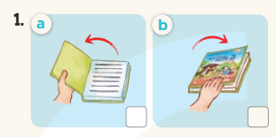  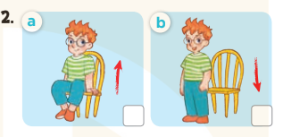  - T ask Ss to guess the answers.  + T writes Ss’guessing on the board.  - Listen to the tape:  + Play the recording  + Play the recording again and get Ss to swap books with their partners.  + Play the recording again to check answers together as a class.  + Write the answers on the board for Ss to correct their answers. Then checks Ss’ guessing.  - Play the recording, sentence by sentence, for the class to listen and repeat in chorus.  Key: 1. a 2. a  Activity 2. Look, complete and read  *Aims: Ss will be able to complete the four target sentence patterns with the help of the picture cues.  *Procedure:  - Get Ss to look at the pictures and identify the instruction used in each picture.  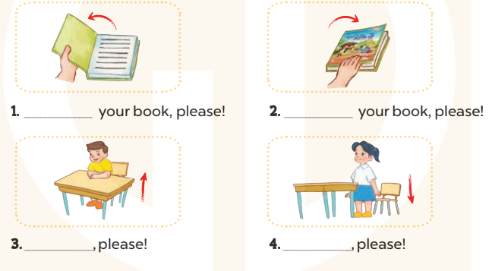  - Have Ss look at the four incomplete sentences. Elicit and model with picture 1  + Ask Ss to read the sentence 1 in chorus.  + Ask Ss what word is missing in the gap (Open). Then have them complete the sentence (Open your book, please!).  -Have Ss work in pairs and complete the sentences 2, 3, 4.  - Ask a few Ss to stand up and read the sentences aloud.  -T gives feedbacks.  Key:  - Open 2. Close  - 3. Stand up 4. Sit down  Activity 3. Let’s play  *Aims: Ss will be able to recognise target words while listening and acting out the classroom instructions by playing the game Sit down, please!  *Procedure:  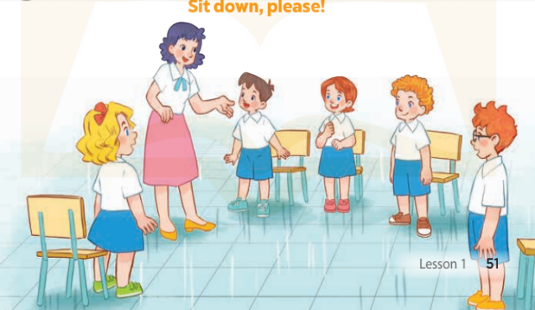  - Put Ss into groups of 5 or 6. Choose one pupil from each group as aperson who gives instructions for the rest of the group to act out.  - Model by saying: Stand up, please! Ss respond to this instruction by  standing up.  - Have groups play the game. One pupil in each group gives instructions for his / her group to act out.  + Ss perform the wrong action are out of the game.  - The winning group is the one that has the highest number of members left at the end of the game.  *Consolidation  *Aims: Ss will be able consolidate and wrap up the content of the lesson.  *Procedure:  - T asks ss to answer the following questions:  + What have you learnt from the lesson today?  +What are the core values of the lesson? (if the teacher can take from the lesson).  - T praises some Ss who are hardworking / active/ good…. as well as encourage others to try more.  - Practice part 5 again.  - Prepare the new lesson: Unit 7, Lesson 2 (1,2,3). | - Ss listen  -Ss play game  - Ss play game  -Ss play game  - Ss open their books  -Look at the pictures and say:  + Picture 1a: a book opening  + Picture1 b: a book closing  + Picture 2a: a boy about to stand up  + Picture 2b: a boy about to sit down  -Ss guess the answers  - Ss listen to the tape and tick  - Ss listen again, tick and swap books with their partners.  - Ss check their answers and guessing  -Ss listen and repeat.  -Ss look at the picture and say  -Ss look and answer  -Ss read  -Ss say and write  -Ss work in pairs and complete  -Ss read aloud  - Ss listen  -Ss play game  -Ss play game  -Ss answer the questions  -Ss listen and clap their hands  -Ss listen and take note
D. ADJUSTMENTS (if necessary):
………………………………………………………………………………………….…..……………………………………………………………………………...………………………………………….…..……………………………………………………………………………….……………………………………………………………………...

