Week 13 Preparing date: December …..,
Period 50 Teaching date: December …..,

Unit 8: My school things
Lesson 1 (1, 2, 3)
A. OBJECTIVES:
By the end of the lesson, Ss will be able to:
1. Knowledge:
- use the words pen, ruler, book, school bag, have in relation to the topic “School things”
- use I have ……….. to talk about having a school thing
- understand and correctly repeat the sentences in two communicative contexts (pictures) to talk about having a school thing.
- Vocabulary: pen, ruler, book, school bag, have
- Skills: speaking and listening
2. Competences:
- Self-control and independent learning: perform listening tasks.
- Communication and collaboration: work in pairs or groups.
- Sociability: talk to each other, say good words to others.
3. Attitude/ Qualities:
- Kindness: Help partners to complete learning tasks.
- Honesty: tell the truth about feelings and emotions
B. TEACHING AIDS:
- Teacher: Teacher’s guide Pages 100, 101, audio Tracks 77, 78, website sachmem.vn, posters, laptop, pictures, textbook, lesson plan, TV or projector.
- Students: Pupil’s book Page 56, notebooks, workbooks, school things.
C. PROCEDURES:
Stages/Time | Teacher’s activities | Students’ activities
1.Warm- up:  (3’)  2. Presentation  (16’)  3.Practice: (7’)  4.Production: (7’)  5. Homework. (2’) | Jigsaw puzzle  *Aims: to create a friendly and active atmosphere in the class to beginning the lesson.  *Procedure:  - Divide class into 4 groups: Tom, Jerry, Miu and Chit.  - Ask Ss look at the pieces of picture.    - Ask Ss go to the board and jigsaw puzzle into the correct picture.  -T checks who’s the winner? - Say “Open your book page 56” and look at “Unit 8, Lesson 1 (1,2,3)”.  Activity 1. Vocabulary.  *Aims: Ss will be able to know the vocabulary in front of starting the new lesson.  *Procedure:  -T elicits the new words  + pen : bút mực (realia)  + ruler : thước kẻ (realia)  + book :quyển sách (realia)  + school bag: cặp sách (realia)  + have : có (translation)  - T models (3 times).  - T writes the words on the board.  - Checking: Rub out and remember  Activity 2. Look, listen and repeat:  *Aims: Ss will be able to understand and correctly repeat the sentences in two communicative contexts (pictures) to talk about having a school thing.  *Procedure:  - Have Ss look at Pictures a and b and identify the characters (Linh and Ben) in the pictures.  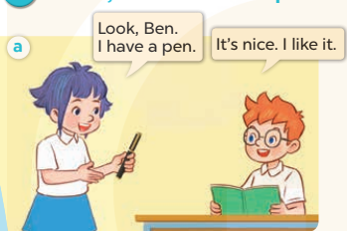  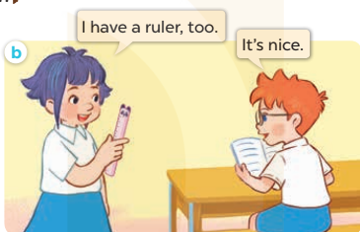  - Play the audio twice (sentence by sentence). Correct their pronunciation where necessary.  - Have Ss to practice the dialogue  - T invites a few pairs to the front of the class to practice.  - T checks pronunciation for ss.  Activity 3 2. Listen, point and say.  *Aims: Ss will be able to correctly say the words and use: I have …….  to talk about having a school thing.  *Procedure:  * Model sentences:  - T asks Ss look at picture a and helps Ss know the structure from the dialogue.  - T introduces new structure for Ss.  - T explains, models and gives meaning.  -Have Ss repeat the model sentences.  *Drill pictures  - Have Ss look at the pictures and identify the school things in the pictures  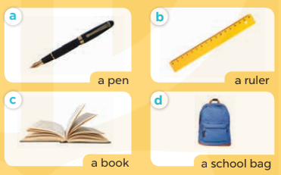  - Run through all the pictures.  - Run through model sentences.  - Have Ss to practise:  +Tell Ss to point at the relevant school thing in the picture when they are repeating the sentence  - T controls and corrects.  - Invite a few pupils to stand up, point at each school thing in the picture and say he sentence aloud.  - T gives feedbacks.  Activity 4. Let’s talk.  *Aims: Ss will be able enhance the correct use of I have ……. to talk about having a school thing.  *Procedure:  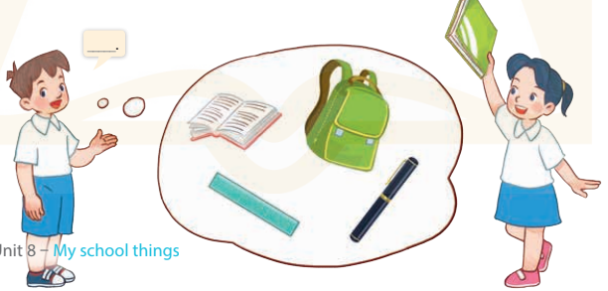  - Have Ss look at the picture and elicit the question and the answer in context.  + Who are they?  + Where are they?  + What are they talking about?  - Point at each school thing, elicit the missing words in the bubble (I have a book /ruler / …).  - Get Ss to say the completed sentence.  - Put Ss into pairs point at the school things in the picture and in the classroom respectively to say the sentence I have……….  *Consolidation  *Aims: Ss will be able consolidate and wrap up the content of the lesson.  *Procedure:  - T asks ss to answer the following questions:  + What have you learnt from the lesson today?  +What are the core values of the lesson? (if the teacher can take from the lesson).  - T review the vocabulary and model sentences.  - T praises some Ss who are hardworking / active/ good…. as well as encourage others to try more.  - Learn the vocabulary and model sentences by heart  - Prepare the new lesson: Unit 8, Lesson 2 (4,5,6). | - Ss listen  -Ss look at the pieces of the picture  -Ss put into the correct picture  -Ss check  -Ss listen and answer  - - Ss listen and repeat  + Choral repetition (3 times).  + Individual repetition (3 ss)  - Ss take note  - Ss look, remember and write  -Look at the pictures and say  + In picture a: Linh shows Ben her new pen and says: Look, Ben. I have a pen. Ben expresses his surprise and says: It's nice. I like it.  + In picture b: Linh shows Ben a ruler and says: I have a ruler, too. Ben says: It's nice.  -Ss listen and repeat in chorus (twice)  -Ss work in pairs to practice  -Ss practice the dialogue  -Ss listen  -Ss look at the picture and answer.  -Ss listen  -Ss listen and repeat  -Ss repeat  - Ss look, listen and answer  + Picture a: a pen  + Picture b: a ruler  + Picture c: a book  + Picture d: a school bag  -Ss listen and repeat  -Ss practice in chorus, individuals.  -Ss point and say  -Ss listen.  -Ss look at the picture and answer  + Two pupils talk about having a school thing (a book, a school bag, a pen and a ruler).  -Ss point and say  -Ss say the sentence  -Ss work in pairs, point and say  -Ss answer the questions  - Ss listen  -Ss listen and clap their hands  -Ss listen and take note
D. ADJUSTMENTS (if necessary):
………………………………………………………………………………………….…..……………………………………………………………………………...………………………………………….…..……………………………………………………………………………….……………………………………………………………………...

