Week 13 Preparing date: December …..,
Period 49 Teaching date: December …..,

Unit 7: Classroom instructions
Lesson 3 (4, 5, 6)
A. OBJECTIVES:
By the end of the lesson, Ss will be able to:
1. Knowledge:
-read and match two sentences and two dialogues with four pictures.
-read, understand and complete the incomplete sentences by writing the correct words in the gaps.
-make classroom instructions, choose one from the box and read it to the classmates to act out.
- Vocabulary: Review
- Skills: speaking, listening, reading and writing.
2. Competences:
- Critical Thinking: self-introduce
- Co-operation: ready to help friends in pair work/ group work.
- Self-control and independent learning: perform listening tasks.
3. Attitude/ Qualities:
- Kindness: Help partners to complete learning tasks.
- Honesty: tell the truth about feelings and emotions.
- Diligence: complete learning tasks.
B. TEACHING AIDS:
- Teacher: Teacher’s guide Pages 98, 99; website sachmem.vn, posters, laptop, pictures, textbook, lesson plan, TV or projector.
- Students: Pupil’s book Page 55, notebooks, workbooks, school things.
C. PROCEDURES:
Stages/Time | Teacher’s activities | Students’ activities
1.Warm- up:  (5’)  2.Practice: (8’)  3.Production: (19’)  4. Homework. (3’) | Game: “Chant”  *Aims: to review the vocabulary and structure about greet and respond to greetings.  *Procedure:  - Ask Ss chant and do the actions in Unit 7, Lesson 3 page 54 in groups.  - Give point for the groups and encourage them.  - Say “Open your book page 55” and look at “Unit 7, Lesson 3 (4, 5, 6)”.  Activity 1. Read and match:  *Aims: Ss will be able to read and match two sentences and two dialogues with four pictures *Procedure:  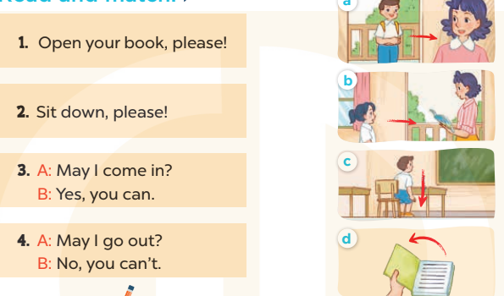  - Elicit and introduce four picture cues, two sentences and two dialogues to match  - Have Ss read the first sentence in chorus  - Model by drawing a line to match it with Picture d and make sure that Ss know how to do the task.  - Give Ss enough time to complete the text.  - Check the answers as a class.  - Have Ss read the text aloud.  Key: 1. d 2. c 3. a 4. b  Activity 2. Let’s write  *Aims: Ss will be able to read, understand and complete the incomplete sentences by writing the correct words in the gaps.  *Procedure:  -Write the first incomplete sentence on the board: 1. Open your.., please!  - Read the incomplete sentence as a class.  + Elicit the word Ss have to write in the first gap and encourage them to say it.  - Give Ss time to write down the answer 2, 3, 4.  - Invite one or two Ss to stand up, listen and repeat the sentences  Key: 1. book(s) 2. Stand  3. come; Yes 4. speak; can’t  Activity 3. Project.  *Aims: Ss will be able to make classroom instructions, choose one from the box and read it to the classmates to act out.  *Procedure:  - Put Ss into groups or ask the whole class to work together.  - Tell Ss to write instructions on their sheets of paper, then fold and put them in a box (each pupil writes just one instruction).  - Get each Ss to choose one instruction in the box then read it to the group/ whole class to act out.  - Give Ss enough time to complete each step.  - Create a class display using the pictures and vote for the most creative.  *Consolidation  *Aims: Ss will be able consolidate and wrap up the content of the lesson.  *Procedure:  - T asks ss to answer the following questions:  + What have you learnt from the lesson today?  +What are the core values of the lesson? (if the teacher can take from the lesson).  - T praises some Ss who are hardworking / active/ good…. as well as encourage others to try more.  - Prepare the new lesson: Unit 8, Lesson 1 (1, 2, 3). | - Ss listen and chant  - Ss open their books  - Ss look at the pictures and answer  -Ss read the first dentence  -Ss match  -Ss match  -Ss check their answer  -Ss read aloud  -Ss look and listen  -Ss read  -Ss write  -Ss do the task  -Ss listen and repeat  -Ss listen  - Ss write instructions  + Example: Stand up / Sit down, please!  Close / Open your book(s), please!  Go to the board, please! Go there / Come here, please!  Tell me / Spell your name, please! …)  -Ss choose instruction and read it  -Ss do the task  -Ss vote for the most creative  -Ss answer the questions  -Ss listen and clap their hands  -Ss listen and take note
D. ADJUSTMENTS (if necessary):
………………………………………………………………………………………….…..……………………………………………………………………………...…………

