Week 14 Preparing date: December …..,
Period 53 Teaching date: December …..,

Unit 8: My school things
Lesson 2 (4, 5, 6)
A. OBJECTIVES:
By the end of the lesson, Ss will be able to:
1. Knowledge:
- listen to and understand four communicative contexts in which pupils ask and answer questions about having a school thing.
- read and match four simple exchanges with the correct pictures
- review vocabulary words for school things and use them in the sentence patterns Do you have ………...? and Yes, I do. / No, I don’t. by playing the matching game or Pelmanism.
- Vocabulary: Review
- Skills: speaking, listening, reading and writing.
2. Competences:
- Critical Thinking: self-introduce
- Co-operation: ready to help friends in pair work/ group work.
- Self-control and independent learning: perform listening tasks.
3. Attitude/ Qualities:
- Kindness: Help partners to complete learning tasks.
- Honesty: tell the truth about feelings and emotions.
- Diligence: complete learning tasks.
B. TEACHING AIDS:
- Teacher: Teacher’s guide Pages 105, 106, 107; audio Tracks 83; website sachmem.vn, posters, laptop, pictures, textbook, lesson plan, TV or projector.
- Students: Pupil’s book Page 59, notebooks, workbooks, school things.
C. PROCEDURES:
Stages/Time | Teacher’s activities | Students’ activities
1.Warm- up:  (5’)  2.Practice: (27’)  3. Homework. (3’) | Game: Who says fast?  *Aims: to create a friendly and active atmosphere in the class to beginning the lesson.  *Procedure:  - Hold a school thing card, then reveal it slowly.  - Ask What is it?  - Ask the Ss guess the answer as fast as possible.  - Then have Ss do the same with the rest.  - This can be played in groups to make it more interesting.  - Say “Open your book page 59” and look at “Unit 8, Lesson 2 (4,5,6)”.  Activity 1. Listen and number:  *Aims: Ss will be able to listen to and understand four communicative contexts in which pupils ask and answer questions about having a school thing.  *Procedure:  - Elicit the words for the school thing in each picture.  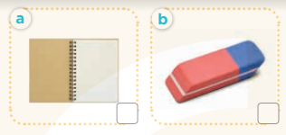  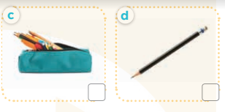  - T ask Ss to guess the answers.  + T writes Ss’guessing on the board.  - Listen to the tape:  + Play the recording  + Play the recording again and get Ss to swap books with their partners.  + Play the recording again to check answers together as a class.  + Write the answers on the board for Ss to correct their answers. Then checks Ss’ guessing.  - Play the recording, sentence by sentence, for the class to listen and repeat in chorus.  Key: 1. c 2. d 3. a 4. b  Activity 2. Read and match  *Aims: Ss will be able to read and match four simple exchanges with the correct pictures.  *Procedure:  - Get Ss to look at the pictures and identify the school things.  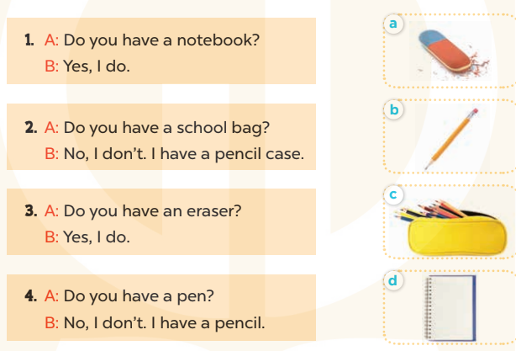  - Have Ss look at the four dialogues and the pictures. Elicit and model with number 1  + Get Ss to read number 1 in chorus. + Ask them what A and B are talking about.  + Write the word notebook on the board.  + Tell Ss to identify the picture of a notebook (Picture d).  + Then match number 1 with Picture d.  -Have Ss work in pairs and match the sentences 2, 3, 4.  - Ask a few Ss to stand up and read the sentences aloud.  -T gives feedbacks.  Key:  1. d 2. c 3. a 4. b  - Activity 3. Let’s play  *Aims: Ss will be able to review vocabulary words for school things and use them in the sentence patterns Do you have ………..? and Yes, I do. / No, I don’t. by playing the matching game or Pelmanism.  *Procedure:  - Explain how to play the game:  + Players take turns to flip over two matching cards.  + A picture matches with the name of the object in the picture.  For example, a picture of a pen matches with the word pen.  + If two cards match, they are left turned face up and the player scores one point.  + If they do not match, they are returned to their face down layout and play passes to the next player.  + Players that successfully match cards get to take another turn and try to match two more cards.  + This continues until that player fails to match a pair.  + The player with the most points is the winner.  - Set a time limit for Ss to play the game in pairs.  - When time runs out, show the cards one by one and invite a few pairs to ask and answer questions using the sentence patterns Do you have ………? And Yes, I do. / No, I don’t.  *Consolidation  *Aims: Ss will be able consolidate and wrap up the content of the lesson.  *Procedure:  - T asks ss to answer the following questions:  + What have you learnt from the lesson today?  +What are the core values of the lesson? (if the teacher can take from the lesson).  - T praises some Ss who are hardworking / active/ good…. as well as encourage others to try more.  - Practice part 5 again.  - Prepare the new lesson: Unit 8, Lesson 3 (1,2,3). | - Ss listen  - Ss play game  -Ss play game  - Ss open their books  -Look at the pictures and say:  + Picture a: a notebook  + Picture b: an esaser  + Picture c: a pencil case  + Picture d: a pencil.  -Ss guess the answers  - Ss listen to the tape and write  - Ss listen again, write and swap books with their partners.  - Ss check their answers and guessing  -Ss listen and repeat.  -Ss look at the picture and say  -Ss look and answer  -Ss read  -Ss answer  -Ss write  -Ss listen and match  -Ss work in pairs and complete  -Ss read aloud  - Ss listen  - Ss play game  -Ss ask and answer the questions  -Ss answer the questions  -Ss listen and clap their hands  -Ss listen and take note
D. ADJUSTMENTS (if necessary):
………………………………………………………………………………………….…..……………………………………………………………………………...………………………………………….…..……………………………………………………………………………….……………………………………………………………………...

