Week 15 Preparing date: December …..,
Period 59 Teaching date: December …..,

Unit 9: Colours
Lesson 2 (4, 5, 6)
A. OBJECTIVES:
By the end of the lesson, Ss will be able to:
1. Knowledge:
- listen to and demonstrate understanding of simple exchanges related to the topic “Colours”
- read and write about colours of school things.
- Vocabulary: Review
- Skills: speaking, listening, reading and writing.
2. Competences:
- Critical Thinking: look, complete and read
- Co-operation: ready to help friends in pair work/ group work.
- Self-control and independent learning: perform listening tasks.
3. Attitude/ Qualities:
- Kindness: Help partners to complete learning tasks.
- Honesty: tell the truth about feelings and emotions.
- Diligence: complete learning tasks.
B. TEACHING AIDS:
- Teacher: Teacher’s guide Pages 116, 117; audio Tracks 92, 93; website sachmem.vn, posters, laptop, pictures, textbook, lesson plan, TV or projector.
- Students: Pupil’s book Page 65, notebooks, workbooks, school things.
C. PROCEDURES:
Stages/Time | Teacher’s activities | Students’ activities
1.Warm- up:  (5’)  2.Practice: (27’)  3. Homework. (3’) | Game: Who says fast?  *Aims: to create a friendly and active atmosphere in the class to beginning the lesson.  *Procedure:  - Hold a school thing card, then reveal it slowly.  - Ask What is it?  - Ask the Ss guess the answer as fast as possible.  - Then have Ss do the same with the rest.  - This can be played in groups to make it more interesting.  - Say “Open your book page 59” and look at “Unit 9, Lesson 2 (4,5,6)”.  Activity 1. Listen and number:  *Aims: Ss will be able to listen to and understand four communicative contexts in which the characters ask and answer questions about the colours of school things and number the correct pictures.  *Procedure:  - Elicit the names and clours of the school thing in each picture.  + What is this?  + What colour is it?  + What are these?  + What colour are they?  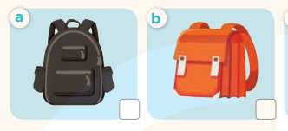  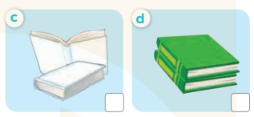  - T ask Ss to guess the answers.  + T writes Ss’guessing on the board.  - Listen to the tape:  + Play the recording  + Play the recording again and get Ss to swap books with their partners.  + Play the recording again to check answers together as a class.  + Write the answers on the board for Ss to correct their answers. Then checks Ss’ guessing.  - Play the recording, sentence by sentence, for the class to listen and repeat in chorus.  Key: 1. b 2. d 3. c 4. a  Activity 2. Look, complete and read  *Aims: Ss will be able to complete the four gapped dialogues with the help of the picture cues  *Procedure:  - Get Ss to look at the pictures and identify the names and colours of the school things.  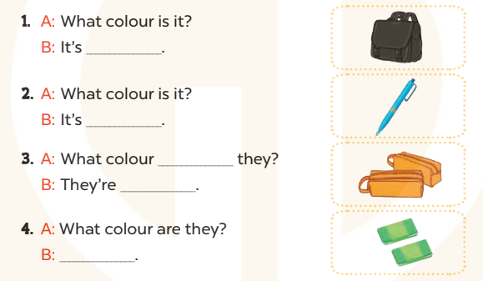  - Have Ss look at the four dialogues and the pictures. Elicit and model with number 1  + Get Ss to read number 1 in chorus. + Ask them what A and B are talking about.  + Write the word notebook on the board.  + Tell Ss to identify the picture of a notebook (black).  + Then write number 1 with black  -Have Ss work in pairs and match the sentences 2, 3, 4.  - Ask a few Ss to stand up and read the sentences aloud.  -T gives feedbacks.  Key:  1. black 2. blue  3. are; orange 4. They’re green.  Activity 3. Let’s sing  *Aims: Ss will be able to sing the song Colours with the correct pronunciation, rhythm, and melody.  *Procedure:  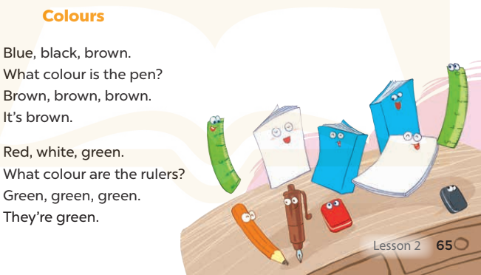  - Introduce the title and lyrics of the song and check comprehension.  + What is the song about?  + What colour is the pen?  + What colour are the rulers?  - Play the recording for Ss to listen to the whole song.  + Have them repeat the title and lyrics line by line.  + Tell Ss to point at the pictures while singing.  - Play the recording all the way through for Ss to listen to pronunciation and melody of the song.  - Play the recording line by line for Ss to listen, repeat and point to the pictures  - Play the recording for Ss to sing and do actions.  - Ask Ss to practice singing and doing actions in pairs or groups.  - Invite groups to the front of the classroom to perform the song  -T gives feedback.  *Consolidation  *Aims: Ss will be able consolidate and wrap up the content of the lesson.  *Procedure:  - T asks ss to answer the following questions:  + What have you learnt from the lesson today?  +What are the core values of the lesson? (if the teacher can take from the lesson).  - T praises some Ss who are hardworking / active/ good…. as well as encourage others to try more.  - Practice part 5 again.  - Prepare the new lesson: Unit 9, Lesson 3 (1,2,3). | - Ss listen  - Ss play game  -Ss play game  - Ss open their books  -Look at the pictures and say:  + Picture a: a black school bag  + Picture b: an orange school bag  + Picture c: two white books  + Picture d: two green books  -Ss guess the answers  - Ss listen to the tape and write  - Ss listen again, write and swap books with their partners.  - Ss check their answers and guessing  -Ss listen and repeat.  -Ss look at the picture and say  -Ss look and answer  -Ss read  -Ss answer  -Ss write  -Ss listen and match  -Ss work in pairs and complete  -Ss read aloud  -Ss listen and answer  -Ss listen to the song  - Ss listen and repeat line by line without the action.  -Ss point to the pictures while singing  -Ss listen to melody of the song  - Ss listen and sing line by line.  - Ss sing and do actions.  + Ss work in groups (two groups) to sing.  -Ss perform in front of the class.  -Ss listen  -Ss answer the questions  -Ss listen and clap their hands  -Ss listen and take note
D. ADJUSTMENTS (if necessary):
………………………………………………………………………………………….…..……………………………………………………………………………...………………………………………….…..……………………………………………………………………………….……………………………………………………………………...

