Week 15 Preparing date: December …..,
Period 57 Teaching date: December …..,

Unit 9: Colours
Lesson 1 (4, 5, 6)
A. OBJECTIVES:
By the end of the lesson, Ss will be able to:
1. Knowledge:
- listen to and demonstrate understanding of simple exchanges related to the topic “Colours”
- read and write about colours of school things.
- Vocabulary: Review
- Skills: speaking, listening, reading and writing.
2. Competences:
- Written Communication: complete the sentences.
- Self-control and independent learning: perform listening tasks.
- Communication and collaboration: work in pairs or groups.
3. Attitude/ Qualities:
- Kindness: Help partners to complete learning tasks.
- Honesty: tell the truth about feelings and emotions.
- Diligence: complete learning tasks.
B. TEACHING AIDS:
- Teacher: Teacher’s guide Pages 113, 114; audio Tracks 89; website sachmem.vn, posters, laptop, pictures, textbook, lesson plan, TV or projector.
- Students: Pupil’s book Page 63, notebooks, workbooks, school things.
C. PROCEDURES:
Stages/Time | Teacher’s activities | Students’ activities
1.Warm- up:  (5’)  2.Practice: (27’)  3. Homework. (3’) | Slap the board  *Aims: to create a friendly and active atmosphere in the class to beginning the lesson.  *Procedure:  - Divide class into 2 groups: Tom and Jerry.  - How to play:  + Each group chooses five Ss to play.  + Class will read aloud.  + Look at the picture, listen and slap the picture you heard.  + Who faster will get 1 mark.  + Which group with higher mark is the winner.  - T gives feedback.  - Say “Open your book page 63” and look at “Unit 9, Lesson 1 (4,5,6)”.  Activity 1. Listen and tick:  *Aims: Ss will be able to listen to and understand two communicative contexts in which pupils ask and answer questions about colours of school things and tick the correct pictures.  *Procedure:  - Elicit the name of the school thing in each picture.  - Check comprehension the difference between the two pictures.  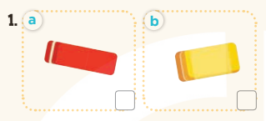  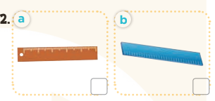  - T ask Ss to guess the answers.  + T writes Ss’guessing on the board.  - Listen to the tape:  + Play the recording  + Play the recording again and get Ss to swap books with their partners.  + Play the recording again to check answers together as a class.  + Write the answers on the board for Ss to correct their answers. Then checks Ss’ guessing.  - Play the recording, sentence by sentence, for the class to listen and repeat in chorus.  Key: 1. b 2. a  Activity 2. Look, complete and read  *Aims: Ss will be able to complete the four gapped dialogues with the help of the picture cues  *Procedure:  - Have Ss look at the picture cues and identify the school things and their colours 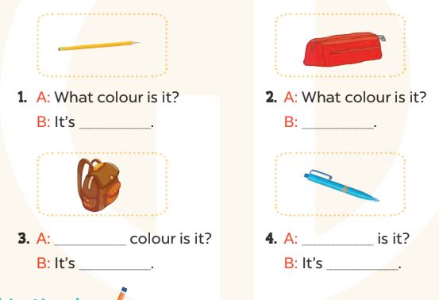  - Have Ss look at the four incomplete sentences. Elicit and model with picture 1  + Ask Ss to read the sentence 1 in chorus.  + Ask Ss what word is missing in the gap (yellow). Then have them complete the sentence (It’s yellow).  -Have Ss work in pairs and complete the sentences 2, 3, 4.  - Ask a few Ss to stand up and read the sentences aloud.  -T gives feedbacks.  Key:  1. yellow 2. It’s red.  3. What; brown  4. What colour; blue  Activity 3. Let’s play  *Aims: Ss will be able to revise the target vocabulary items through the puzzle, then ask and answer questions about the colours of school things.  *Procedure:  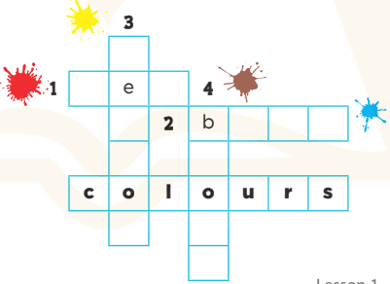  - Tell Ss the goal of the game and how to play it.  - Then have them look at the word colours and the colour clues to find appropriate letters to complete the words.  - Give Ss a time limit to do the puzzle individually.  - Have Ss work in pairs. One points and asks What colour is it? It’s ….  -T gives feedback.  Key: 1. red 2. blue  3. yellow 4. brown  *Consolidation  *Aims: Ss will be able consolidate and wrap up the content of the lesson.  *Procedure:  - T asks ss to answer the following questions:  + What have you learnt from the lesson today?  +What are the core values of the lesson? (if the teacher can take from the lesson).  - T praises some Ss who are hardworking / active/ good…. as well as encourage others to try more.  - Practice part 5 again.  - Prepare the new lesson: Unit 9, Lesson 2 (1,2,3). | - Ss listen  -Ss listen  - Ss play game  -Ss congratuate the winner  - Ss open their books  -Look at the pictures and say:  + Picture 1a: a red eraser  + Picture1 b: an yellow eraser  + Picture 2a: a brown ruler  + Picture 2b: a blue ruler  -Ss guess the answers  - Ss listen to the tape and tick  - Ss listen again, tick and swap books with their partners.  - Ss check their answers and guessing  -Ss listen and repeat.  -Ss look at the picture and say  + a yellow pencil, a red pencil case, a brown school bag and a blue pen.  -Ss look and answer  -Ss read  -Ss say and write  -Ss work in pairs and complete  -Ss read aloud  -Ss listen  - Ss look and find the letter to complete  - Ss do the puzzle  - Ss work in pairs to ask and answer  -Ss listen  -Ss answer the questions  -Ss listen and clap their hands  -Ss listen and take note
D. ADJUSTMENTS (if necessary):
………………………………………………………………………………………….…..……………………………………………………………………………...………………………………………….…..……………………………………………………………………………….……………………………………………………………………...

