Week 34 Preparing date: …… ………
Period 133 Teaching date: …….. ………

Unit 20: Our summer holidays
Lesson 2 (4, 5, 6)
A. OBJECTIVES:
By the end of the lesson, Ss will be able to:
1. Knowledge:
- listen to and understand two communicative contexts in which characters talk about places someone plans to visit and activities to do in the summer, and circle the correct pictures
- complete two gapped exchanges with the help of picture cues.
- revise the target vocabulary items and structures related to the topic “Our summer holidays” by playing the game Who has more correct answers?
- Vocabulary: Review
- Skills: speaking, listening, reading and writing.
2. Competences:
- Communication and collaboration: work in pairs and groups to complete the learning tasks.
3. Attitude/ Qualities:
- They can remember or imagine places they might visit and all the things they might do during summer break, like playing games, going on trips, or spending time with family.
B. TEACHING AIDS:
- Teacher: Teacher’s guide Pages 323, 324, 325; audio Tracks 98; website hoclieu.vn, posters, laptop, pictures, textbook, lesson plan, TV or projector.
- Students: Student’s book Page 67, notebooks, workbooks, school things.
C. PROCEDURES:
Teacher’s activities | Students’ activities
1.Warm- up and review: (4’)  Play a game: Board race  *Aims: to revise the learnt structure *Procedure:  - Divide the class into two teams.  - Arrange the flash cards on the board.  - Invite a student from each team to go to the board.  - Teacher says a word and the ss run to tap the right card as quickly as possible.  - If they tap the right card, they will get 1 point for their team.  - The team with more points wins.  - Say “Open your book page 67” and look at “Unit 20, Lesson 2 (4,5,6)”.  2. Practice: (27’)  Activity 1. Listen and circle:  *Aims: Ss will be able to listen to and understand two communicative contexts in which characters talk about places someone plans to visit and activities to do in the summer, and circle the correct pictures  *Procedure:  - Have ss look at the pictures and ask  + What place can you see in each picture?  + What means of transport can you see in each picture?  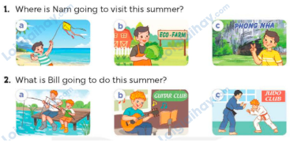  - T ask Ss to guess the answers.  + T writes Ss’guessing on the board.  - Listen to the tape:  + Play the recording  + Play the recording again and get Ss to swap books with their partners.  + Play the recording again to check answers together as a class.  + Write the answers on the board for Ss to correct their answers. Then checks Ss’ guessing.  - Play the recording, sentence by sentence, for the class to listen and repeat in chorus.  Key: 1. b 2. c  Activity 2. Read and complete  *Aims: Ss will be able to complete two gapped exchanges with the help of picture cues.  *Procedure:  - Ask Ss to look at the pictures and identify the places to visit and activities to do in the summer.  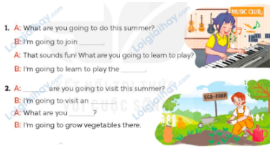  - Have Ss look at the 2 incomplete exchanges and elicits the missing words in the sentences.  - T models with the first sentence  + Ask Ss what is missing in the sentence (a music club).  + Have Ss look at the picture and identify the needed information (I’m going to join a music club)  - Have Ss work in pairs and complete  - Get Ss to swap books with a partner and check their answers before checking as a class.  Key: 1. a music club; piano  2. Where; eco-farm; going to do  Activity 3. Let’s play.  *Aims: Ss will be able to revise the target vocabulary items and structures related to the topic “Our summer holidays” by playing the game Who has more correct answers?  *Procedure:  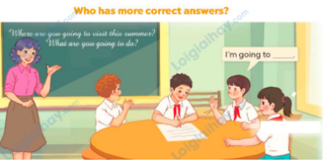  - Tell ss that they are going to play the game Who has more correct answers.  - Ss play the game in groups of five. Each group makes a list of answers to the questions What are you going to do this summer? What are you going to do this summer? within three minutes.  - When time is up, invite each group to read about their answers. Count the correct answers of each group.  - Reward the group with the most correct answers.  3. Fun corner and wrap- up (4’)  Game: Pass the balls  - Give two different colored balls to two pupils, a red ball (ask the question about a place to visit or means of transport to get there) and a yellow ball (answer the question).  - Ask ss to listen to music and pass the balls.  - Stop music suddenly.  - Have the student with a red ball ask a question. Have the student with a yellow ball answer the question.  - Praise ss if they do the activity well. | - Ss pay attention.  -Ss play the game  - Ss congratulate to the winner  - Ss open their books  - Ss look at the pictures and answers.  -Ss guess the answers  - Ss listen to the tape  - Ss listen again, tick or cross and swap books with their partners.  - Ss check their answers and guessing  - Ss answer and check  -Ss listen and repeat.  -Ss look at the picture and say  -Ss follow the teacher.  -Ss read and answer  -Ss work in pairs and fill in the gaps  - Ss swap books and check  - Ss listen to the teacher’s explanation.  - Ss play the game  - Ss continue to play the game  -Ss listen to the teacher  -Ss play the game  A: What are you going to do this summer?  B: I’m going to join a swimming club.  -Ss praise the winner.

D. ADJUSTMENTS (if necessary):
………………………………………………………………………………………….…..……………………………………………………………………………...……

