Week 32 Preparing date: …… ………
Period 125 Teaching date: …….. ………

Unit 19: Places of interest
Lesson 1 (4, 5, 6)
A. OBJECTIVES:
By the end of the lesson, Ss will be able to:
1. Knowledge:
- listen to and understand four communicative contexts in which speakers ask and answer questions about their opinion of a place, and then circle the correct words.
- complete four gapped exchanges with the help of picture cues.
- sing the song What do you think of …? with correct pronunciation, rhythm and melody.
- Vocabulary: Review
- Skills: speaking, listening, reading and writing.
2. Competences:
- Communication and collaboration: work in pairs and groups to complete the learning tasks.
3. Attitude/ Qualities:
- Gain appreciation for the diversity of human experiences and the value of preserving historical and cultural landmarks.
B. TEACHING AIDS:
- Teacher: Teacher’s guide Pages 303, 304, 305; audio Tracks 84, 85; website hoclieu.vn, posters, laptop, pictures, textbook, lesson plan, TV or projector.
- Students: Student’s book Page 59, notebooks, workbooks, school things.
C. PROCEDURES:
Teacher’s activities | Students’ activities
1.Warm- up and review: (4’)  Play a game: Lucky Doraemon  *Aims: to revise the learnt lesson.  *Procedure:  - Divide the class into 2 teams (team boys and team girls)  - Each team takes turns to choose a number that Doraemon is holding, then look at the pictures, and answer the questions.  - Check the ss’ answers as a whole class.  - If they give the correct answers, they can get the points.  - The teams with the most points is the winner.  - Say “Open your book page 59” and look at “Unit 19, Lesson 1 (4,5,6)”.  2. Practice: (27’)  Activity 1. Listen and circle:  *Aims: Ss will be able to listen to and understand four communicative contexts in which speakers ask and answer questions about their opinion of a place, and then circle the correct words.  *Procedure:  - Have ss look at the pictures and identify the names of the places  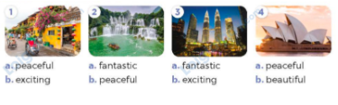  - T ask Ss to guess the answers.  + T writes Ss’guessing on the board.  - Listen to the tape:  + Play the recording  + Play the recording again and get Ss to swap books with their partners.  + Play the recording again to check answers together as a class.  + Write the answers on the board for Ss to correct their answers. Then checks Ss’ guessing.  - Play the recording, sentence by sentence, for the class to listen and repeat in chorus.  Key: 1.b 2.b 3.a 4.a  Activity 2. Read and complete  *Aims: Ss will be able to complete four gapped exchanges with the help of picture cues.  *Procedure:  - Have ss look at the pictures and identify the places of interest. 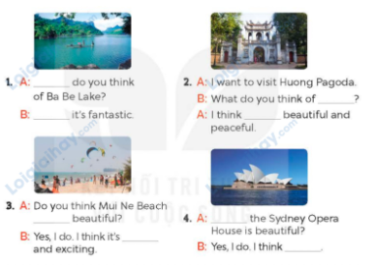  - Have Ss look at the 4 incomplete exchanges and elicits the missing words in the sentences.  - T models with the first sentence  + Ask Ss what is missing in the sentence (What).  + Have Ss look at the picture and identify the needed information (What do you think of Ba Be Lake?)  - Have Ss work in pairs and complete  - Get Ss to swap books with a partner and check their answers before checking as a class.  Key: 1. What , I think 2. it Huong Pagoda  3.is, beautiful 4. Do you think, it’s beautiful  Activity 3. Let’s sing.  *Aims: Ss will be able to sing the song What do you think of …? with correct pronunciation, rhythm and melody.  *Procedure:  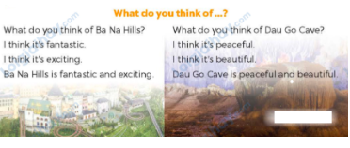  - Draw ss’ attention to the title and lyrics of the song and the words fantastic, exciting, peaceful and beautiful.  - Play the recording all the way through  - Play it again line by line, for ss to listen and repeat.  - Put ss into two groups. One group sings the questions and the other sings the answers.  - Invite a few groups to the front of the class to sing the song.  - Have pupils brainstorm some other places to replace Ba Na Hills and Dau Go Cave (ex: What do you think of Nha Trang Beach? Nha Trang Beach is fantastic and exciting. What do you think of Ha Long Bay? Ha Long Bay is peaceful and beautiful.) Then let ss sing the song with the new lyrics.  3. Fun corner and wrap- up (4’)  Game: Roll the dice  - Divide the class into groups of six. Have each student count the numbers from one to six.  - Ask a student from each group to roll the dice to choose a student asking the question.  - Ask that student to ask the question and invite another student of the group to answer the question about the location of some school rooms in their school.  - The student who gives the correct answers will continue rolling the dice. | - Ss pay attention.  -Ss play the game  -Ss play the game  - Ss open their books  - Ss read the questions and say  -Ss guess the answers  - Ss listen to the tape  - Ss listen again, circle and swap books with their partners.  - Ss check their answers and guessing  - Ss answer and check  -Ss listen and repeat.  -Ss look at the picture and say  -Ss follow the teacher.  -Ss read and answer  -Ss work in pairs and fill in the gaps  - Ss swap books and check  - Ss pay attention to the title and lyrics of the song.  - Ss listen to the song  - Ss listen and repeat, line by line  -Ss sign and do actions  - Ss listen all the way through and sing along.  - Ss work in groups and come to the front of the class to perform  -Ss listen to the teacher’s instruction  -Ss play the game  A: What do you think of Huong Pagoda?  B: I think it’s beautiful and peaceful.  -Ss play the game.
D. ADJUSTMENTS (if necessary):
………………………………………………………………………………………….…..……………………………………………………………………………...……

