Week 29 Preparing date: …… ………
Period 113 Teaching date: …….. ………

Unit 17: Stories for children
Lesson 1 (4, 5, 6)
A. OBJECTIVES:
By the end of the lesson, Ss will be able to:
1. Knowledge:
- listen to and understand three statements about the main characters in stories and circle the correct answers.
- complete four gapped exchanges with the help of picture cues.
- review the target vocabulary and structures related to the topic “Stories for children” by playing the game Who am I?
- Vocabulary: Review
- Skills: speaking, listening, reading and writing.
2. Competences:
- Communication and collaboration: work in pairs and groups to complete the learning tasks.
3. Attitude/ Qualities:
- Show their pride in school things they have and great respect for other people’s school things by using appropriate gestures and intonation when asking and answering about school things.
B. TEACHING AIDS:
- Teacher: Teacher’s guide Pages 275, 276; audio Tracks 64; website hoclieu.vn, posters, laptop, pictures, textbook, lesson plan, TV or projector.
- Students: Student’s book Page 47, notebooks, workbooks, school things.
C. PROCEDURES:
Teacher’s activities | Students’ activities
1.Warm- up and review: (4’)  Play a game: Pass the card  *Aims: to revise the learnt lesson.  *Procedure:  - Prepare some cards (Snow White, the seven dwarfs, the ant, the grasshopper, the tortoise, the hare, the fox, the crow).  - Divide the class into two groups.  - Have ss from each group stand in a line.  - Give the first student of each group a card and say “Go.”  - The ss say the given words and pass the cards over their heads to the ones behind them.  - Have groups continue the game until their card reaches the last person.  - The last student in each line races to hand their card to the teacher and says the word.  - Give the first group to name their card correctly one point.  - The group that gets more points wins.  - Say “Open your book page 47” and look at “Unit 17, Lesson 1 (4,5,6)”.  2. Practice: (27’)  Activity 1. Listen and circle:  *Aims: Ss will be able to listen to and understand three statements about the main characters in stories and circle the correct answers to complete the sentences *Procedure:  - Have ss read the questions and elicit the characters in the pictures  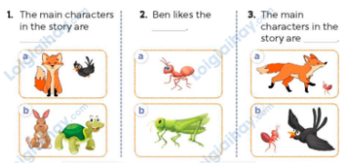  - T ask Ss to guess the answers.  + T writes Ss’guessing on the board.  - Listen to the tape:  + Play the recording  + Play the recording again and get Ss to swap books with their partners.  + Play the recording again to check answers together as a class.  + Write the answers on the board for Ss to correct their answers. Then checks Ss’ guessing.  - Play the recording, sentence by sentence, for the class to listen and repeat in chorus.  Key: 1. b; 2. a; 3. a  Activity 2. Read and complete  *Aims: Ss will be able to complete four gapped exchanges with the help of picture cues.  *Procedure:  - Ask Ss to look at the pictures and identify the name of a character. 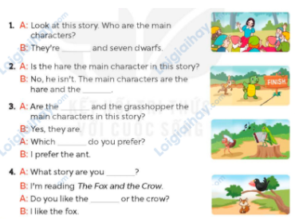  - Have Ss look at the 4 incomplete exchanges and elicits the missing words in the sentences.  - T models with the first sentence  + Ask Ss what is missing in the sentence (Snow White).  + Have Ss look at the picture and identify the needed information (They’re Snow White and the seven dwarfs)  - Have Ss work in pairs and complete  - Get Ss to swap books with a partner and check their answers before checking as a class.  Key: 1. Snow White 2. tortoise  3. ant, character / one 4. reading, fox  Activity 3. Let’s play.  *Aims: Ss will be able to review the target vocabulary and structure related to the topic “Stories for children” by playing the game Who am I?  *Procedure:  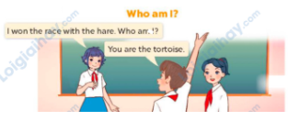  - Divide the class into 8 or 10 groups. Each group pretends to be one character and prepares one or two sentences about the character.  - Each group reads the sentence aloud and the other groups guess what character it is. The groups raise their hands to get a turn to answer. The group with the correct answer gets one point.  - After 4 minutes, the group with the most points is the winner.  - Get ss to play the game in pairs.  3. Fun corner and wrap- up (4’)  Game: Pictionary  - Invite a student to come to the front of the class and whisper the name of a character he/she has to draw.  Ex: Snow White, the seven dwarfs, the ant, the grasshopper, the tortoise, the hare, the fox, the crow  - The student draws the picture on the board for the rest of the class to guess what it is.  - The first student to guess the character correctly comes to the front of the class to draw the next picture.  - Repeat until all of the target vocabulary has been used. | - Ss pay attention.  -Ss play the game  -Ss play the game  - Ss congratulate to the winner  - Ss open their books  - Ss read the questions and answers (the fox, the crow, the hare, the tortoise, the ant, and the grasshopper)  -Ss guess the answers  - Ss listen to the tape  - Ss listen again, circle and swap books with their partners.  - Ss check their answers and guessing  - Ss answer and check  -Ss listen and repeat.  -Ss look at the picture and say  -Ss follow the teacher.  -Ss read and answer  -Ss work in pairs and fill in the gaps  - Ss swap books and check  - Ss work in 8 or 10 groups  - Ss follow the teacher’s instructions.  - Ss play the game in pairs.  -Ss listen to the teacher  -Ss play the game  -Ss play the game  -Ss play the game

D. ADJUSTMENTS (if necessary):
………………………………………………………………………………………….…..……………………………………………………………………………...……

