Week 31 Preparing date: …… ………
Period 121 Teaching date: …….. ………

Unit 18: Means of transport
Lesson 2 (4, 5, 6)
A. OBJECTIVES:
By the end of the lesson, Ss will be able to:
1. Knowledge:
- listen to and understand two communicative contexts in which characters talk about places to visit and means of transport to get there, and tick or cross the pictures according to what they hear.
- complete the gapped exchanges with the help of picture cues.
- review the target vocabulary for places to visit and means of transport by playing the game Tic-Tac-Toe.
- Vocabulary: Review
- Skills: speaking, listening, reading and writing.
2. Competences:
- Communication and collaboration: work in pairs and groups to complete the learning tasks.
3. Attitude/ Qualities:
- Show their pride in famous places of Viet Nam by using appropriate gestures and intonation when asking and answering questions about places someone wants to visit B. TEACHING AIDS:
- Teacher: Teacher’s guide Pages 294, 295, 296; audio Tracks 78; website hoclieu.vn, posters, laptop, pictures, textbook, lesson plan, TV or projector.
- Students: Student’s book Page 55, notebooks, workbooks, school things.
C. PROCEDURES:
Teacher’s activities | Students’ activities
1.Warm- up and review: (4’)  Play a game: Board race  *Aims: to revise the learnt structure *Procedure:  - Divide the class into two teams.  - Arrange the flash cards on the board.  - Invite a student from each team to go to the board.  - Teacher says a word and the ss run to tap the right card as quickly as possible.  - If they tap the right card, they will get 1 point for their team.  - The team with more points wins.  - Say “Open your book page 55” and look at “Unit 18, Lesson 2 (4,5,6)”.  2. Practice: (27’)  Activity 1. Listen and tick or cross:  *Aims: Ss will be able to listen to and understand two communicative contexts in which characters ask and answer questions about the places to visit and means of transport to get there, and tick or cross the pictures according to what they hear  *Procedure:  - Have ss look at the pictures and ask  + What place can you see in each picture?  + What means of transport can you see in each picture?  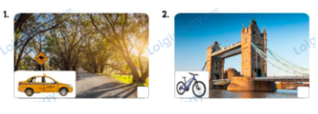  - T ask Ss to guess the answers.  + T writes Ss’guessing on the board.  - Listen to the tape:  + Play the recording  + Play the recording again and get Ss to swap books with their partners.  + Play the recording again to check answers together as a class.  + Write the answers on the board for Ss to correct their answers. Then checks Ss’ guessing.  - Play the recording, sentence by sentence, for the class to listen and repeat in chorus.  Key: 1. v 2. x  Activity 2. Read and complete  *Aims: Ss will be able to complete the gapped exchanges with the help of picture cues.  *Procedure:  - Ask Ss to look at the pictures and identify the places to visit and means of transport to get there.  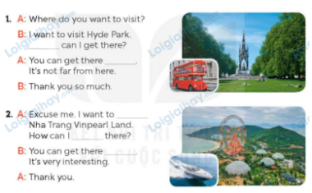  - Have Ss look at the 2 incomplete exchanges and elicits the missing words in the sentences.  - T models with the first sentence  + Ask Ss what is missing in the sentence (how).  + Have Ss look at the picture and identify the needed information (How can I get there?)  - Have Ss work in pairs and complete  - Get Ss to swap books with a partner and check their answers before checking as a class.  Key: 1. How; by bus  2. go to / visit; get; by boat  Activity 3. Let’s play.  *Aims: Ss will be able to review target vocabulary for places to visit and means of transport by playing the game Tic-Tac-Toe. *Procedure:  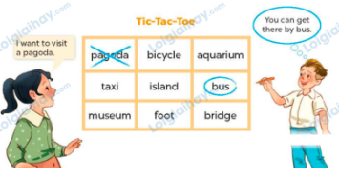  - Tell ss that they are going to play the game Tic-Tac-Toe. Two ss play at a time. One student is X, and the other is O. The ss choose a square by saying a word and a sentence with that word, and put their mark in the corresponding square. The first student to write three marks in a vertical, horizontal or diagonal line is the winner.  - Invite two ss to play at a time.  - Change the words in the grid and let ss play the game several times if there is enough time.  3. Fun corner and wrap- up (4’)  Game: Pass the balls  - Give two different colored balls to two pupils, a red ball (ask the question about a place to visit or means of transport to get there) and a yellow ball (answer the question).  - Ask ss to listen to music and pass the balls.  - Stop music suddenly.  - Have the student with a red ball ask a question. Have the student with a yellow ball answer the question.  - Praise ss if they do the activity well. | - Ss pay attention.  -Ss play the game  - Ss congratulate to the winner  - Ss open their books  - Ss look at the pictures and answers.  -Ss guess the answers  - Ss listen to the tape  - Ss listen again, tick or cross and swap books with their partners.  - Ss check their answers and guessing  - Ss answer and check  -Ss listen and repeat.  -Ss look at the picture and say  -Ss follow the teacher.  -Ss read and answer  -Ss work in pairs and fill in the gaps  - Ss swap books and check  - Ss listen to the teacher’s explanation.  - Two ss play at a time.  - Ss continue to play the game  -Ss listen to the teacher  -Ss play the game  A: How can I get to the pagoda?  B: You can get there on foot.  -Ss praise the winner.

D. ADJUSTMENTS (if necessary):
………………………………………………………………………………………….…..……………………………………………………………………………...……

