Week 19 Preparing date: ……..……..
Period 75 Teaching date: ……………..

Unit 11: Family time
Lesson 2 (1, 2, 3)
A. OBJECTIVES:
By the end of the lesson, Ss will be able to:
1. Knowledge:
- understand and correctly repeat the sentences in two communicative contexts focusing on asking and answering questions about what someone did somewhere in the past.
- correctly say the words and use What did your family do in ____? - We ___. to ask and answer questions about what someone did somewhere in the past.
- correctly use What did your family do in _____? - ___. and What did your family do there? – ……. in a freer context.
- Vocabulary: take a boat trip around the bay, eat seafood, see some interesting places and buy souvenirs.
- Structures: A: What did your family do in Ha Long?
B: We took a boat trip around the bay.
- Skills: speaking and listening
2. Competences:
- Critical thinking and creativity: learn how to ask and answer questions about what someone did somewhere in the past correctly and fluently.
- Communication and collaboration: work in pairs and groups to complete the learning tasks.
3. Attitude/ Qualities:
- Show their love and interest in outdoor activities.
- Raise their awareness of doing outdoor activities carefully.
B. TEACHING AIDS:
- Teacher: Teacher’s guide Pages 183, 184, 185, 196; audio Tracks 5, 6, website hoclieu.vn, posters, laptop, pictures, textbook, lesson plan, TV or projector.
- Students: Students’ book Page 8, notebooks, workbooks, school things.
C. PROCEDURES:
Teacher’s activities | Students’ activities
1.Warm- up and review: (4’)  Game: Lucky star game  *Aims: to revise the sentence structures about someone who did something in the past.  *Procedure:  - Divide the class into 2 groups: boys and girls.  - Tell ss they are going to look at the pictures and ask and answer the questions about the pictures.  - Have two ss from each group take turns to choose a star and do the task.  - If they ask and answer the question correctly, they will get one point. If they don’t ask and answer the question correctly, the other group will ask and answer.  - If the group chooses a lucky star, they will get one point and continue the next turn.  - Get corresponding points for their group.  - Continue with the other ss.  - The group that gets the most points will win. Praise the winner.  - Say “Open your book page 8” and look at “Unit 11, Lesson 2 (1,2,3)”.  2. Presentation (16’)  Activity 1. Vocabulary.  *Aims: Ss will be able to know the vocabulary in the new lesson.  *Procedure:  -T elicits the new words  + take a boat trip around the bay : đi du lịch bằng tàu thuỷ vòng quanh vịnh  (picture)  + eat seafood : ăn hải sản (picture)  + see some interesting places: thăm 1 vài nơi thú vị (picture)  + buy souvenirs.: mua quà lưu niệm  (example)  - T models (3 times).  - T writes the words on the board.  - Checking: Rub out and remember  Activity 2. Look, listen and repeat:  *Aims: Ss will be able to understand and correctly repeat the sentences in two communicative contexts focusing on asking and answering questions about what someone did somewhere in the past.  *Procedure:  - Have Ss look at Pictures a and b and identify the place, characters and their activities in the pictures.  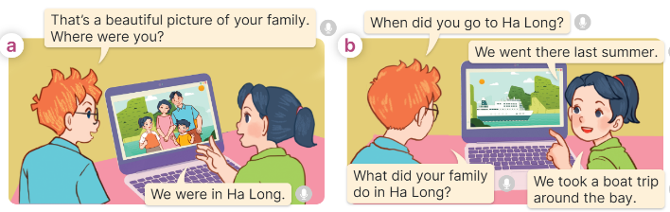  - Play the recording for them to listen.  - Play the recording again (sentence by sentence) for Ss to listen and repeat Correct their pronunciation where necessary.  - Invite a few pairs to the front of the classroom to listen to and repeat the sentences.  - T checks pronunciation for ss.  Activity 3. Listen, point and say.  *Aims: Ss will be able to correctly say the words and use What did your family do in ….? - We …... to ask and answer questions about what someone did somewhere in the past.  *Procedure:  * Structures:  - T asks Ss look at picture b and helps Ss know the structure from the dialogue.  - T introduces new structure for Ss.  - T explains, models and gives meaning.  - Have Ss repeat the structures.  A: What did your family do in Ha Long?  B: We took a boat trip around the bay.  3.Practice: (6’)  *Drill pictures  - Have Ss look at the pictures and elicit the activities of the characters in each picture.  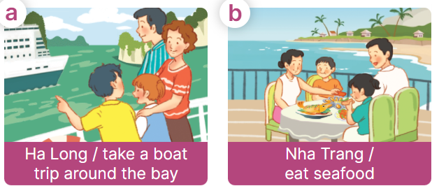    - Explain that the answer is used to express the activity someone did in the past and that took is the past tense of the verb take  + take – took + eat – ate  + see – saw + buy - bought  - Have Ss point at pictures, listen and run through all the pictures.  - Have Ss point at the bubbles, listen and run through model sentences.  - Have Ss to practise:  + T asks the first picture, Ss answer  + Ss asks the second picture, T answers  + Group A asks the third picture, group B  answers  + Group B asks the last picture, group A  - Ask Ss to work in pairs to practise asking and answering the question What did your family do in ….? - We …...  - T controls and corrects.  - Invite a few pairs to point at the pictures and say the questions and answers in front of the class.  - T gives feedbacks.  4.Production: (5’)  Activity 4. Let’s talk.  *Aims: Ss will be able to correctly use What did your family do in _____? - ___. and What did your family do  there? – ___. in a freer context.  *Procedure:  - Ask questions to help them identify the context.  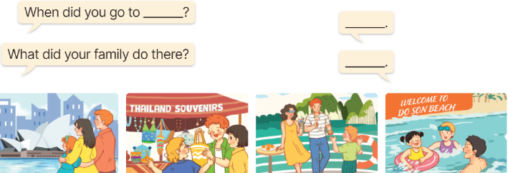  - Elicit the answer in the speech bubble and write it on the board. Get Ss to say the completed sentences.  - Have Ss role-play to practise asking the questions and giving their answers in pairs, using the picture cue What did your family do in _____? - ___. and What did your family do there? – ___.  - Invite a few pairs to point at the pictures and ask and answer questions.  - Invite some pairs of ss to ask and answer questions about the real activities: when and what someone’s family did in the past.  5. Fun corner and wrap- up (4’)  Game: Matching the word with the correct picture  - Tell ss how the game is played. Give an example.  - Put the pictures on the board. Point to each picture one at a time for ss to say the time.  - Give cards with phrases to different pupils. Ask them to come to the front of the class and put their card below the appropriate picture, ex: the pupil with the card “buy souvenirs” puts his / her card below the picture “a picture of someone buying souvenirs”.  - Praise ss if they do the activity well. | - Ss listen to teacher’s instruction  - Ss play the game  Ex:  A: Did you take a photo yesterday?  B: Yes, I did. I took a photo with my sister.  - Ss open their books  -Ss listen and answer  - - Ss listen and repeat  + Choral repetition (3 times).  + Individual repetition (3 ss)  - Ss take note  - Ss look, remember and write  -Look at the pictures and get to know the characters in the pictures.  + In picture a:  Ben: That’s a beautiful picture of your family. Where were you?  Mai: We were in Ha Long.  – In picture b:  Ben: When did you go to Ha Long?  Mai: We went there last summer.  Ben: What did your family do in Ha Long?  Mai: We took a boat trip round the bay.  -Ss listen  -Ss listen and repeat in chorus  - Pairs of Ss listen and repeat  -Ss listen  -Ss look at the picture and answer.  -Ss listen  -Ss listen and repeat  -Ss repeat to the structures.  - Ss look, listen and answer  a. family taking a boat trip around Ha Long  b. a family eating seafood in Nha Trang  c. a family visiting Sydney  d. a family buying souvenirs in Singapore  -Ss listen to the teacher’s instruction  -Ss point at pictures, listen and repeat  -Ss point at the bubbles, listen and repeat  -Ss practice in chorus  -Ss practice in chorus  -Ss work in pairs to practise asking and answering the question  - Pairs of Ss point at the pictures and say in front of the class  -Ss look at the picture and answer  + a family visiting some interesting places in Sydney; a family buying souvenirs at the souvenir shop in Thailand; a family taking a boat trip at Ha Long Bay; a family swimming in the sea in Do Son  - Ss say the completed sentences.  -Ss work in pairs to ask and answer  + We went there last summer.  + We visited some interesting places.  -Ss perform in front of the class.  - Ss ask and answer about their family.  -Ss listen to the teacher  - Ss play the game  - Continue playing the game.
D. ADJUSTMENTS (if necessary):
………………………………………………………………………………………….…..……………………………………………………………………………...……

