Week 20 Preparing date: ………….…..
Period 77 Teaching date: ……………….

Unit 11: Family time
Lesson 3 (1, 2, 3)
A. OBJECTIVES:
By the end of the lesson, Ss will be able to:
1. Knowledge:
- stress the correct words in Wh-questions in the questions 'When did they 'go to 'London? and 'What did they 'do in 'Finland?
- identify and underline the missing stressed word in four questions, and to say the questions with the correct stress while listening
- say the chant with the correct pronunciation, word stress and rhythm.
- Vocabulary: Review
- Skills: speaking, listening, reading and writing.
2. Competences:
- Communication and collaboration: work in pairs and groups to complete the learning tasks.
- Self-control and independent learning: perform pronunciation and listening tasks.
3. Attitude/ Qualities:
- Show their love and interest in outdoor activities.
- Raise their awareness of doing outdoor activities carefully.
B. TEACHING AIDS:
- Teacher: Teacher’s guide Pages 188, 189, 190; audio Tracks 8, 9, 10; website hoclieu.vn, posters, laptop, pictures, textbook, lesson plan, TV or projector.
- Students: Students’ book Page 10, notebooks, workbooks, school things.
C. PROCEDURES:
Teacher’s activities | Students’ activities
1.Warm- up and review: (5’)  Game: Pass the balls  *Aims: to revise the learnt words and structures.  *Procedure:  - Give two different coloured balls to two ss, a red ball (ask the question) and a yellow ball (answer the question).  - Ask ss to listen to music and pass the balls.  - Stop music suddenly.  - The teacher raises a picture. Have the student with a red ball make a question. Have the student with a yellow ball answer the question.  - Praise ss if they do the activity well.  - Say “Open your book page 10” and look at “Unit 11, Lesson 3 (1,2,3)”.  2. Presentation (9’)  Activity 1. Listen and repeat:  *Aims: Ss will be able to stress the correct words in Wh-questions in the questions 'When did they 'go to 'London? and 'What did they 'do in 'Finland? *Procedure:  - T gives instruction the sentences 'When did they 'go to 'London? and 'What did they 'do in 'Finland?  - Play the recording and encourage Ss to point to the word and sentence while listening  - Play the recording again and encourage Ss to listen and repeat.  - Have Ss work in pairs or groups to do this several times until Ss feel confident.  - T invites some Ss to practice.  3.Practice: (17’)  Activity 2. Listen and underline one more stressed word. Then repeat  *Aims: Ss will be able to identify and underline the missing stressed word in four questions, and to say the questions with the correct stress while listening.  *Procedure:  - Tell ss the goal of the activity and explain that they have to listen to the recording and underline one more stressed word.  - Play the recording all the way through for ss to listen to the questions.  - Play the recording again for ss to underline one more stressed word of the questions.  - Tell ss to swap books with a partner, then check the answers together as a class.  - Have ss discuss with ss if they can spot a pattern to what words are stressed in Wh-questions (the wh-question word, the main verb and the place).  - Play the recording again for ss to double-check their answers.  - Invite one or two ss to stand up and repeat the correct answers.  Key: 1. Sydney 2. Paris  3. When 4. do  Activity 3. Let’s chant  *Aims: Ss will be able to say the chant with the correct pronunciation, word stress and rhythm  *Procedure:  - Introduce the title and lyrics of the chant.  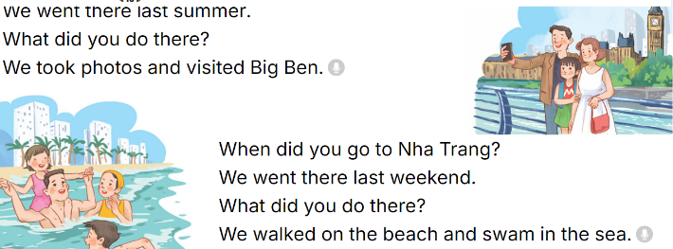  - Play the recording for Ss to listen to the whole chant.  + Have them repeat the title and lyrics line by line.  + Ask Ss to atten the word stress in the Wh-questions  - Play the recording all the way through for Ss to listen to pronunciation and melody.  - Play the recording line by line for Ss to listen and repeat  - Play the recording for Ss to chant and clap along.  - Ask Ss to practice chant and clap along in pairs or groups.  - Invite groups to the front of the classroom to perform the chant  3. Fun corner and wrap- up (4’)  Game: Whisper  - Tell ss how the game is played. Give an example.  - Divide the class into two groups.  - Have ss from each group stand or sit in a row.  - Whisper a sentence to the first student in each row.  - Have the first student whisper the sentence to the second student  - Have groups continue whispering the sentence until it reaches the last student.  - The last student in the row has to say out the correct sentence.  - Give the first group saying the sentence correctly one point.  - The group with more points wins. Praise the winner. | - Ss listen  -Ss listen the rules  - Ss play the game  Ex:  A: What did your family do in Sydney?  B: We saw some interesting places.  - Ss open their books  - - Ss pay attention  - Ss listen and point  - Ss listen again and repeat  -Ss work in pairs and practice  -Ss say the language in front of the class  - Ss listen to the teacher’s explanation.  - Ss listen to the questions  - Ss listen again and underline one more stressed word of the questions.  - Ss swap books and check the answers as a class.  -Ss listen to the teacher’s instruction.  - Ss listen to the recording again to double-check their answers.  - Ss stand up and repeat the correct answers.  - Ss listen to the chant  - Ss listen and repeat line by line without clap their hands  - Ss note the rhythm and pronunciation.  -Ss listen to melody of the chant  - Ss listen and chant line by line.  - Ss chant and clap along.  - Ss work in groups (two groups) to chant  -Ss perform in front of the class.  -Ss listen  -Ss play the game  Ex:  Round 1. 'When did you 'go to 'Sydney?/ 'What did he 'do in 'Paris?  Round 2. 'When did she 'go to 'England?/ 'What did they 'do in 'Thailand?  -Ss praise the winner
D. ADJUSTMENTS (if necessary):
………………………………………………………………………………………….…..……………………………………………………………………………...………………………………………….…..………………………………………………

