Week 34 Preparing date: …………………..
Period 136 Teaching date: ……………………..

Review 4 Parts 1, 2
A. OBJECTIVES:
By the end of the lesson, Ss will be able to:
1. Knowledge:
- listen to and understand five communicative contexts 2 in which characters talk about familiar topics such as seasons and weather, stories for children, means of transports, places of interest, summer holidays, and tick the correct pictures.
- ask and answer questions using picture cues or personal information.
- Vocabulary: Review
- Skills: speaking, listening, reading and writing.
2. Competences:
- Communication and collaboration: work in pairs and teams to complete the learning tasks.
- Self-control and independent learning: perform reading and writing tasks.
3. Attitude/ Qualities:
- Study hard to review the vocabulary and sentence patterns they have learnt.
- Be honest in the learning tasks.
B. TEACHING AIDS:
- Teacher: Teacher’s guide Pages 329, 330, 331; Track 102; website hoclieu.vn, posters, laptop, pictures, textbook, lesson plan, TV or projector.
- Students: Student’s book Page 70, notebooks, workbooks, school things.
C. PROCEDURES:
Teacher’s activities | Students’ activities
1.Warm- up and review: (5’)  Game: Whispering  *Aims: to revise the sentence structures they have learnt.  *Procedure:  - Divide class into 2 groups.  - Ask 5 Ss in each group stand in a straight line.  - T says a word or phrase to the first student in this line.  - Then, the first student whispers what she/ he hear to the second person in line; the second one whispers what he/ she hears to the third one and so on until the last student in group hears the word or phrase.  - The last student says the word or phrase out loud.  - The faster group has correct word or phrase is the winner.  - Say “Open your book page 70” and look at Review 4.  2.Practice: (26’)  Activity 1. Listen and tick:  *Aims: Ss will be able to listen to and understand five communicative contexts2 in which characters talk about familiar topics such as seasons and weather, stories for children, means of transports, places of interest, summer holidays, and tick the correct pictures.  *Procedure:  - Draw Ss’ attention to the pictures and elicit the informations  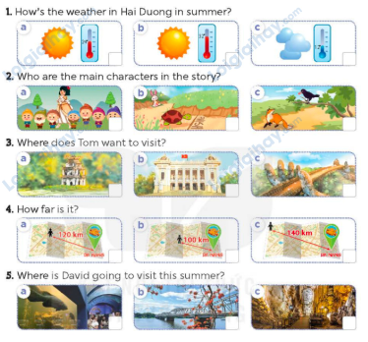  - Play the recording for Ss to do the task. (three times)  - Get Ss to swap books with a partner, then check answers as a class.  - Write the correct answers on the board.  - Play the recording for S to double-check their answers.  - Play the recording, have Ss listen and repeat in chorus.  Key: 1 b 2 c 3 a 4 b 5 c  Activity 2. Ask and answer:  *Aims: Ss will be able to ask and answer questions using picture cues personal information.  *Procedure:  - Draw ss’ attention to look at the picture, the questions and elicit the answer.  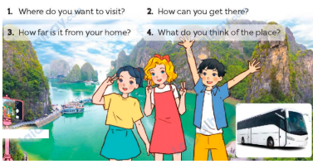  - Have Ss look at the picture to answer the question.  - Have Ss work in pairs to role-play the four questions  - Invite pairs of Ss to stand up and take it in turns to role-play the target exchanges.  Suggested answers:  1. I want to visit Ha Long Bay.  2. I can get there by bus (coach).  3. It’s about 79 km from Hai Phong.  4. I think it’s fantastic.  3. Fun corner and wrap- up (4’)  Game: “Pass the ball”  - Give two different colored balls to two pupils, a blue ball (ask the question) and a white ball (answer the question).  - Ask Ss to listen to music and pass the balls.  - Stop music suddenly. Have the student with a blue ball make a question. Have the student with a white ball answer the question.  - Repeat the game several times. | - Ss listen  -Ss play game  -Ss play game  -Ss praise the winner  - Ss open their books  - Ss listen and say  + Picture 1a: Icon for sunny, 24oC + Picture 1b: Icon for sunny, 32oC + Picture 1c: Icon for cloudy, 12oC + Picture 2a: Story Snow White and the seven dwarfs  + Picture 2b: Story the Tortoise and the Hare  + Picture 2c: Story the Fox and the Crow  + Picture 3a: Hoan Kiem Lake  + Picture 3b: Hanoi Opera House + Picture 3c: Golden Bridge in Da Nang  + Picture 4a: A map showing the distance from a place to Danang: 120 km  + Picture 4b: A map showing the distance from a place to Danang: 100 km  + Picture 4c: A map showing the distance from a place to Danang: 140 km  + Picture 5a: Dam Sen Aquarium in Ho Chi Minh City  + Picture 5b: Huong River in Hue  + Picture 5c: Phong Nha Cave in Quang Binh  - Ss listen to the recording and do the task.  - Ss swap books with a partner, then check answers as a class.  - Ss listen to the recording to double-check their answers.  - Sls listen to the recording and repeat  -Look at the pictures and say  - Ss look at and answer.  - Ss work in pairs to role play  - Ss role play  -Ss listen to the teacher  -Ss play the game  Ex: A: Where do you want to visit?  B: I want to visit My Khe Beach  -Ss continue playing the game.
D. ADJUSTMENTS (if necessary):
………………………………………………………………………………………….…..……………………………………………………………………………...…….

