Week 20 Preparing date: ……………..
Period 80 Teaching date: ……….……….

Unit 12: Our Tet holiday
Lesson 1 (4, 5, 6)
A. OBJECTIVES:
By the end of the lesson, Ss will be able to:
1. Knowledge:
- listen to and understand two communicative contexts in which characters ask and answer questions whether someone will do something for Tet, and tick the correct pictures
- complete four gapped exchanges with the help of picture cues
- sing the song Tet is a happy time for us. with the correct pronunciation, rhythm and melody.
- Vocabulary: Review
- Skills: speaking, listening, reading and writing.
2. Competences:
- Communication and collaboration: work in pairs and groups to complete the learning tasks.
- Self-control and independent learning: perform listening and reading tasks.
3. Attitude/ Qualities:
- Show their pride in their personal home and address.
B. TEACHING AIDS:
- Teacher: Teacher’s guide Pages 195, 196, 197; audio Tracks 17; website hoclieu.vn, posters, laptop, pictures, textbook, lesson plan, TV or projector.
- Students: Student’s book Page 13, notebooks, workbooks, school things.
C. PROCEDURES:
Teacher’s activities | Students’ activities
1.Warm- up and review: (5’)  Game: Help Kitchen Gods  *Aims: to revise the learned sentence structures.  *Procedure:  - Explain how to play the game.  - Tell ss it’s the end of year, so they are going to help the Kitchen God collect all the reports.  - Ss take turns to choose the houses, look at the pictures, ask and answer the questions.  - Check the Ss’ answers as a whole class.  - If they give the correct answers, they can get a report.  - Ss take turns to choose all the houses and collect all the reports.  - After they get all the reports, teacher acts as the Kitchen God and say: “Well done! You helped me to collect all reports. Now I will go and report good things that you did this year to the King of Heaven. Happy New Year!”  - Say “Open your book page 13” and look at “Unit 12, Lesson 1 (4,5,6)”.  2.Practice: (25’)  Activity 1. Listen and number:  *Aims: Ss will be able to listen to and understand two communicative contexts in which characters ask and  answer questions about whether someone will do something for Tet and tick the correct  pictures.  *Procedure:  - Elicit and ask questions to elicit the home in the pictures  + What can you see in this picture?  + Where are they?  + What do they do?  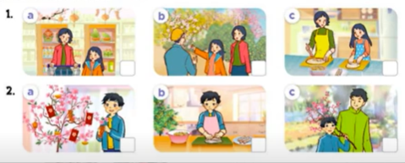  - T ask Ss to guess the answers.  + T writes Ss’guessing on the board.  - Listen to the tape:  + Play the recording  + Play the recording again for pupils to do the task.  + Play the recording a third time for pupils to check their answers.  - Get Ss to swap books with their partner, then check answers as a class.  + Write the answers on the board for Ss to correct their answers. Then checks Ss’ guessing.  - If time allows, play the recording, sentence by sentence, for Ss to listen and repeat individually and in chorus Key: 1. c 2. d 3. b 4. a  Activity 2. Read and complete.  *Aims: Ss will be able to read and complete four gapped exchanges with the help of picture cues.  *Procedure:  - Have Ss read the question and answer, and guess the missing word in the question.  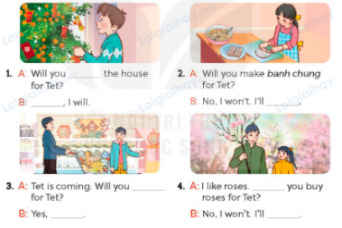  - Have Ss look at the four incomplete exchanges and elicits the missing words in the sentences.  - T models with sentence 1  + Have Ss look at the picture and identify the needed information (decorate).  - Have Ss work in groups and complete the exchanges 2, 3 and 4.  - Get Ss to swap books with a partner and check their answers before checking as a class.  - Invite four pairs of Ss to act out the four completed exchanges in front of the class  Key:  1. decorate; Yes  2. make spring rolls  3. do the shopping; I will  4. Will; buy a branch of peach blossoms  Activity 3. Let’s sing.  *Aims: Ss will be able to sing the song Tet is a happy time for us. with the correct pronunciation, rhythm and  melody.  *Procedure:  - Introduce the title and lyrics of the song: “Tet is a happy time for us”  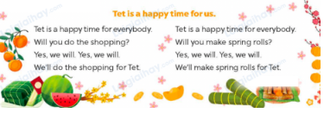  - Play the recording for Ss to listen to the whole song.  + Have them repeat the title and lyrics line by line.  + Tell Ss to point at the pictures while singing.  - Play the recording all the way through for Ss to listen to pronunciation and melody of the song.  - Play the recording line by line for Ss to listen, repeat and point to the pictures  - Play the recording for Ss to sing and do actions.  - Ask Ss to practice singing and doing actions in pairs or groups.  - Invite groups to the front of the classroom to perform the song  -T gives feedback.  3. Fun corner and wrap- up (5’)  Game: Get the lucky money  - Tell ss that they are going to play in 2 teams.  - Choose a number and answer the questions about whether someone will do something for Tet.  - If their answers are correct, ss will get 10 points. There are two lucky numbers with 20 points for each correct answer.  - Teams with more points will be the winner. | - Ss listen  - Ss play the game  - Ask and answer the question  - Continue playing the game.  - Ss open their books  -Look at the pictures and say:  + Picture 1a: a mother and her daughter doing the shopping  + Picture 1b: a mother and her daughter buying a branch of peach blossoms  + Picture 1c: a mother and her daughter making spring rolls  + Picture 2a: a boy decorating the house  + Picture 2b: a boy making spring rolls  + Picture 2c: a boy buying a branch of peach blossoms with his father  -Ss guess the answers  - Ss listen to the tape  - Ss listen again and do the task.  - Ss listen and check their answers  - Ss swap books with their partner, then check answers as a class and guessing  -Ss listen and repeat  -Ss look at the picture and identify personal information in each picture.  -Ss look and follow the teacher demonstrating the exchange 1.  -Ss answer: (Will you decorate the house for Tet?).  -Ss complete the sentences  -Ss swap books with a partner and check their answers before checking as a class.  -Ss read the completed exchanges aloud.  - Ss listen  -Ss listen to the song  - Ss listen and repeat line by line without the action.  -Ss point to the pictures while singing  -Ss listen to melody of the song  - Ss listen and sing line by line.  - Ss sing and do actions.  + Ss work in groups (two groups) to sing.  -Ss perform in front of the class.  -Ss listen  -Ss listen  -Ss play a game  - Ss continue playing the game.  -Ss praise the winner
D. ADJUSTMENTS (if necessary):
………………………………………………………………………………………….…..……………………………………………………………………………...…..…

