Week 19 Preparing date: …… ………
Period 73 Teaching date: ……… ……..

Unit 11: Family time
Lesson 1 (1, 2, 3)
A. OBJECTIVES:
By the end of the lesson, Ss will be able to:
1. Knowledge:
- understand and correctly repeat the sentences in two communicative contexts focusing on asking and answering questions about whether someone did something in the past.
- correctly say the words and use Did you ……? - Yes, I ……. I …….. to ask and answer questions about whether someone did something in the past;
- correctly use Did you ……? - Yes, I …… I …….. to ask and answer questions about whether someone did something in the past in a freer context
- Vocabulary: take a photo, collect seashells, walk on the beach, buy postcards.
- Structures: A: Did you swim?
B: Yes, I did. I swam with my mother.
- Skills: speaking and listening
2. Competences:
- Communication and collaboration: work in pairs and groups to complete the learning tasks.
- Self-control and independent learning: perform pronunciation and speaking tasks.
3. Attitude/ Qualities:
- Show their love and interest in outdoor activities.
- Raise their awareness of doing outdoor activities carefully.
B. TEACHING AIDS:
- Teacher: Teacher’s guide Pages 178, 179, 180, 181, audio Tracks 1, 2, website hoclieu.vn, posters, laptop, pictures, textbook, lesson plan, TV or projector.
- Students: Students’ book Page 6, notebooks, workbooks, school things.
C. PROCEDURES:
Teacher’s activities | Students’ activities
1.Warm- up: (3’)  Sing a song: Chicken dance  *Aims: to create a friendly and active atmosphere in the class to beginning the lesson.  *Procedure:  - Show the song on the screen.  https://www.youtube.com/watch?v=WZJAIkmT3Rg&t=10s  - Ask Ss to listen, sing and dance the song  - Say “Open your book page 6” and look at “Unit 11, Lesson 1 (1,2,3)”.  2. Presentation (15’)  Activity 1. Vocabulary.  *Aims: Ss will be able to know the vocabulary in the new lesson.  *Procedure:  -T elicits the new words  + take photos: chụp hình (mime)  + collect seashells : nhặt vỏ sò (picture)  + walk on the beach : đi bộ trên bãi biển  (picture)  +buy postcards: mua bưu thiếp (picture)  - T models (3 times).  - T writes the words on the board.  - Checking: Rub out and remember  Activity 2. Look, listen and repeat:  *Aims: Ss will be able to understand and correctly repeat the sentences in two communicative contexts focusing  on asking and answering questions about whether someone did something in the past.  *Procedure:  - Have Ss look at Pictures a and b and identify the characters and their activities in the pictures.  + Who are they?  + Where are they?  + What are they talking about?  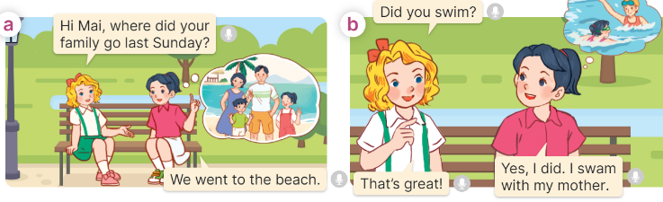  - Play the audio twice (sentence by sentence). Correct their pronunciation where necessary.  - Have Ss to practice the dialogue  - T invites a few pairs to the front of the class to practice.  - T checks pronunciation for ss.  Activity 3 Listen, point and say.  *Aims: Ss will be able to correctly say the words and use Did you …….? - Yes, I …... I …… to ask and answer questions about whether someone did something in the past.  *Procedure:  * Structures:  - T asks Ss look at picture b in activity 1 and helps Ss know the structure from the dialogue.  - T introduces new structures for Ss.  - T explains, models and gives meaning.  - Have Ss repeat the structures  A: Did you swim?  B: Yes, I did. I swam with my mother.  3.Practice: (7’)  *Drill pictures  - Have Ss look at the picture and identify the characters and their activities in the past.  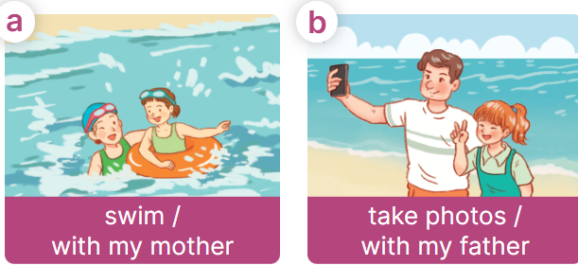  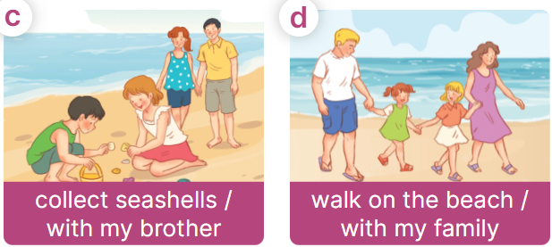  - Explain that the question and answer are used to express the activity someone did in the past and that swam is the past tense of the verb swim  + swim – swam + take – took  + collect – collected + walk - walked  - Have Ss point at pictures, listen and run through all the pictures.  - Have Ss point at the bubbles, listen and run through model sentences.  - Have Ss to practise:  + T asks the first picture, Ss answer  + Ss asks the second picture, T answers  + Group A asks the third picture, group B  answers  + Group B asks the last picture, group A  - Ask Ss to work in pairs to practise asking and answering the question Did you ……?  B: Yes, I ……. I ………  - T controls and corrects.  - Invite a few pairs to point at the pictures and say the questions and answers in front of the class.  4. Production: (6’)  Activity 4. Let’s talk.  *Aims: Ss will be able to correctly use Did you …….? - Yes, I ……... I …... to ask and answer questions about whether someone did something in the past in a freer context.  *Procedure:  - Have ss look at the picture and ask questions to help them identify the context  +What can you see in the picture?  +What are they doing?  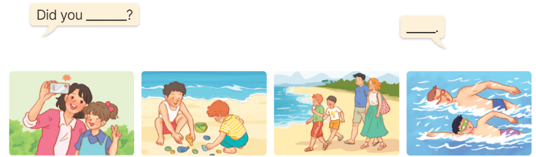  - Elicit the answer in the speech bubble and write it on the board. Get Ss to say the completed sentences.  - Have Ss role-play to practise asking the questions and giving their answers in pairs, using the picture cue.  - Invite a few pairs to point at the pictures and ask and answer questions.  5. Fun corner and wrap- up (4’)  Game: Lucky animals  - Divide the class into two groups.  - Have two ss from each group take turns to choose an animal and do the task.  - If the group chooses a lucky animal, they will get points and continue the next turn.  - Get corresponding points for their group.  - Continue with the other ss.  - The group that gets the most points wins. Praise the winner. | - Sing and dance the song together.  - Ss listen and open their books  -Ss listen and answer  - - Ss listen and repeat  + Choral repetition (3 times).  + Individual repetition (3 ss)  - Ss take note  - Ss look, remember and write  -Look at the pictures and say  +In picture a:  Mary: Hi Mai, where did your family go last Sunday?  Mai: We went to the beach.  + In picture b:  Mary: Did you swim?  Mai: Yes, I did. I swam with my mother.  Mary: That’s great!  -Ss listen and repeat in chorus (twice)  -Ss work in pairs to practice  -Ss come to the front of the classroom to practice.  -Ss listen  - Ss look at the picture and answer.  -Ss listen  -Ss listen and repeat  -Ss repeat to the structures  - Ss look, listen and repeat  +Picture a: a girl swimming with her mother.  + Picture b: a girl taking photos with his father.  + Picture c: a girl collecting seashells with her brother.  + Picture d: a girl walking on the beach with her family.  -Ss listen to the teacher’s instructions  -Ss point at pictures, listen and repeat  -Ss point at the bubbles, listen and repeat  -Ss practice in chorus  -Ss practice in chorus  -Ss work in pairs to practise asking and answering the question  - Pairs of Ss point at the pictures and say in front of the class  -Ss look at the picture and answer  + a girl taking photos with her mother; a boy collecting seashells with his brother; a boy walking on the beach with his family; a boy swimming with his father  - Ss say the completed sentences.  -Ss work in pairs to ask and answer  -Ss perform in front of the class.  - Ss listen  -Ss listen and play the game  Ex:  A: Did you swim?  B: Yes, I did. I swam with my father.  -Ss continue to play the game.  -Ss praise the winner.
D. ADJUSTMENTS (if necessary):
………………………………………………………………………………………….…..……………………………………………………………………………...……

