Week 35 Preparing date: ……. …….
Period 138 Teaching date: ………………

Extension activities
A. OBJECTIVES:
By the end of the lesson, Ss will be able to:
1. Knowledge:
- revise the target vocabulary by doing the quiz What type of story is it?
- revise the target vocabulary about types of story by completing sentences using words from a box.
- complete a short paragraph about story preferences and favourite stories.
- Vocabulary: Review
- Skills: speaking, writing and listening
2. Competences:
- Co-operation: ready to help friends in pair work/ group work.
- Sociability: Talk to each other, say good words to others.
3. Attitude/ Qualities:
- Kindness: Help partners to complete learning tasks.
B. TEACHING AIDS:
- Teacher: Teacher’s guide Pages 334, 335; website hoclieu.vn, posters, laptop, pictures, textbook, lesson plan, TV or projector.
- Students: Student’s book Page 72, 73, notebooks, workbooks, school things.
C. PROCEDURES:
Teacher’s activities | Students’ activities
1.Warm- up: (3’)  Game: Pass the cards  *Aims: to create a friendly and active atmosphere in the class to beginning the lesson.  *Procedure:  - Give a card to a student.  - Play music. Have that student pass the card to the next one.  - Stop music suddenly. Have the student holding a card to ask a question and invite another student to answer the question.  - Repeat the game several times.  - Say “Open your book page 72, 73” and look at “Extension activites”.  2. Practice (28’)  Activity 1. Do the quiz  *Aims: Ss will be able to revise vocabulary related to activities by correctly categorising activities.  *Procedure:  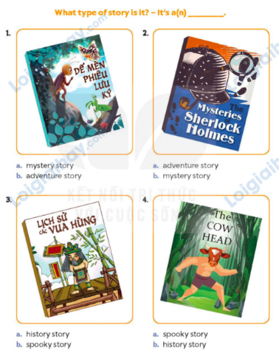  - Look at the pictures and learn some words about types of story.  - Tell ss the goal of the quiz and explain that they have to read the title and look at the cover of each story and guess what type of story it is.  - Draw ss’ attention to the two answer options (a and b).  - Set a time limit for ss to do the task independently.  - Get ss to compare their answers with a partner, then check answers together as a class.  - Get ss work in pairs ask and answer using the sentence pattern and picture hints  Key: 1. b 2. b 3. a 4. a  Activity 2. Read and complete  *Aims: Ss will be able to revise the target vocabulary about types of story by completing sentences using words from a box.  *Procedure:  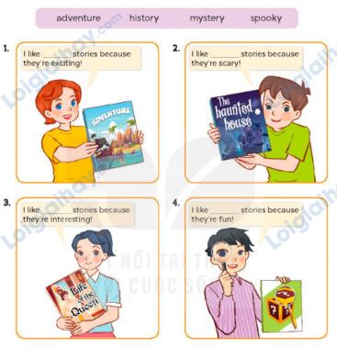  - Tell Ss the goal of the activity and elicit the character’s name and the title of the book  - Have Ss read the sentences and elicit and answer.  - Have Ss time to complete independenlty.  - Have ss check their answer in pairs, before checking as a class.  Key: 1. adventure 2. spooky  3. history 4. mystery  Activity 3. Write and say  *Aims: Ss will be able to complete a short paragraph about story preferences and favourite stories.  *Procedure:  - Tell ss the goal of the activity and explain that they have to complete a short paragraph about stories with their own information.  - Have ss read the first sentence aloud and point at each gap and ask What is missing? (a type of story; why I like it).  - Have ss complete the gaps independently, then check their answers as a class.  - Have ss present their favourite books to the class. They should say what types of story they are, who the main characters are and what happens.  Ex:  I like adventure stories because they are exciting. My favourite adventure story is Treasure Island.  3. Fun corner and wrap- up (4’)  Sing a song: A ram sam sam  - Show the song on the screen.  https://www.youtube.com/watch?v=SwjvlJCelN0  - Ask Ss to listen, sing and dance the song. | - Ss listen  - Ss play the game  Ex: A: Where are you going to visit this summer?  B: I’m goinf to Ly Son Island.  -Ss continue playing the game  -Ss open the book  -Look at the picture, read the words  - Ss read the title and look at the cover of each story and guess what type of story it is.  - Ss look at the two options  and choose the correct answers.  - Ss do the task independently  - Ss compare answers with a partner  -Ss check answer  -Ss listen to the teacher  -Ss read and answer  -Ss read and do the task  -Ss check the answer together  - Ss listen to teacher’s instructions  - Ss read the first sentence aloud, guess, guess what type of information they need to complete.  - Ss complete paragraphs  - Ss present their favourite books to the class  - Ss listen, sing and dance together
D. ADJUSTMENTS (if necessary):
………………………………………………………………………………………….…..……………………………………………………………………………...……

