Week 16 Preparing date:18/12/ 2024
Period 63 Teaching date: 27/12/ 2024

Unit 10: Our summer holiday
Lesson 1 (4, 5, 6)
A. OBJECTIVES:
By the end of the lesson, Ss will be able to:
1. Knowledge:
- use the phrases at the campsite, at the zoo, in the countryside, on the beach in relation to the topic “Our summer holidays”
- listen to and demonstrate understanding of simple communicative contexts in relation to the topic “Our summer holidays”.
- Vocabulary: Review
- Skills: speaking, listening, reading and writing.
2. Competences:
- Written Communication: complete the sentences.
- Self-control and independent learning: perform listening tasks.
- Communication and collaboration: work in pairs or groups.
3. Attitude/ Qualities:
- Show pride in where they were to and what they did in their summer holidays
B. TEACHING AIDS:
- Teacher: Teacher’s guide Pages 140, 141, 142; audio Tracks 99, 100, website sachmem.vn, posters, laptop, pictures, textbook, lesson plan, TV or projector.
- Students: Pupil’s book Page 69, notebooks, workbooks, school things.
C. PROCEDURES:
Stages&Time | Teacher’s activities | Students’ activities
1.Warm- up: (5’)  2.Presentation(10’)  - Practice: (10’)  4.Production(7’)  5. Homework. (3’) | Slap the board  *Aims: to create a friendly and active atmosphere in the class to beginning the lesson.  *Procedure:  - Divide class into 2 groups: Tom and Jerry.  - How to play:  + Each group chooses five Ss to play.  + Class will read aloud.  + Look at the picture, listen and slap the picture you heard.  + Who faster will get 1 mark.  + Which group with higher mark is the winner.  - T gives feedback.  - Say “Open your book page 69” and look at “Unit 10, Lesson 1 (4,5,6)”.  Activity 1. Listen and tick:  *Aims: Ss will be able to listen to and understand two communicative contexts about if someone was somewhere in the past and tick the correct pictures.  *Procedure:  - Elicit the name of the character and their activities in each picture.  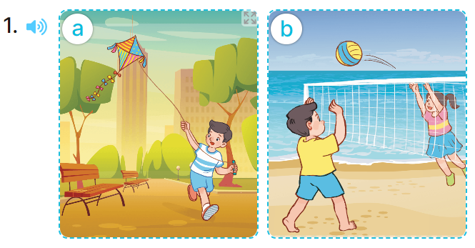  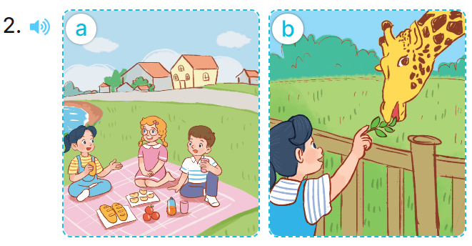  - T ask Ss to guess the answers.  + T writes Ss’guessing on the board.  - Listen to the tape:  + Play the recording  + Play the recording again and get Ss to swap books with their partners.  + Play the recording again to check answers together as a class.  + Write the answers on the board for Ss to correct their answers. Then checks Ss’ guessing.  - Play the recording, sentence by sentence, for the class to listen and repeat in chorus.  Key: 1. b 2. b  Activity 2. Look, complete and read  *Aims: Ss will be able to complete two gapped sentences and two gapped exchanges with the help of picture cues.  *Procedure:  - Have Ss look at the pictures and identify the the characters and places in the picture  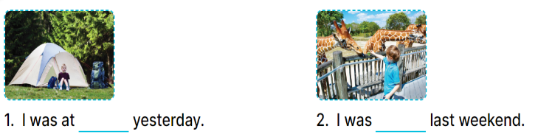  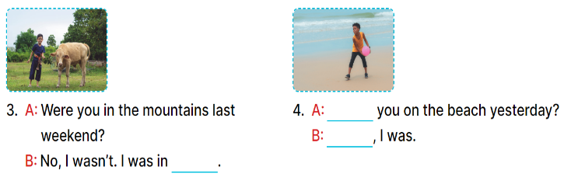  - Have Ss look at the four incomplete sentences. Elicit and model with picture 1  + Ask Ss to read the sentence 1 in chorus.  + Ask Ss what word is missing in the gap (the campsite). Then have them complete the sentence (I was at the campsite yesterday.)  -Have Ss work in pairs and complete the sentences 2, 3, 4.  - Ask a few Ss to stand up and read the sentences aloud.  -T gives feedbacks.  Key:  1.the campsite  2. at the zoo  3. the countryside  4. Were/ yes  Activity 3. Let’s sing  *Aims: Ss will be able to sing the song Were you on the beach yesterday? with the correct pronunciation, rhythm and melody.  *Procedure:  - Introduce the title and lyrics of the song and check comprehension.  + What is the song about?  + What are they doing?  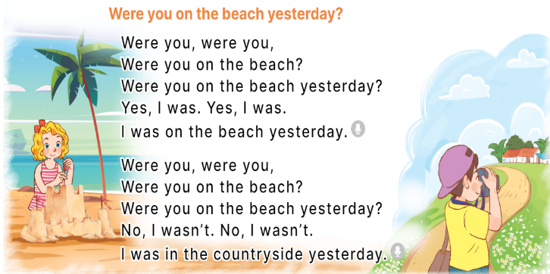  - Play the recording for Ss to listen to the whole song.  + Have them repeat the title and lyrics line by line.  + Tell Ss to point at the pictures while singing.  - Play the recording all the way through for Ss to listen to pronunciation and melody of the song.  - Play the recording line by line for Ss to listen, repeat and point to the pictures  - Play the recording for Ss to sing and do actions.  - Ask Ss to practice singing and doing actions in pairs or groups.  - Invite groups to the front of the classroom to perform the song  -T gives feedback.  *Consolidation  *Aims: Ss will be able consolidate and wrap up the content of the lesson.  *Procedure:  - T asks ss to answer the following questions:  + What have you learnt from the lesson today?  +What are the core values of the lesson? (if the teacher can take from the lesson).  - T praises some Ss who are hardworking / active/ good…. as well as encourage others to try more.  - Practice part 5 again.  - Prepare the new lesson: Unit 10, Lesson 2 (1,2,3). | - Ss listen  -Ss listen  - Ss play game  -Ss congratuate the winner  - Ss open their books  -Look at the pictures and say:  + Picture 1a. Nam at the park  + Picture 1b. Nam on the beach  + Picture 2a. Mai in the countryside  + Picture 2b. Mai at the zoo.  -Ss guess the answers  - Ss listen to the tape and tick  - Ss listen again, tick and swap books with their partners.  - Ss check their answers and guessing  -Ss listen and repeat.  -Ss look at the picture and say  -Ss look and answer  -Ss read  -Ss say and write  -Ss work in pairs and complete  -Ss read aloud  -Ss listen and answer  -Ss listen to the song  - Ss listen and repeat line by line without the action.  -Ss point to the pictures while singing  -Ss listen to melody of the song  - Ss listen and sing line by line.  - Ss sing and do actions.  + Ss work in groups (two groups) to sing.  -Ss perform in front of the class.  -Ss listen  -Ss answer the questions  -Ss listen and clap their hands  -Ss listen and take note
D. ADJUSTMENTS (if necessary):
………………………………………………………………………………………….…..……………………………………………………………………………...………………………………………….…..……………………………………………………………………………….……………………………………………………………………...

