Week 16 Preparing date: 17/12/2024
Period 61 Teaching date: 24/12/2024

Unit 9: Our sports day
Lesson 3 (4, 5, 6)
A. OBJECTIVES:
By the end of the lesson, Ss will be able to:
1. Knowledge:
- listen to and demonstrate understanding of simple exchanges in relation to the topic "Our sports day";
- read and write about sports days;
- make a sports day poster and present it to the class at Project time.
- Vocabulary: Review
- Skills: speaking, listening, reading and writing.
2. Competences:
- Written communication: write about the colours of school things
- Critical thinking: complete a task in reading a text.
- Co-operation: ready to help friends in pair work/ group work.
- Self-control and independent learning: perform listening tasks.
3. Attitude/ Qualities:
- Kindness: Help partners to complete learning tasks.
- Honesty: tell the truth about feelings and emotions.
- Diligence: complete learning tasks.
B. TEACHING AIDS:
- Teacher: Teacher’s guide Pages 136, 137; website hoclieu.vn, posters, laptop, pictures, textbook, lesson plan, TV or projector.
- Students: Pupil’s book Page 67, notebooks, workbooks, school things.
C. PROCEDURES:
Stages&Time | Teacher’s activities | Students’ activities
1.Warm- up: (5’)  2.Presentation(11’)  3.Practice: (8’)  4.Production: (9’)  4. Homework. (3’) | Game: “Chant”  *Aims: to review the vocabulary and structure about greet and respond to greetings.  *Procedure:  - Ask Ss chant and do the actions in Unit 9, Lesson 3 page 66 in groups.  - Give point for the groups and encourage them.  - Say “Open your book page 67” and look at “Unit 9, Lesson 3 (4, 5, 6)”.  Activity 1. Read and tick True or False:  *Aims: Ss will be able to read and show understanding of a text by deciding if the statements are true or false.  *Procedure:  - Have pupil look at the text, the four statements and read it together as a class.  - Have pupils pay attention to the sentences about sports day and what the boys, the girls do on sports day in the text. - Give pupils time to tick the correct boxes.  - Tell pupils to swap books with a partner, then check answers together as a class.  -Write the correct answers on the board.  - Ask the pupils to read the text aloud in front of the class.  Key: 1. T 2. F 3. T 4. F  Activity 2. Let’s write  *Aims: Ss will be able to read, understand and complete the gapped text about a sports day.  *Procedure:  - Tell the class the goal of this activity: Pupils are to read the gapped text and fill in the gaps.  - Write the first gapped sentence on the board: Our school sports day is in… .  - Read the sentence, point at it and encourage pupils to say the answer.  - Give pupils time to write the answer.  - Invite a few pupils to read the sentences they have completed in front of the class.  Key: Pupils’ answer  Ex: Our sports day is in November. We play sports and games in the school playground. The boys play badminton. The girls play football. The teachers play basketball. We all love our sports day.  Activity 3. Project.  *Aims: Ss will be able to make sports day posters at home and present them to the class, using the target language.  *Procedure:  - Explain that they are going to show sports day posters that they have made at home and tell the class about their sports day.  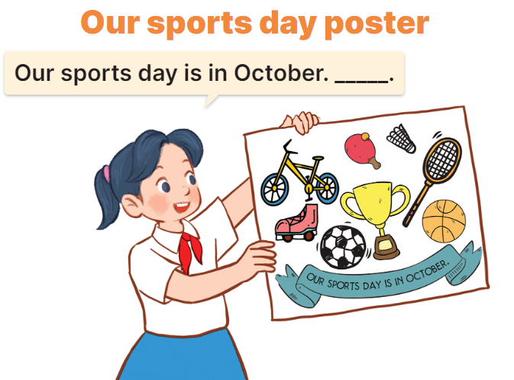  - Have pupils work in groups of five. Each pupil shows his / her poster and tells the group about sports day, ex: Our sports day is in October. I cycle. My friends play badminton.  - Invite some pupils to show their work and talk about their sports days.  - Have pupils stick their posters on the walls of the classroom as a display.  *Consolidation  *Aims: Ss will be able consolidate and wrap up the content of the lesson.  *Procedure:  - T asks ss to answer the following questions:  + What have you learnt from the lesson today?  +What are the core values of the lesson? (if the teacher can take from the lesson).  - T praises some Ss who are hardworking / active/ good…. as well as encourage others to try more.  - Prepare the new lesson: Unit 10, Lesson 1 (1, 2, 3). | - Ss listen and chant  - Ss open their books  -Ss read together  -Ss pay attention  -Ss tick the correct boxes  -Ss swap their answers and check their answer  -Ss write the correct answer  -Ss read aloud  -Ss listen and read  -Ss pay attention  -Ss listen and say the answer  -Ss do the task  -Ss read the sentences aloud  - Ss listen  -Ss work in groups and say the picture  -Ss show the picture and talk about their sports day in font of the the class  -Ss stick their posters on the walls and vote the best beautiful poster.  -Ss answer the questions  -Ss listen and clap their hands  -Ss listen and take note
D. ADJUSTMENTS (if necessary):
………………………………………………………………………………………….…
……………………………………………………………………………………………………………………………………………………………………………………….

