Week 11 Preparing date: November 12 ^{th} , 2024
Period 41 Teaching date: November 19 ^{th}, 2024

Unit 6: Our school facilities
Lesson 2 (4, 5, 6)
A. OBJECTIVES:
By the end of the lesson, Ss will be able to:
1. Knowledge:
- use How many …. are there at your school? – There is ……. / There are …..to ask and answer questions about the quantity of school facilities.
- listen to and demonstrate understanding of simple communicative contexts in relation to the topic “Our school facilities”.
- draw their school with some facilities and present it to the class.
- Vocabulary: Review
- Skills: speaking, listening, reading and writing.
2. Competences:
- Critical Thinking: self-introduce
- Co-operation: ready to help friends in pair work/ group work.
- Self-control and independent learning: perform listening tasks.
3. Attitude/ Qualities:
- Kindness: Help partners to complete learning tasks.
- Honesty: tell the truth about feelings and emotions.
- Show pride and responsibility in the facilities they have at their school.
B. TEACHING AIDS:
- Teacher: Teacher’s guide Pages 94,95; audio Tracks 62,63; website hoclieu.vn, posters, laptop, pictures, textbook, lesson plan, TV or projector.
- Students: Pupil’s book Page 47, notebooks, workbooks, school things.
C. PROCEDURES:
Stages & Time | Teacher’s activities | Students’ activities
1.Warm- up: (5’)  2.Presentation: (10’)  2.Practice: (10’)  4.Production  7’  5. Homework. (3’) | Game: Slap the board  *Aims: to create a friendly and active atmosphere in the class to beginning the lesson.  *Procedure:  - Divide class into 2 groups  - How to play:  + Each group chooses five Ss to play.  + Class will read aloud.  + Look at the picture, listen and slap the picture you heard.  + Who faster will get 1 mark.  + Which group with higher mark is the winner.  - T gives feedback.  - Say “Open your book page 47” and look at “Unit 6, Lesson 2 (4,5,6)”.  Activity 1. Listen and tick:  *Aims: Ss will be able to listen to and understand two communicative contexts in which characters ask and answer questions about the quantity of school facilities, and tick the correct pictures.  *Procedure:  - Elicit the word for the place in each picture  - Point at the pictures respectively to explain the context.  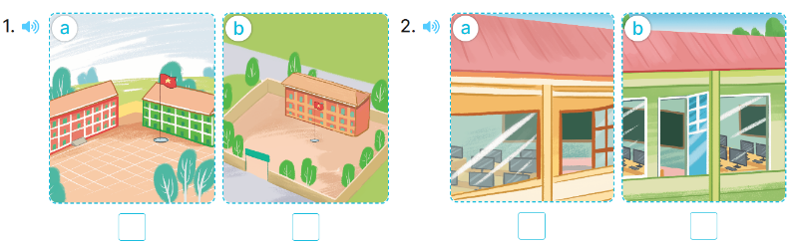  - T ask Ss to guess the answers.  + T writes Ss’guessing on the board.  - Listen to the tape:  + Play the recording  + Play the recording again and get Ss to swap books with their partners.  + Play the recording again to check answers together as a class.  + Write the answers on the board for Ss to correct their answers. Then checks Ss’ guessing.  - Play the recording, sentence by sentence, for the class to listen and repeat in chorus.  Key: 1. a 2. a  Activity 2. Look, compelete and read  *Aims: Ss will be able to complete target sentence patterns in two dialogues with the help of picture cues.  *Procedure:  - Get Ss to look at the pictures and identify about school location.  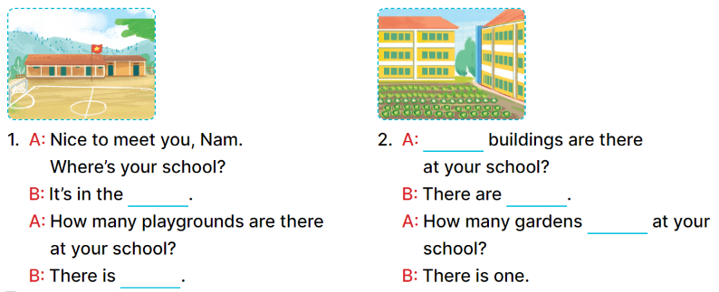  - Give pupils complete the gaps in Dialogue 1, then have them compare their answers in pairs.  - Ask some pairs to read aloud the dialogue.  - Repeat the same procedure with Dialogue 2.  - Invite one or two Ss to stand up and read the completed sentences.  Key:  - mountains, one  - How many, two, are there  Activity 3. Let’s sing  *Aims: Ss will be able to sing the song How many …? with the correct pronunciation, rhythm and melody.  *Procedure:  - Have pupils read the lyrics to familiarise themselves with the questions and answers  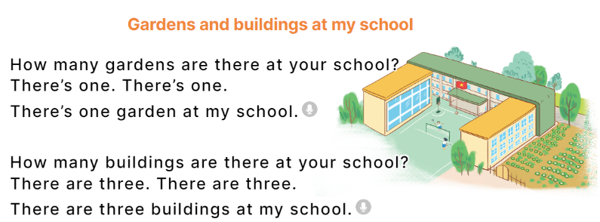  - Have pupils listen to the whole song, drawing their attention to the pronunciation, the rhythm and the melody of the song.  - Play the recording of the song once or twice for pupils to listen and repeat line by line and do related actions, ex: using fingers for numbers one and three.  - Ask the to sing the whole song while doing actions or clapping hands.  - Invite a few groups to the front of the class to sing the song. The class may sing along to reinforce the activity.  *Consolidation  *Aims: Ss will be able consolidate and wrap up the content of the lesson.  *Procedure:  - T asks ss to answer the following questions:  + What have you learnt from the lesson today?  +What are the core values of the lesson? (if the teacher can take from the lesson).  - T praises some Ss who are hardworking / active/ good…. as well as encourage others to try more.  - Practice part 5 again.  - Prepare the new lesson: Unit 6, Lesson 3 (1,2,3). | - Ss read the words  - Ss play game  -Ss play game  - Ss open their books  -Look at the pictures and say:  + Picture 1a. a school with a red building and a green building  + Picture 1b. a school with three buildings  + Picture 2a. a school with a computer room  + Picture 2b. a school with two computer rooms  -Ss guess the answers  - Ss listen to the tape and tick  - Ss listen again, tick and swap books with their partners.  - Ss check their answers and guessing  -Ss listen and repeat.  -Ss look at the picture and say  -Ss look and answer  -Ss read aloud  -Ss work in pairs and complete  -Ss read aloud  - Ss listen  -Ss listen and pay attention  -Ss listen and repeat line by line  -Ss sing the whole song  -Ss sing in front of the class  -Ss answer the questions  -Ss listen and clap their hands  -Ss listen and take note
D. ADJUSTMENTS (if necessary):
………………………………………………………………………………………….…..……………………………………………………………………………...………………………………………….…..……………………………………………………………………………….……………………………………………………………………...

