Week 8 Preparing date: October 17 ^{th}., 2023
Period 32 Teaching date: October 26 ^{th}., 2023

Unit 5: Things we can do
Lesson 2 (4, 5, 6)
A. OBJECTIVES:
By the end of the lesson, Ss will be able to:
1. Knowledge:
- listen to and understand four communicative contexts in which pupils talk about abilities and lack of abilities and tick or cross the pictures.
- complete four gapped exchanges with the help of picture cues.
- sing the song Things they can do with the correct pronunciation, rhythm and melody.
- Vocabulary: Review
- Skills: speaking, listening, reading and writing.
2. Competences:
- Critical Thinking: self-introduce
- Co-operation: ready to help friends in pair work/ group work.
- Self-control and independent learning: perform listening tasks.
3. Attitude/ Qualities:
- Kindness: Help partners to complete learning tasks.
- Honesty: tell the truth about feelings and emotions.
- Diligence: complete learning tasks.
B. TEACHING AIDS:
- Teacher: Teacher’s guide Pages 75,76; audio Tracks 51, 52; website hoclieu.vn, posters, laptop, pictures, textbook, lesson plan, TV or projector.
- Students: Pupil’s book Page 37, notebooks, workbooks, school things.
C. PROCEDURES:
Stages and time | Teacher’s activities | Students’ activities
1.Warm- up: (5’)  2.Presentation: (10’)  3.Practice: (10’)  4. Production  7’  5. Homework. (3’) | Sing a song: Slap the board  *Aims: to create a friendly and active atmosphere in the class to beginning the lesson.  *Procedure:  - Divide the class into two or three teams.  - Teacher puts up a set of pictures or words on a board.  - A pupil from each team comes up to the board with fly swatters.  - They listen as the teacher calls out a word or a sentence and they race to slap the correct picture.  - Whoever is the fastest with the correct slap gets a point for their team.  - Team with the most points is the winner.  - Say “Open your book page 13” and look at “Unit 5, Lesson 2 (4,5,6)”.  Activity 1. Listen and tick or cross:  *Aims: Ss will be able to listen to and understand two communicative contexts in which pupils discuss different hobbies.  *Procedure:  - Elicit the activities in the pictures and tick or cross the boxes while listening.  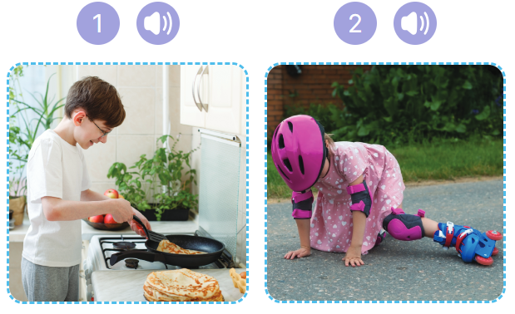  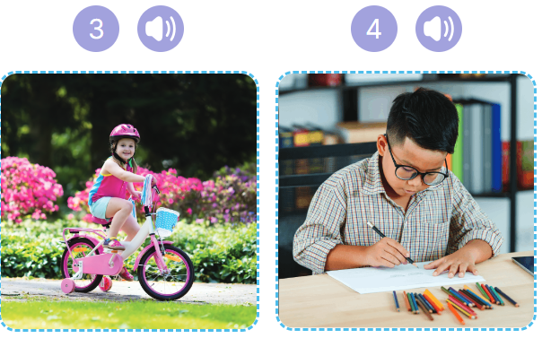  - T ask Ss to guess the answers.  + T writes Ss’guessing on the board.  - Listen to the tape:  + Play the recording  + Play the recording again and get Ss to swap books with their partners.  + Play the recording again to check answers together as a class.  + Write the answers on the board for Ss to correct their answers. Then checks Ss’ guessing.  - Play the recording, sentence by sentence, for the class to listen and repeat in chorus.  Key: 1. Tick 2. Cross 4.Tick 5.Cross  Activity 2. Look, complete and read  *Aims: Ss will be able to complete four target sentences with the help of picture cues.  *Procedure:  - Draw pupils’ attention to the picture and elicit the words to complete the sentence.  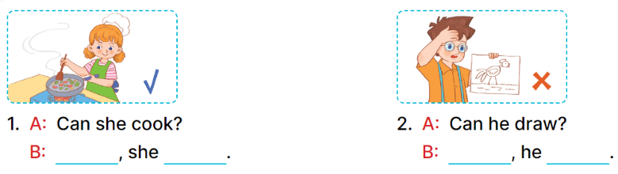  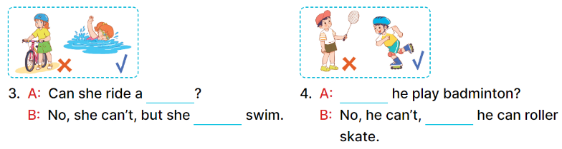  - Have Ss look at the four incomplete sentences and elicits the missing words in the sentences.  - T models with picture 1  + Ask Ss what is missing in the sentence.  + Have Ss look at the picture and complete the gap, then read the completed sentence in chorus.  -Have Ss work in groups and complete the picture 2, 3 and 4.  - Ask a few Ss to stand up and read the completed sentences aloud.  -T gives feedbacks.  Key: 1. Yes; can 2. No; can’t  3. bike; can 4. Can; but  Activity 3. Let’s sing.  *Aims: Ss will be able to sing the song Things they can do with the correct pronunciation, rhythm and melody.  *Procedure:  - Introduce the title and lyrics of the song: “ Things they can do ”  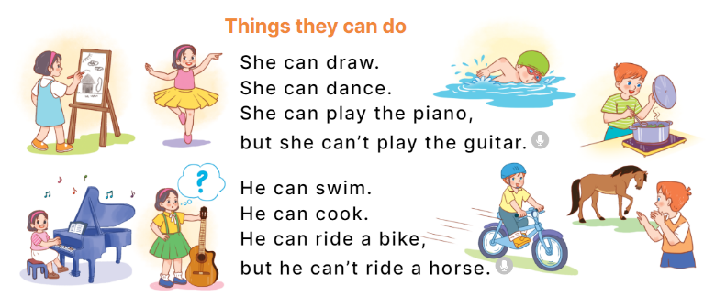  - Play the recording for Ss to listen to the whole song.  + Have them repeat the title and lyrics line by line.  + Tell Ss to point at the pictures while singing.  - Play the recording all the way through for Ss to listen to pronunciation and melody of the song.  - Play the recording line by line for Ss to listen, repeat and point to the pictures  - Play the recording for Ss to sing and do actions.  - Ask Ss to practice singing and doing actions in pairs or groups.  - Invite groups to the front of the classroom to perform the song  -T gives feedback.  *Consolidation  *Aims: Ss will be able consolidate and wrap up the content of the lesson.  *Procedure:  - T asks ss to answer the following questions:  + What have you learnt from the lesson today?  +What are the core values of the lesson? (if the teacher can take from the lesson).  - T praises some Ss who are hardworking / active/ good…. as well as encourage others to try more.  - Practice part 5 again.  - Prepare the new lesson: Unit 5, Lesson 3 (1,2,3). | - Ss listen  - Ss play game  - Ss open their books  -Look at the pictures and say:  + Picture 1. a boy cooking  + Picture 2. a girl falling off her roller skates  + Picture 3. a girl riding a bike  + Picture 4. a girl painting  -Ss guess the answers  - Ss listen to the tape and tick/ cross  - Ss listen again, tick/ cross and swap books with their partners.  - Ss check their answers and guessing  -Ss listen and repeat.  -Ss look at the picture and say  -Ss answer: Yes, she can  -Ss look, complete and read the completed sentence in chorus.  -Ss complete the sentence  -Ss read aloud  - Ss listen  -Ss listen to the song  - Ss listen and repeat line by line without the action.  -Ss point to the pictures while singing  -Ss listen to melody of the song  - Ss listen and sing line by line.  - Ss sing and do actions.  + Ss work in groups (two groups) to sing.  -Ss perform in front of the class.  -Ss listen  -Ss answer the questions  - Ss listen  -Ss listen and clap their hands  -Ss listen

D. ADJUSTMENTS (if necessary):
………………………………………………………………………………………….…..……………………………………………………………………………...………………………………………….…..………………………………………………………….

