Week 7 Preparing date: 23/10/2024
Period 28 Teaching date:25/10/2024

Unit 4: My birthday party
Lesson 3 (4, 5, 6)
A. OBJECTIVES:
By the end of the lesson, Ss will be able to:
1. Knowledge:
- read and understand a text (Bill’s letter) and circle the correct answers.
- complete a gapped text using pupils’ personal information.
- make birthday party invitations at home and present them to the class by using the target language.
- Vocabulary: Review
- Skills: speaking, listening, reading and writing.
2. Competences:
- Critical Thinking: self-introduce
- Co-operation: ready to help friends in pair work/ group work.
- Self-control and independent learning: perform listening tasks.
3. Attitude/ Qualities:
- Kindness: Show kindness in inviting someone to a birthday party and offering them food and drink they want.
- Honesty: Show pride in the date of birth of themselves and others’ and respect to their parents for their presence.
B. TEACHING AIDS:
- Teacher: Teacher’s guide Pages 66, 67; website hoclieu.vn, posters, laptop, pictures, textbook, lesson plan, TV or projector.
- Students: Pupil’s book Page 33, notebooks, workbooks, school things.
C. PROCEDURES:
Stages and Time | Teacher’s activities | Students’ activities
1.Warm- up: (5’)  2.Prentation: (10’)  3.Practice: (8’)  4.Production: (7’)  5. Homework. (3’) | Game: “Chant”  *Aims: to review the vocabulary and structure about greet and respond to greetings.  *Procedure:  - Ask Ss chant and do the actions in Unit 4, Lesson 3 page 32 in groups.  - Give point for the groups and encourage them.  - Say “Open your book page 33” and look at “Unit 4, Lesson 3 (4, 5, 6)”.  Activity 1. Read and circle:  *Aims: Ss will be able to read and understand a text (Bill’s letter) and circle the correct answers.  *Procedure:  - Draw pupils’ attention to Bill’s letter and read it together as a class.  - Have pupils pay attention to the gap and the three answer options for each sentence.  - Ask pupils to read the letter again and circle the correct options.  - Tell pupils to swap books with a partner, then check answers together as a class.  - Write the correct answers on the board.  - Tell pupils to return the books to their partners.  - Ask pupils to look at the board and check their answers again.  Key: 1. b 2. a 3. a 4. b  Activity 2. Let’s write  *Aims: Ss will be able to complete a gapped text using pupils’ personal information.  *Procedure:  - Tell the class the goal of this activity: to read the text and fill in the gaps using their personal information.  - Write the first sentence on the board.  - Read the sentence as a class. When you reach the gap, point at it and encourage pupils to say their own names.  - Give pupils time to write the answers.  - Repeat the same procedure with the other sentences.  - Invite a few pupils to read the sentences they have completed aloud in front of the class.  Ex: My name is Huong. I am from Nghia Lam Village. My birthday is in October. I want some chips, milk and a birthday cake at the party.  Activity 3. Project.  *Aims: Ss will be able to make birthday party invitations at home and present them to the class by using the target language.  *Procedure:  - Tell pupils the goal of this activity.  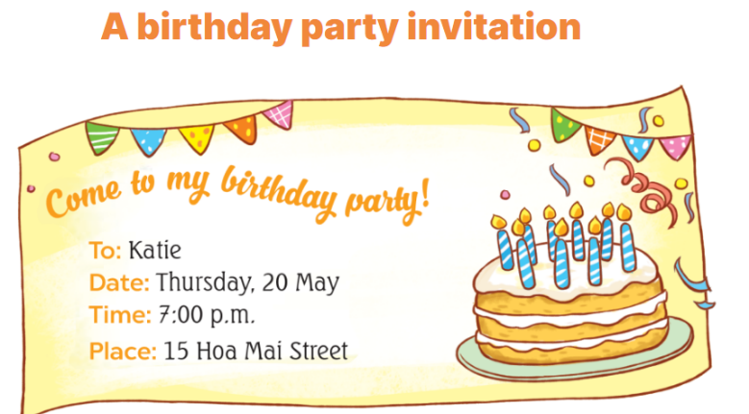  - Explain that they are going to show the birthday party invitations that they have made at home and tell the class about their birthdays.  - Have pupils work in groups of five.  + Each pupil shows his / her invitation and tells the group about his / her birthday  + Ex: My birthday’s in May.  - Invite some pupils to show their work and talk about their birthdays.  - Have pupils stick their invitations on the wall of the classroom as a display.  *Consolidation  *Aims: Ss will be able consolidate and wrap up the content of the lesson.  *Procedure:  - T asks ss to answer the following questions:  + What have you learnt from the lesson today?  +What are the core values of the lesson? (if the teacher can take from the lesson).  - T praises some Ss who are hardworking / active/ good…. as well as encourage others to try more.  - Prepare the new lesson: Unit 5, Lesson 1 (1, 2, 3). | - Ss listen and chant  - Ss open their books  - Ss look at the letter and answer  -Ss read and pay attention  -SS read again and circle  -Ss swap books and check  -Ss write the correct answer  -Ss return the books to their partners  -Ss check their answer again.  -Ss pay attention  -Ss listen and asnwer  -Ss write  -Ss write about themselves  -Ss write about themselves  -Ss read the sentences they have completed.  -Ss listen  -Ss listen to the teacher  -Ss work in groups and talk  -Some Ss perfom in front of the class.  -Ss vote the best invitations  -Ss answer the questions  -Ss listen and clap their hands  -Ss listen and take note
D. ADJUSTMENTS (if necessary):
………………………………………………………………………………………….…..……………………………………………………………………………...…………

