Week 5 Preparing date:5/10/ 2024
Period 17 Teaching date:8/10/ 2024

Unit 3: My week
Lesson 1 (1, 2, 3)
A. OBJECTIVES:
By the end of the lesson, Ss will be able to:
1. Knowledge:
- understand and correctly repeat the sentences in two communicative contexts (pictures) in which pupils ask and answer questions about the days of the week.
- correctly say the words and use What day is it today? – It’s ………. to ask and answer questions about the days of the week.
- enhance the correct use of What day is it today? – It’s …….. to ask and answer questions about the days of the week in a freer context.
- Vocabulary: Monday, Tuesday, Wednesday, Thursday, Friday, Saturday, Sunday, today.
- Skills: speaking and listening
2. Competences:
- Critical Thinking: self-introduce
- Co-operation: ready to help friends in pair work/ group work.
- Sociability: Talk to each other, say good words to others.
3. Attitude/ Qualities:
- Kindness: Help partners to complete learning tasks.
- Honesty: tell the truth about feelings and emotions
B. TEACHING AIDS:
- Teacher: Teacher’s guide Pages 43, 44, 45, audio Tracks 26, 27, website hoclieu.vn, posters, laptop, pictures, textbook, lesson plan, TV or projector.
- Students: Pupil’s book Page 22, notebooks, workbooks, school things.
C. PROCEDURES:
Stages & Time | Teacher’s activities | Students’ activities
1.Warm- up: (3’)  2. Presentation (16’)  3.Practice: (7’)  4.Production: (7’)  5. Homework. (2’) | Sing: What day is it today?  *Aims: to create a friendly and active atmosphere in the class to beginning the lesson.  *Procedure:  - Show the song on the screen.  https://www.youtube.com/watch?v=ij0iWJB2uMo  - Ask pupils to listen, sing and dance the song.  - Say “Open your book page 22” and look at “Unit 3, Lesson 1 (1,2,3)”.  Activity 1. Vocabulary.  *Aims: Ss will be able to know the vocabulary in the new lesson.  *Procedure:  -T elicits the new words  + Monday : thứ 2 (situation)  + Tuesday : thứ 3 (situation)  + Wednesday :thứ 4 (situation)  + Thursday : thứ 5 (translation)  + Friday : thứ 6 (translation)  + Saturday : thứ 7 (situation)  + Sunday : chủ nhật (situation)  + today : hôm nay (translation)  - T models (3 times).  - T writes the words on the board.  - Checking: Matching  Activity 2. Look, listen and repeat:  *Aims: Ss will be able to understand and correctly repeat the sentences in two communicative contexts (pictures) in which pupils ask and answer questions about the days of the week.  *Procedure:  - Have Ss look at Pictures a and b and identify the characters in the pictures.  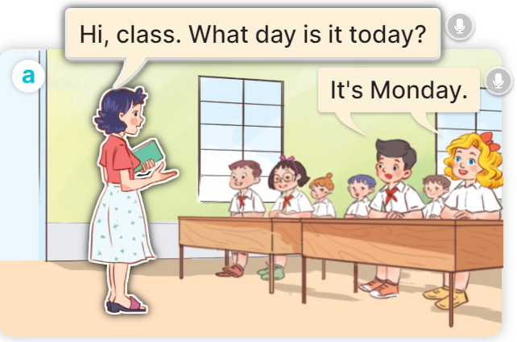  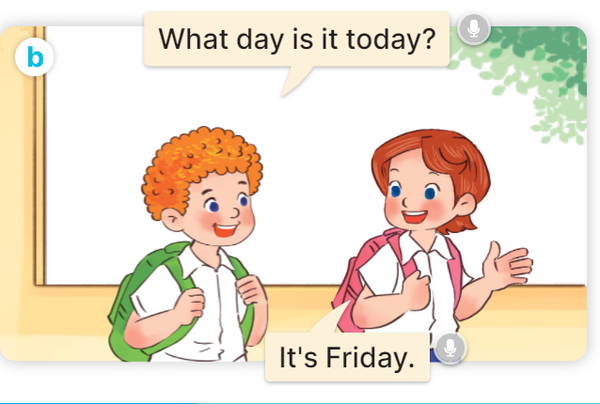  - Play the audio twice (sentence by sentence). Correct their pronunciation where necessary.  - Have Ss to practice the dialogue  - T invites a few pairs to the front of the class to practice.  - T checks pronunciation for ss.  Activity 3 Listen, point and say.  *Aims: Ss will be able to correctly say the words and use What day is it today? – It’s …….. to ask and answer questions about the days of the week.  *Procedure:  * Model sentences:  - T asks Ss look at picture a, b and helps Ss know the structure from the dialogue.  - T introduces new structure for Ss.  - T explains, models and gives meaning.  - Have Ss repeat the model sentences.  A: What day is it today?  B: It’s Monday.  *Drill pictures  - Elicit and check comprehension the name of each character.      - Run through all the pictures.  - Run through model sentences.  - Have Ss to practise:  + T says the first picture  + Ss says the second picture  + Group A says the third picture  + Group B say the last picture.  - Ask Ss to work in pairs.  - T controls and corrects.  - Invite a few pairs to come to the front of the classroom, point at the relevant character in each picture, and act out his/her role.  - Encourage Ss to practise speaking English.  - T gives feedbacks.  Activity 4. Let’s talk.  *Aims: Ss will be able to enhance the correct use of What day is it today? – It’s …….. to ask and answer questions about the days of the week in a freer context.  *Procedure:  - T asks ss to guess each character and what the children say.  + What can you see in the picture?  +Who are they?  +Where are they?  +What are they saying?  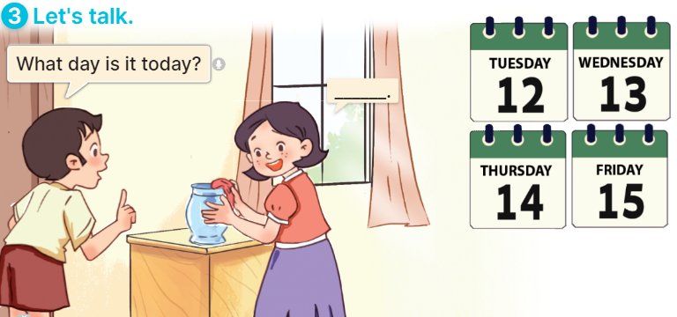  - T fills the gaps and writes the sentences on the board.  - T models  - T asks Ss to greet and introduce someone. (groups of four)  - Invite some groups to perform.  - Give feedbacks  *Consolidation  *Aims: Ss will be able consolidate and wrap up the content of the lesson.  *Procedure:  - T asks ss to answer the following questions:  + What have you learnt from the lesson today?  +What are the core values of the lesson? (if the teacher can take from the lesson).  - T review the vocabulary and model sentences.  - T praises some Ss who are hardworking / active/ good…. as well as encourage others to try more.  - Learn the vocabulary and model sentences by heart  - Prepare the new lesson: Unit 3, Lesson 1 (4,5,6). | - Ss sing and dance the song  - Ss open their books  -Ss listen and answer  - - Ss listen and repeat  + Choral repetition (3 times).  + Individual repetition (3 ss)  - Ss take note  - Ss look, remember and match  -Look at the pictures and get to know the characters in the pictures.  + In picture a: Ms Hoa says: Hi, class. What day is it today? And Mr Long says: It’s Monday.  + In picture b: Mai says: That’s Mr Long. And Bill says: Hello, Mr Long.  -Ss listen and repeat in chorus (twice)  -Ss work in pairs to practice  -Ss practice the dialogue  -Ss listen  -Ss look at the picture and answer.  -Ss listen  -Ss listen and repeat  -Ss repeat to the introduce someone.  - Ss look, listen and answer  +Picture a: Monday  + Picture b: Tuesday  + Picture c: Wednesday  + Picture d: Thursday  -Ss listen and repeat  -Ss practice in chorus  -Ss practice  -Ss work in pairs to practice  -Ss point and say  -Ss listen.  -Ss listen  -Ss look at the picture and answer  + a boy asks a girl about the days of the week: Tuesday, Wednesday, Thursday, Friday (illustrated by calendars).  -Ss note  - Ss say the completed sentences.  -Ss pay attention  -Ss work in groups  -Ss perform in front of the class.  -Ss answer the questions  - Ss listen  -Ss listen and clap their hands  -Ss listen and take note

D. ADJUSTMENTS (if necessary):
Sthdents do the mind map about Days of the week and show in front of the class the next time.

