Week 3 Preparing date: September 19 ^{th}, 2024
Period 12 Teaching date: September 27 ^{th}., 2024

Unit 2: Time and daily routines
Lesson 1 (4,5,6)
A. OBJECTIVES:
By the end of the lesson, Ss will be able to:
1. Knowledge:
- listen to and understand two communicative contexts in which two pupils play a game asking and telling the time and tick the correct pictures.
- complete four gapped exchanges with the help of picture cues.
- review telling the time by playing the game Which clock says ...?
- Vocabulary: Review
- Skills: speaking, listening, reading and writing.
2. Competences:
- Critical Thinking: self-introduce
- Co-operation: ready to help friends in pair work/ group work.
- Self-control and independent learning: perform listening tasks.
3. Attitude/ Qualities:
- Kindness: Help partners to complete learning tasks.
- Honesty: tell the truth about feelings and emotions.
- Diligence: complete learning tasks.
B. TEACHING AIDS:
- Teacher: Teacher’s guide Pages 32,33,34; audio Tracks 18; website hoclieu.vn, posters, laptop, pictures, textbook, lesson plan, TV or projector.
- Students: Pupil’s book Page 17, notebooks, workbooks, school things.

C. PROCEDURES:
Stages & Time | Teacher’s activities | Students’ activities
1.Warm- up: (5’)  2.Presentation: (7’)  3.Practice: (10’)  4. Production  (10’)  3. Homework. (3’) | Sing a song: What time is it?  *Aims: to create a friendly and active atmosphere in the class to beginning the lesson.  *Procedure:  - Show the song on the screen.  https://www.youtube.com/watch?v=0Yq_rztquuU  - Ask pupils to listen, sing and dance the song.  - Say “Open your book page 17” and look at “Unit 2, Lesson 1 (4,5,6)”.  Activity 1. Listen and tick:  *Aims: Ss will be able to listen to and understand two communicative contexts in which two pupils play a game asking and telling the time and tick the correct pictures.  *Procedure:  - Elicit the names of the characters in the pictures.  - Point at the pictures respectively to explain the context.  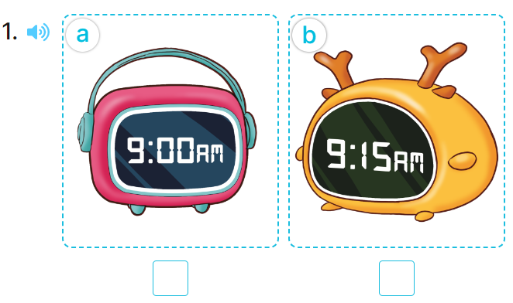  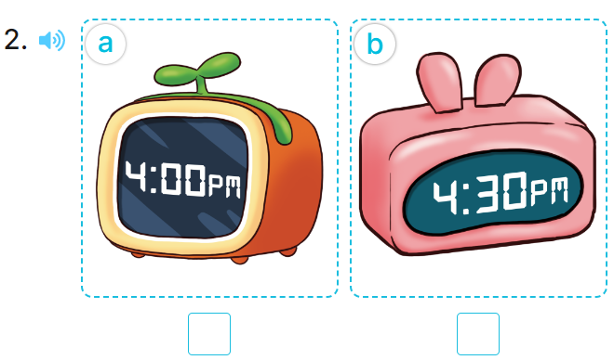  - T ask Ss to guess the answers.  + T writes Ss’guessing on the board.  - Listen to the tape:  + Play the recording  + Play the recording again and get Ss to swap books with their partners.  + Play the recording again to check answers together as a class.  - Play the recording, sentence by sentence, for the class to listen and repeat in chorus.  Key: 1.b 2.b  Activity 2. Look, complete and read.  *Aims: Ss will be able to complete four gapped exchanges with the help of picture cues.  *Procedure:  - Get Ss to look at the pictures and identify the time on the four clocks.  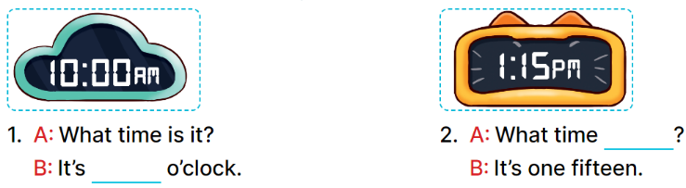  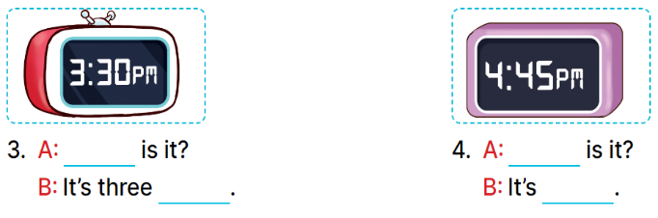  - Ask pupils to look at each gapped exchange. Draw their attention to the missing words and time.  - Have pupils look at Picture 1. Ask them what is missing in the answer (ten).  + Then have them complete the gap (It’s ten o’clock.).  + Repeat the same procedure with Pictures 2, 3 and 4.  - Set a time limit for pupils to complete the gapped exchanges individually  - Invite a few pairs to stand up to ask and tell the time on the clock faces.  Key:  1. ten 2. is it  3. What time; thirty  4. What time; four forty-five  Activity 3. Let’s play.  *Aims: Ss will be able to review telling the time by playing the game Which clock says ...?  *Procedure:  - Divide class into 2 groups  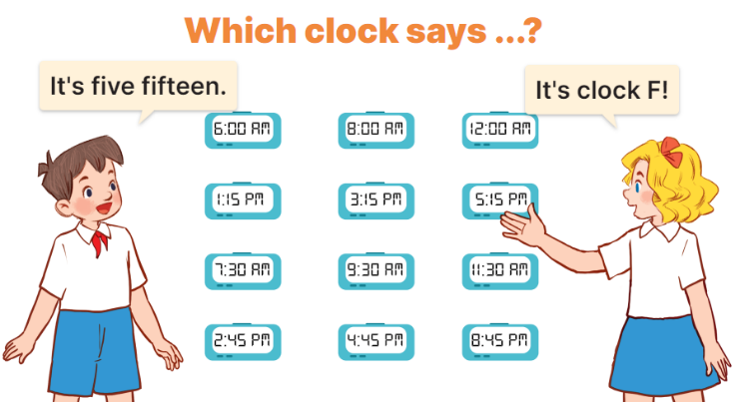  - Tell pupils that they are going to play a game that involves finding and saying which clock shows the time told by another player.  - Invite two volunteers to stand in front of the board.  +Tell them to decide who is the time teller and who is the clock finder.  - The time teller will tell a certain time.  - When the game is over, the player who has the most points is the winner.  *Consolidation  *Aims: Ss will be able consolidate and wrap up the content of the lesson.  *Procedure:  - T asks ss to answer the following questions:  + What have you learnt from the lesson today?  +What are the core values of the lesson? (if the teacher can take from the lesson).  - T praises some Ss who are hardworking / active/ good…. as well as encourage others to try more.  - Ask and answer about the pictures in part 5.  - Prepare the new lesson: Unit 2, Lesson 2 (1,2,3). | - Ss listen  -Ss sing and dance  - Ss open their books  -Look at the pictures and say:  + Picture 1a: a clock showing 9:00 AM + Picture 1b: a clock showing 9:15 AM + Picture 2a: a clock showing 4:00 PM + Picture 2b: a clock showing 4:30 PM  -Ss guess the answers  - Ss listen to the tape and tick  - Ss listen again, tick and swap books with their partners.  - Ss check their answers and guessing  -Ss listen and repeat.  -Ss look at the picture and say  -Ss listen and answer  -Ss answer: It’s ten o’clock.  -Ss look and complete  .  -Ss complete the sentence  -Ss ask and tell the time on the clock faces.  - Ss look and listen.  -Ss play game  Example: 5:15, for the other player to find the clock which shows the correct time by saying its letter.  + If it is correct, the correct finder will get one point.  +Every player has eight times to try. +After the first round, the time teller will become the clock finder.  +All the clocks on the board are kept for later use  -Ss listen to the teacher  -Ss answer the questions  -Ss listen and clap their hands  -Ss listen and take note
D. ADJUSTMENTS (if necessary):
………………………………………………………………………………………….…..……………………………………………………………………………...………………………………………….…..……………………………………………………………………………….……………………………………………………………………...

