Week 3 Preparing date: September 15 ^{th}, 2023
Period 10 Teaching date: September24 ^{th} , 2023

Unit 1: Hello
Lesson 3 (4,5,6)
A. OBJECTIVES:
By the end of the lesson, Ss will be able to:
1. Knowledge:
- correctly pronounce the sounds of the letters a and ia in isolation, in the words
America and Australia, and in the sentences I’m from America. and She’s from
Australia.
- use the words America, Australia, Britain, Japan, Malaysia, Singapore,
Thailand, and Viet Nam in relation to the topic “My friends”.
- use Where are you from? – I’m from ……….. and Where’s he / she from?
– He’s / She’s from …………. to ask and answer questions about where someone
comes from
- read and write about where someone comes from.
- Vocabulary: Review
- Skills: speaking, listening, reading and writing.
2. Competences:
- Critical Thinking: self-introduce
- Co-operation: ready to help friends in pair work/ group work.
- Self-control and independent learning: perform listening tasks.
3. Attitude/ Qualities:
- Kindness: Help partners to complete learning tasks.
- Honesty: tell the truth about feelings and emotions.
- Diligence: complete learning tasks.
B. TEACHING AIDS:
- Teacher: Teacher’s guide Pages 25, 26; website hoclieu.vn, posters, laptop, pictures, textbook, lesson plan, TV or projector.
- Students: Pupil’s book Page 15, notebooks, workbooks, school things.
C. PROCEDURES:
Stages&Time | Teacher’s activities | Students’ activities
1.Warm- up: (5’)  2.Presentation: (7’)  3.Practice: (10’)  4. Production(10’)  5. Homework. (3’) | Game: “ Backward spelling”  *Aims: to review the vocabulary and structure about greet and respond to greetings.  *Procedure:  - T divides class into teams.  - Each team takes turns to have a pupil stand in front of the board.  - The rest spell the word written by the teacher on the board backwards.  - The team that guesses the word first gets 1 point. The team with the most points is the winner.  Ex: N-A-P-A-J JAPAN  M-A-N-T-E-I-V VIETNAM  E-R-O-P-A-G-N-I-S SINGAPORE  - Say “Open your book page 15” and look at “Unit 1, Lesson 3 (4,5,6)”.  Activity 1. Read and tick True or False:  *Aims: Ss will be able to read and show understanding the sentences by deciding if the  statements are true or false  *Procedure:  - Tell pupils the goal of the activity and explain that they should read the sentences and tick True or False.  - Model the first sentence. First, have pupils read the sentence and identify Minh’s age.  -Then have them read the text and find the correct information to tick the appropriate  box  - Set a time limit for pupils to do the task independently.  - Get pupils to swap their books with a partner and check their answers before checking as a class.  - Correct the answers where necessary.  - Invite one or two pupils to read the text and the sentences in front of the class.  -T gives feedbacks.  Key: 1. True 2. True 3. False 4. False  Activity 2. Let’s write  *Aims: Ss will be able to complete a gapped text about themselves and their friends  *Procedure:  - Tell and explain the class the goal of the activity.  - Explain that the gaps in the text focus on  their names and age(s), their friends’ names and where they are from  - Have pupils do the first gapped sentence together as an example.  - Give pupils time to complete the text independently.  - Get pupils to swap their books with a partner and check their answers before checking as a class.  - Invite one or two pupils to read their completed texts in front of the class.  Key:  1. Pupil’s answer  Activity 3. Project.  *Aims: Ss will be able to make pupil cards at home and present them to the class by using the target language  *Procedure:  - Stick the pupil card sample on the board and model with the name, age and country.  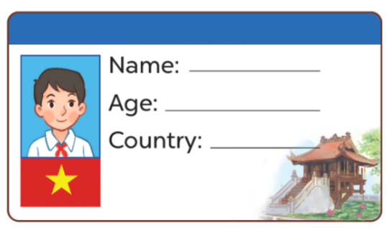  - T asks Ss to make their name cards and present them to their class.  - T asks ss to work in groups of five and do the project in class.  - Invite a few pupils to show their cards and tell the class about them.  - T gives feedback.  *Consolidation  *Aims: Ss will be able consolidate and wrap up the content of the lesson.  *Procedure:  - T asks ss to answer the following questions:  + What have you learnt from the lesson today?  +What are the core values of the lesson? (if the teacher can take from the lesson).  - T praises some Ss who are hardworking / active/ good…. as well as encourage others to try more.  - Read again the text.  - Prepare the new lesson: Unit 2, Lesson 1 (1,2,3). | - Ss listen and answer  - Ss listen to the rules  -Ss play game  - Ss open their books  - Ss look at the sentences and listen  -Ss read and circle  -Ss read the text and tick  -Ss read again and tick  -Ss swap books and check  -Ss check the correct their answers  -Ss read the text in front of the class  -Ss listen  -Ss listen and pay attention  -Ss look, listen and pay attention  -Ss write their names in the gap.  -Ss complete the text  -Ss swap books and check their answers  -Ss read the completed texts in font of the class  - Ss look and listen  -Ss prepare necessary school things to carry out the project (paper, pens, pencils, coloured pencils, scissors , glue,…..)  -Ss make their name cards and present them to their class.  -Ss work in groups  -Ss present their cards  Ex: Hi. My name’s Huong. I’m from Viet Nam. This is Jenny. She’s nine years old. She’s from England. And this is Kate. He’s ten years old. He’s from Australia.  -Ss answer the questions  -Ss listen and clap their hands  -Ss listen and take note
D. ADJUSTMENTS (if necessary):
………………………………………………………………………………………….…..……………………………………………………………………………...…………

