Week 1 Preparing date: September 6 ^{th}, 2024
Period 3 Teaching date: September 13 ^{th}, 2024

STARTER
B. Classroom activities
A. OBJECTIVES:
By the end of the lesson, Ss will be able to revise some competences learnt in Grade 3:
1. Knowledge:
- greeting, introducing themselves and introducing each other.
- talking about activities in the classroom.
- talking about outdoor activities.
- Vocabulary: Review
- Skills: speaking and listening
2. Competences:
- Critical thinking: read the clasroom activities.
- Oral communication: practice speaking
- Co-operation: ready to help friends in pair work/ group work.
3. Attitude/ Qualities:
- Kindness: Help partners to complete learning tasks.
- Leadership: collaborate with teachers to enhance language skills.
B. TEACHING AIDS:
- Teacher: Teacher’s guide Page 12,13, audio Track 3,4,5, website hoclieu.vn, posters, laptop, pictures, textbook, lesson plan, TV or projector.
- Students: Pupil’s book Page 8, notebooks, workbooks, school things.
C. PROCEDURES:
Stages & Time | Teacher’s activities | Students’ activities
1.Warm- up: (3’)  2. Presentation  (15’)  3. Practice (10’)  4.Consolidation  (5’)  4. Homework. (2’) | Sing a song: Stand up sit down  *Aims: to create a friendly and active atmosphere in the class to beginning the lesson.  *Procedure:  - Show the song on the screen.  https://www.youtube.com/watch?v=DiXMZJi_2NU  - Ask pupils to listen, sing and dance the song.  - Say “Open your book page 8” and look at “Starter, Classroom activites”.  Activity 1. Let’s chant:  *Aims: Ss will be able to say the chant with the correct rhythm and pronunciation  *Procedure:  - Have pupils read the chant and elicit its meaning. Check comprehension.  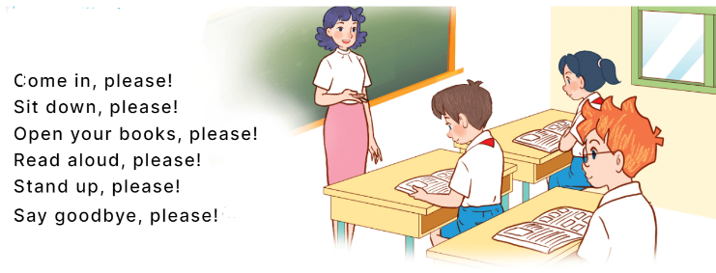  - Play the recording for pupils to listen to and repeat the chant, line by line.  - Draw their attention to the rhythm and pronunciation.  - Play the recording all the way through for pupils to chant and clap.  - Invite a few groups of pupils to listen to and repeat the chant in front of the class.  - Praise them to encourage their performance.  Activity 2: Listen and number  *Aims: Ss will be able to listen to and understand four sentences describing what the characters are doing in the classroom at break time and number the correct pictures.  *Procedure:  - Draw pupils’ attention to the pictures and ask and answer the questions:  +Who are they?  +What are they doing?  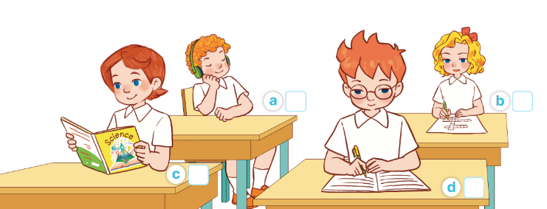  - Play the recording all the way through for pupils to listen and familiarise themslves with the speaker’s voice.  - Play the recording again for pupils to listen and number the pictures.  - Get pupils to swap books with a partner to check their answers before checking as a class.  - Check the correct answer and give feedback.  - Play the recording, sentence by sentence, for pupils to listen and repeat in chorus.  Key: 1.a 2.c 3.d 4.b  Activity 3. Listen and act out  *Aims: Ss will be able to listen and understand a chant with seven sentences describing what the characters usually do in the classroom, and act out the chant.  *Procedure:  - Draw pupils’ attention to the picture and answer the question:  +Who are they?  + What are they doing?  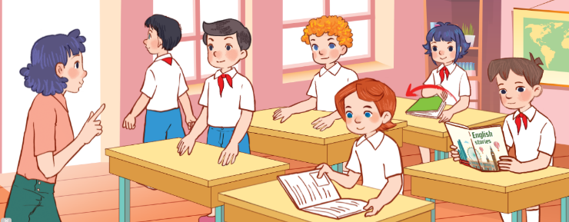  - Play the recording all the way through for pupils to listen and familiarise themselves with the speaker’s voice.  - Play the recording again for pupils to listen and point at the pictures  - Give pupils listen to the recording, line by line, and act out.  - Invite a group to listen and act out in front of the class.  - Play the recording, line by line, for pupils to listen and repeat in chorus.  *Aims: Ss will be able consolidate and wrap up the content of the lesson.  *Procedure:  - T asks ss to answer the following questions:  + What have you learnt from the lesson today?  - T review the classroom activites.  - Learn the classroom activites.  - Prepare the new lesson: C.Outdoor activites | - Sing and dance the song in chorus.  - Ss listen and open their books.  -Look at the chant and read.  -Ss listen and repeat.  -Ss listen and pay attention  -Ss listen and repeat  -Ss sing and perform the chant in front of the class  - Ss listen.  -Look at the pictures and answer  -Ss listen to the tape  - Ss listen again and write the number  -Ss swap books with the partner and check.  -Ss check the answer together.  - Ss listen and repeat, sentence by sentence.  -Ss listen and answer  -Ss listen and pay attention  -Ss listen again and point at the pictures  -Ss listen again and act out.  -Ss listen and act out in front of the class  -Ss listen and repeat.  -Ss answer the questions  - Ss listen  -Ss listen
D. ADJUSTMENTS (if necessary):
………………………………………………………………………………………….…..……………………………………………………………………………...……………

