Week 17 Preparing date: 26/12/2024
Period 67 Teaching date: 3/1/2025

Unit 10: Our summer holidays
Lesson 3 (4, 5, 6)
A. OBJECTIVES:
By the end of the lesson, Ss will be able to:
1. Knowledge:
- read and write about if someone was somewhere and where someone was in the past.
- make a mind map of where pupils were on holiday in the previous summer and present the results to the class at Project time.
- Vocabulary: Review
- Skills: speaking, listening, reading and writing.
2. Competences:
- Critical thinking: complete a task in reading a text.
- Co-operation: ready to help friends in pair work/ group work.
- Self-control and independent learning: perform listening tasks.
3. Attitude/ Qualities:
- Show pride in the travelling experience in their summer holidays.
B. TEACHING AIDS:
- Teacher: Teacher’s guide Pages 149, 150; website hoclieu.vn, posters, laptop, pictures, textbook, lesson plan, TV or projector.
- Students: Pupil’s book Page 73, notebooks, workbooks, school things.
C. PROCEDURES:
Teacher’s activities | Students’ activities
1.Warm- up: (5’)  Game: “Chant”  *Aims: to review the vocabulary and structure about greet and respond to greetings.  *Procedure:  - Ask Ss chant and do the actions in Unit 10, Lesson 3 page 66 in groups.  - Give point for the groups and encourage them.  - Say “Open your book page 73” and look at “Unit 10, Lesson 3 (4, 5, 6)”.  2.Practice: (8’)  Activity 1. Read and complete:  *Aims: Ss will be able to read two texts and complete the sentences about Mai’s and Tony’s summer holiday.  *Procedure:  - Elicit Sentence 1 about the location, Sentence 2 about the description of Ha Long Bay, Sentence 3 about the people in London, and Sentence 4 about Mai’s and Tony’s feelings of their summer holidays.  - Have pupils read the texts to find the information and complete four sentences.  - Have pupils work in pairs and do the task  - Get pupils to swap their answers with a partner.  - Check answers together as a class.  Key: 1. Ha Long Bay. 2. beautiful.  3. helpful 4. great.  3.Production: (19’)  Activity 2. Let’s write  *Aims: Ss will be able to read and complete a gapped paragraph about where someone was on holiday in the previous summer *Procedure:  - Check comprehension and elicit to Ss read the gapped text and fill in the gaps.  - Let Ss read the gapped text and fill in the gaps.  - Have Ss complete the first gap together as an example: I am Huong.  - Ask Ss to look at the gap and ask them what is missing. Then let them identify the the name. After that, let them write down the suitable word in the gap.  - Give Ss time to complete the text independently.  - In pairs or groups, ask Ss to swap their complete texts before checking as a class.  - Invite some Ss to come to the board and read the answer.  Key: Pupils’ answer  Example: I am Huong. Last summer, I was on holiday in London with my family. The city was busy. The food was good. The people were friendly. My holiday was great!  Activity 3. Project.  *Aims: Ss will be able to make a mind map of where pupils were on holiday in the previous summer, and use the notes to make a presentation to the class  *Procedure:  - Explain that they have to look at the notes in their mind maps and present the results to the class.  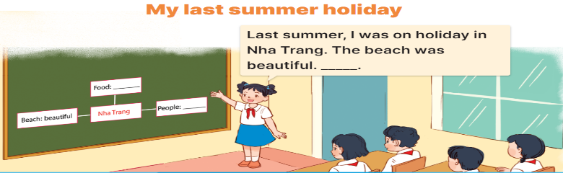  - Have pupils work in groups of five.  + Each pupil looks at the notes in his / her mind map and tells the group about where he / she was on holiday in the previous summer, and describe the place.  - Invite a few pupils to look at the notes in their mind maps and tell the class about them, ex: Last summer, I was on holiday in Nha Trang. The beach was beautiful ...  - Have the rest of the class give comments and praise pupils if they perform well.  *Consolidation  *Aims: Ss will be able consolidate and wrap up the content of the lesson.  *Procedure:  - T asks ss to answer the following questions:  + What have you learnt from the lesson today?  +What are the core values of the lesson? (if the teacher can take from the lesson).  - T praises some Ss who are hardworking / active/ good…. as well as encourage others to try more.  4. Homework. (3’)  - Prepare the new lesson: Review 2 (1, 2). | - Ss listen and chant  - Ss open their books  -Ss read  -Ss read the text and complete  -Ss work in pairs and complete  -Ss swap their answers  -Ss check their answer  -Ss pay attention and read  -Ss read the gapped text  -Ss complete the first gap  -Ss answer and write  - Ss complete the text independently.  -Ss swap the book and check together  -Ss read the answer  - Ss listen and answer  -Ss work in groups and tell about their holiday.  -Ss look at the notes in their mind maps and tall the class.  -Ss clap their hands or congratulation.  -Ss answer the questions  -Ss listen and clap their hands  -Ss listen and take note
D. ADJUSTMENTS (if necessary):
………………………………………………………………………………………….…..……………………………………………………………………………...…………

