Week 17 Preparing date:24/12/2024
Period 66 Teaching date: 31/12/ 2024

Unit 10: Our summer holidays
Lesson 3 (1, 2, 3)
A. OBJECTIVES:
By the end of the lesson, Ss will be able to:
1. Knowledge:
- correctly repeat the sounds of the letter ere in isolation, in the words were and where, and in the sentences Were you on the beach last summer? and Where were you last weekend? with correct pronunciation and intonation.
- identify the target words were and where while listening.
- listen to and demonstrate understanding of simple communicative contexts in relation to the topic “Our summer holidays”
- say the chant with the correct rhythm and pronunciation.
- Vocabulary: Review
- Skills: speaking, listening, reading and writing.
2. Competences:
- Co-operation: ready to help friends in pair work/ group work.
- Sociability: Talk to each other, say good words to others.
3. Attitude/ Qualities:
- Kindness: Help partners to complete learning tasks.
- Honesty: tell the truth about feelings and emotions
B. TEACHING AIDS:
- Teacher: Teacher’s guide Pages 147, 148; audio Tracks 104, 105, 106; website hoclieu.vn, posters, laptop, pictures, textbook, lesson plan, TV or projector.
- Students: Pupil’s book Page 72, notebooks, workbooks, school things.
C. PROCEDURES:
Teacher’s activities | Students’ activities
1.Warm- up: (5’)  Sing a song: If you’re happy and you know it  *Aims: to create a friendly and active atmosphere in the class to beginning the lesson.  *Procedure:  - Show the song in the screen  https://www.youtube.com/watch?v=zyMWcWqmhRc  - Have pupils to sing and dance together  - Say “Open your book page 72” and look at “Unit 10, Lesson 3 (1,2,3)”.  2. Presentation (9’)  Activity 1. Listen and repeat:  *Aims: Ss will be able to correctly repeat the sounds of the letter ere in isolation, in the words were and where, and in the sentences Were you on the beach last summer? and Where were you last weekend? with correct pronunciation and intonation.  *Procedure:  - T gives instruction to the letter ere, the words were and where, and in the sentences Were you on the beach last summer? and Where were you last weekend?  - Play the recording for the letter ere.  - Encourage Ss to point at the letter/ word/ sentence while listening.  - Play the recording again and encourage Ss to listen and repeat.  - Do this several times until Ss feel confident.  - T calls some Ss to practice.  - T gives feedbacks.  3.Practice: (19’)  Activity 2. Listen and circle.  *Aims: Ss will be able to identify the target words were and where while listening.  *Procedure:  - Explain that they have to listen to the recording and circle the correct options.  - Play the recording for pupils to listen.  - Play the recording again for them to listen and circle the correct options.  - Tell pupils to swap books with a partner, then check the answers together as a class. - Write the correct answers on the board.  - Play the recording again for pupils to double-check their answers.  - Invite one or two pupils to stand up, listen to and repeat the sentences.  Key: 1.b 2.c  Activity 3. Let’s chant  *Aims: Ss will be able to say the chant with the correct rhythm and pronunciation  *Procedure:  - Introduce the title and lyrics of the chant.  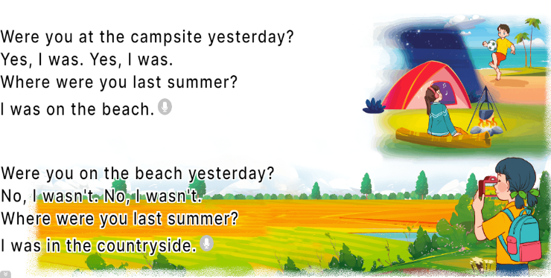  - Play the recording for Ss to listen to the whole chant.  + Have them repeat the title and lyrics line by line.  + Ask Ss to attend to the sounds of the letters ere and the words were and where.  - Play the recording all the way through for Ss to listen to pronunciation and melody.  - Play the recording line by line for Ss to listen and repeat  - Play the recording for Ss to chant and clap along.  - Ask Ss to practice chant and clap along in pairs or groups.  - Invite groups to the front of the classroom to perform the chant  -T gives feedback.  *Consolidation  *Aims: Ss will be able consolidate and wrap up the content of the lesson.  *Procedure:  - T asks ss to answer the following questions:  + What have you learnt from the lesson today?  +What are the core values of the lesson? (if the teacher can take from the lesson).  - T praises some Ss who are hardworking / active/ good…. as well as encourage others to try more.  4. Homework. (2’)  - Practice the chant more.  - Prepare the new lesson: Unit 10, Lesson 3 (4, 5, 6). | - Ss listen  -Ss sing and dance  - Ss open their books  - Ss recognize the differences about color of letter  - - Ss listen  - Ss listen and point  - Ss listen again and repeat  -Ss listen again and repeat  -Ss practice  -Ss listen  -Ss listen and pay attention  -Ss listen to the tape  - Ss listen to the tape and circle  - Ss listen again, circle and swap books with their partners.  - Ss write the correct answer  - Ss check their answers  -Ss listen and repeat.  - Ss look and listen.  -Ss listen to the chant  - Ss listen and repeat line by line without clap their hands  -Ss note the sounds, words  -Ss listen to melody of the chant  - Ss listen and chant line by line.  - Ss chant and clap along.  - Ss work in groups (two groups) to chant  -Ss perform in front of the class.  -Ss listen  -Ss answer the questions  -Ss listen and clap their hands  -Ss listen and take note

D. ADJUSTMENTS (if necessary):
………………………………………………………………………………………….…..……………………………………………………………………………...……………

