Week 15 Preparing date:10/12/2024
Period 58 Teaching date: 17/12/ 2024

Unit 9: Our sports day
Lesson 2 (1, 2, 3)
A. OBJECTIVES:
By the end of the lesson, Ss will be able to:
1. Knowledge:
- use the words and phrase December, July, June, November, October, September, sports day in relation to the topic "Our sports day".
- use When's your sports day? – It's in ……... to ask and answer questions about when a sport day is;
- listen to and demonstrate understanding of simple exchanges in relation to the topic "Our sports day"
- Vocabulary: December, November, October, September
- Skills: speaking and listening
2. Competences:
- Self-control and independent learning: perform listening tasks.
- Communication and collaboration: work in pairs or groups.
3. Attitude/ Qualities:
- Develop their interests in sports and show their responsibility by raising awareness of time and date.
B. TEACHING AIDS:
- Teacher: Teacher’s guide Pages 130, 131, audio Tracks 91, 92, website hoclieu.vn, posters, laptop, pictures, textbook, lesson plan, TV or projector.
- Students: Pupil’s book Page 64, notebooks, workbooks, school things.
C. PROCEDURES:
Stages&Time | Teacher’s activities | Students’ activities
1.Warm- up: (5’)  2. Presentation (16’)  3.Practice: (7’)  4.Production: (7’)  5. Homework. (2’) | Lucky number  *Aims: to create a friendly and active atmosphere in the class to beginning the lesson.  *Procedure:  - Divide the class into 2 teams (boys and girls).  - Each team takes turns to choose a number.  - They need to ask and answer with the picture corresponding to that number to get points.  - The group with more points at the end of the game will be the winner.  - Praise the winner, encourage the other team.  - Say “Open your book page 64” and look at “Unit 9, Lesson 2 (1, 2, 3)”.  Activity 1. Vocabulary.  *Aims: Ss will be able to know the vocabulary in the new lesson.  *Procedure:  -T elicits the new words  + September : tháng 9 (situation)  + October : tháng 10 (translation)  + November: tháng 11 (situation)  + December: tháng 12 (translation)  - T models (3 times).  - T writes the words on the board.  - Checking: Rub out and remember  Activity 2. Look, listen and repeat:  *Aims: Ss will be able to understand and correctly repeat the sentences in two communicative contexts focusing on asking and answering questions about when a sports day is.  *Procedure:  - Have Ss look at Pictures a and b and identify the characters (Minh and Lucy) in the pictures.  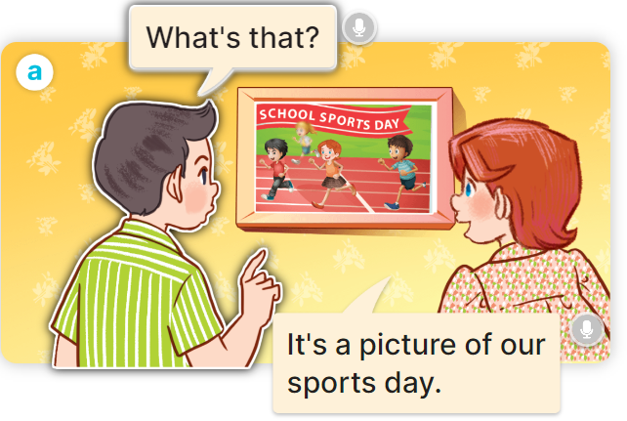  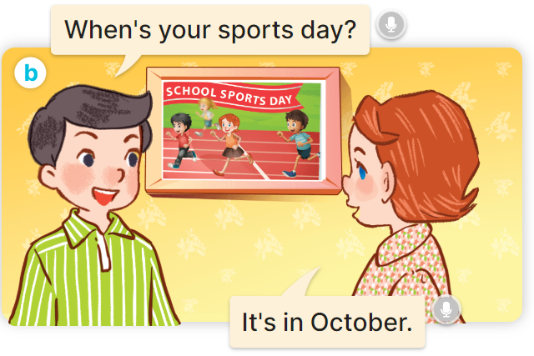  - Play the audio twice (sentence by sentence). Correct their pronunciation where necessary.  - Have Ss to practice the dialogue  - T invites a few pairs to the front of the class to practice.  - T checks pronunciation for ss.  Activity 3 Listen, point and say.  *Aims: Ss will be able to correctly say the words and use When's your sports day? – It's in……… to ask and answer questions about when a sports day is.  *Procedure:  * Model sentences:  - T asks Ss look at picture b and helps Ss know the structure from the dialogue.  - T introduces new structure for Ss.  - T explains, models and gives meaning.  - Have Ss repeat the model sentences.  A:When's your sports day? B:It's in Ocotber.  *Drill pictures  - Have pupils look at the pictures and elicit the name of each month.      - Run through all the pictures.  - Run through model sentences.  +Run through question sentence  +Run through answer sentence  - Have Ss to practise:  + T asks, Ss answer picture a  + Ss asks, T answers picture b  + Group A ask, group B answer picture c  + Group B ask, group A answer picture d  - Ask Ss to work in pairs.  - T controls and corrects.  - Invite a few pupils to stand up, point at each school thing in the picture and say the sentence aloud.  - T gives feedbacks  Activity 4. Let’s talk.  *Aims: Ss will be able to enhance the correct use of When's your sports day? – It's in ……. to ask and answer questions about when a sports day is in a freer context.  *Procedure:  - Have Ss look at the picture and elicit the question and the answer in context.    - Elicit the missing words in the second speech bubble and write them on the board.  - Get pupils to say the completed sentences.  - Have pupils look at the bubbles to understand how the sentence pattern is used.  - Have pupils role-play to practise asking the questions and giving their answers in pairs, using picture cues.  - Invite a few pupils to stand up, point at each month in the picture and say the sentence aloud.  *Consolidation  *Aims: Ss will be able consolidate and wrap up the content of the lesson.  *Procedure:  - T asks ss to answer the following questions:  + What have you learnt from the lesson today?  +What are the core values of the lesson? (if the teacher can take from the lesson).  - T review the vocabulary and model sentences.  - T praises some Ss who are hardworking / active/ good…. as well as encourage others to try more.  - Learn the vocabulary and model sentences by heart  - Prepare the new lesson: Unit 9, Lesson 2 (4,5,6). | - Ss listen  -Ss play game  -Ss clap the hands  -Ss open their books  -Ss listen and answer  - - Ss listen and repeat  + Choral repetition (3 times).  + Individual repetition (3 ss)  - Ss take note  - Ss look, remember and write  -Look at the pictures and say  + In picture a:  Nam: What’s that?  Lucy: It’s a picture of our sports day.  + In picture b:  Nam: When's your sports day?  Lucy: It's in October.  -Ss listen and repeat in chorus (twice)  -Ss work in pairs to practice  -Ss practice the dialogue  -Ss listen  -Ss look at the picture and answer.  -Ss listen  -Ss listen and repeat  -Ss repeat  - Ss look, listen and answer  + Picture a. a calendar showing September  + Picture b. a calendar showing October  + Picture c. a calendar showing November  + Picture d. a calendar showing December  -Ss listen and repeat  -Ss practice in chorus, individuals.  -Ss practice in chorus, individuals.  -Ss work in pairs  -Ss listen to the teacher  -Ss point and say  -Ss listen.  -Ss look at the picture and answer  + a school sports day and the months of the year.  -Ss pay attention  -Ss say the completed sentences  -Ss pay attention  -Ss work in pairs, point and ask and answer using When’s your sports day?  -Ss ask and answer in front of the class  -Ss answer the questions  - Ss listen  -Ss listen and clap their hands  -Ss listen and take note
D. ADJUSTMENTS (if necessary):
………………………………………………………………………………………….…..……………………………………………………………………………...………………………………………….…..…………………………………………………………

