Week 14 Preparing date:3/12/2024
Period 54 Teaching date:10/12/ 2024

Unit 8: My favourite subjects
Lesson 3 (1, 2, 3)
A. OBJECTIVES:
By the end of the lesson, Ss will be able to:
1. Knowledge:
- correctly pronounce the sounds of the letters ke and te in isolation, in the words like and write, and in the sentences I like English. and Let's write.
– use the words and phrases art, music, PE, IT, an English teacher, a maths teacher, a painter and a singer in relation to the topic “My favourite subjects”
– use Why do you like …….? – Because I want to be …….. to ask for and give reasons for liking a school subject
– listen to and demonstrate understanding of simple communicative contexts in relation to the topic “My favourite subjects”
- Vocabulary: Review
- Skills: speaking, listening, reading and writing.
2. Competences:
- Co-operation: ready to help friends in pair work/ group work.
- Sociability: Talk to each other, say good words to others.
3. Attitude/ Qualities:
- Kindness: Help partners to complete learning tasks.
- Honesty: tell the truth about feelings and emotions
B. TEACHING AIDS:
- Teacher: Teacher’s guide Pages 121,122; audio Tracks 84, 85, 86; website hoclieu.vn, posters, laptop, pictures, textbook, lesson plan, TV or projector.
- Students: Pupil’s book Page 60, notebooks, workbooks, school things.
C. PROCEDURES:
Stages&Time | Teacher’s activities | Students’ activities
1.Warm- up: (5’)  2.Presentation (10’)  3.Practice: (10’)  4.Production (7’)  4. Homework. (3’) | Game: Find and circle the words  *Aims: to create a friendly and active atmosphere in the class to beginning the lesson.  *Procedure:  L I K E E W S C M T  H C T H N R H C A H  C L U A A I A O K I  L E L N N T T S E N  A A W K E E O E E K  A C D E G H O S V B  F A V O U R I T E H  B I K E I A S D A Y  D T S S R S N O T E  A C E B F E Z Y W  - Divide class into 2 groups  - Ask Ss to find and circle the words that they learnt.  - Which groups find the best correct words is winner.  - Give Ss time to play the game.  Rows: like, bike, note, favourite  Columns: write, make  -T checks who’s winner?  - Say “Open your book page 60” and look at “Unit 8, Lesson 3 (1,2,3)”.  Activity 1. Listen and repeat:  *Aims: Ss will be able to correctly repeat the sounds of the letter cluster ke and letter te in isolation, in the words like and write, and in the sentences I like English. and Let’s write with correct pronunciation and intonation.  *Procedure:  - T gives instruction to the letter ke and te, like and write, and in the sentences I like English. and Let’s write.  - Play the recording for the letter ke, te.  - Encourage Ss to point at the letter/ word/ sentence while listening.  - Play the recording again and encourage Ss to listen and repeat.  - Do this several times until Ss feel confident.  - T calls some Ss to practice.  - T gives feedbacks.  Activity 2. Listen and circle.  *Aims: Ss will be able to identify the target words like and write while listening.  *Procedure:  - Elicit the sentences and the gap-fill options.  - T ask Ss to guess the answers.  + T writes Ss’guessing on the board.  - Listen to the tape:  + Play the recording  + Play the recording again and get Ss to swap books with their partners.  + Play the recording again to check answers together as a class.  + Write the answers on the board for Ss to correct their answers. Then checks Ss’ guessing.  - Play the recording, sentence by sentence, for the class to listen and repeat in chorus.  - Invite one or two Ss to stand up and read the completed sentences.  Key: 1.a 2.b  Activity 3. Let’s chant  *Aims: Ss will be able to say the chant with the correct rhythm and pronunciation  *Procedure:  - Introduce the title and lyrics of the chant.  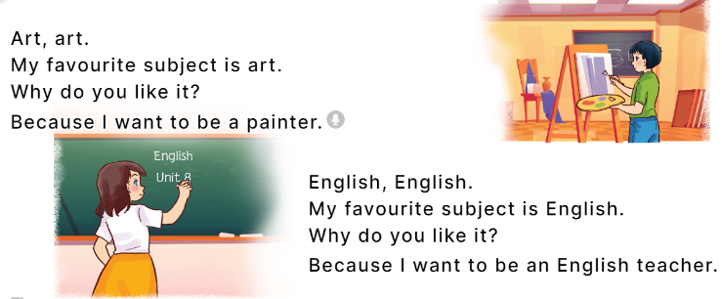  - Play the recording for Ss to listen to the whole chant.  + Have them repeat the title and lyrics line by line.  + Ask Ss to attend to the sounds of the letters ke and te and the words like and write.  - Play the recording all the way through for Ss to listen to pronunciation and melody.  - Play the recording line by line for Ss to listen and repeat  - Play the recording for Ss to chant and clap along.  - Ask Ss to practice chant and clap along in pairs or groups.  - Invite groups to the front of the classroom to perform the chant  -T gives feedback.  *Consolidation  *Aims: Ss will be able consolidate and wrap up the content of the lesson.  *Procedure:  - T asks ss to answer the following questions:  + What have you learnt from the lesson today?  +What are the core values of the lesson? (if the teacher can take from the lesson).  - T praises some Ss who are hardworking / active/ good…. as well as encourage others to try more.  - Practice the chant more.  - Collect three school things  - Prepare the new lesson: Unit 8, Lesson 3 (4, 5, 6). | - Ss listen  -Ss play game  - Ss open their books  - Ss recognize the differences about color of letter  - - Ss listen  - Ss listen and point  - Ss listen again and repeat  -Ss listen again and repeat  -Ss practice  -Ss listen  -Ss listen and say  -Ss guess the answers  - Ss listen to the tape and circle  - Ss listen again, circle and swap books with their partners.  - Ss check their answers and guessing  -Ss listen and repeat.  -Ss read the sentences  - Ss look and listen.  -Ss listen to the chant  - Ss listen and repeat line by line without clap their hands  -Ss note the sounds, words  -Ss listen to melody of the chant  - Ss listen and chant line by line.  - Ss chant and clap along.  - Ss work in groups (two groups) to chant  -Ss perform in front of the class.  -Ss listen  -Ss listen.  -Ss answer the questions  -Ss listen and clap their hands  -Ss listen and take note

D. ADJUSTMENTS (if necessary):
………………………………………………………………………………………….…..……………………………………………………………………………...………………………………………….…..……………………………………………………………………………….……………………………………………………………………...

