Week 6 Preparing date: October 10 ^{th} , 2023
Period 23 Teaching date: October 12 ^{th} , 2023

Unit 4: My birthday party
Lesson 1 (1, 2, 3)
A. OBJECTIVES:
By the end of the lesson, Ss will be able to:
1. Knowledge:
- understand and correctly repeat the sentences in two communicative contexts focusing on asking and answering questions about birthdays.
- correctly say the words and use When’s your birthday? – It’s in …... to ask and answer questions about someone’s birthday.
- enhance the correct use of When’s your birthday? – It’s in ……... to ask and answer questions about someone’s birthday in a freer context.
- Vocabulary: January, February, March, April, May, June, birthday.
- Skills: speaking and listening
2. Competences:
- Co-operation: ready to help friends in pair work/ group work.
- Sociability: Talk to each other, say good words to others.
3. Attitude/ Qualities:
- Kindness: Help partners to complete learning tasks.
- Honesty: tell the truth about feelings and emotions
B. TEACHING AIDS:
- Teacher: Teacher’s guide Pages 55,56,57 audio Tracks 36,37; website hoclieu.vn, posters, laptop, pictures, textbook, lesson plan, TV or projector.
- Students: Pupil’s book Page 28, notebooks, workbooks, school things.
C. PROCEDURES:
Stages & Time | Teacher’s activities | Students’ activities
1.Warm- up: (3’)  2. Presentation (16’)  3.Practice: (7’)  4.Production: (7’)  5. Homework. (2’) | Sing: Happy birthday to you  *Aims: to create a friendly and active atmosphere in the class to beginning the lesson  *Procedure:  - Show the song on the screen.  https://www.youtube.com/watch?v=90w2RegGf9w  - Ask pupils to listen, sing and dance the song.  - Say “Open your book page 28” and look at “Unit 4, Lesson 1 (1,2,3)”.  Activity 1. Vocabulary.  *Aims: Ss will be able to know the vocabulary in the new lesson.  *Procedure:  -T elicits the new words  + January :tháng 1 (siuation)  + February :tháng 2 (situation)  + March :tháng 3 (translation)  + April :tháng 4 (translation)  + May :tháng 5 (situation)  + June :tháng 6 (translation)  +birthday : ngày sinh, sinh nhật (picture)  - T models (3 times).  - T writes the words on the board.  - Checking: Rub out and remember  Activity 2. 1. Look, listen and repeat:  *Aims: Ss will be able to understand and correctly repeat the sentences in two communicative contexts focusing on asking and answering questions about birthdays  *Procedure:  - Have Ss look at Pictures a and b and identify the characters in the pictures.  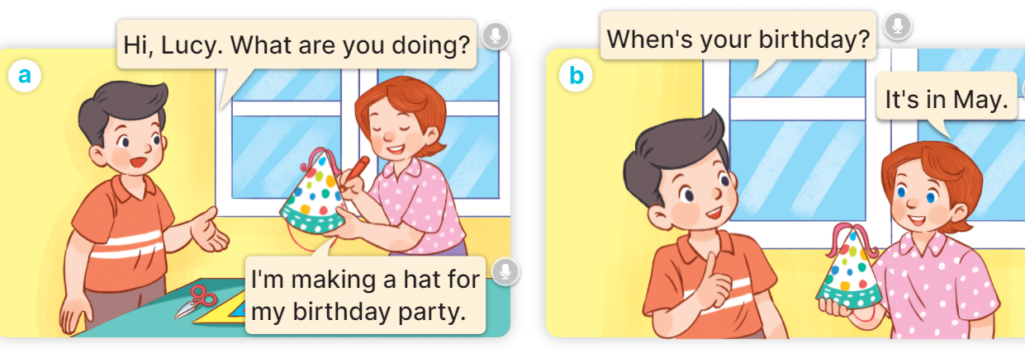  - Play the audio twice (sentence by sentence). Correct their pronunciation where necessary.  - Have Ss to practice the dialogue  - T invites a few pairs to the front of the class to practice.  - T checks pronunciation for ss.  Activity 3 2. Listen, point and say.  *Aims: Ss will be able to correctly say the words and use When’s your birthday? – It’s in …… to ask and answer questions about someone’s birthday.  *Procedure:  * Model sentences:  - T asks Ss look at picture b and helps Ss know the structure from the dialogue.  - T introduces new structure for Ss.  - T explains, models and gives meaning.  -Have Ss repeat the model sentences.  A: When’s your birthday?  B: It’s in May.  *Drill pictures  - Have pupils look at the pictures and elicit the names of the months.      - Run through all the pictures.  - Run through model sentences.  - Have Ss to practise:  + T asks the first picture, Ss answer  + Ss asks the second picture, T answers  + Group A asks the third picture, group B answers  + Group B asks the last picture, group A answers.  - Ask Ss to work in pairs.  - T controls and corrects.  - Invite a few pairs to come to the front of the classroom, point at the pictures, and say the questions and answers in front of the class.  - T gives feedbacks.  Activity 4. Let’s talk.  *Aims: Ss will be able to enhance the correct use of When’s your birthday? – It’s in …….. to ask and answer questions about someone’s birthday in a freer context.  *Procedure:  - Have pupils say the names of the months in the picture.  + When’s your birthday? – It’s in ……..  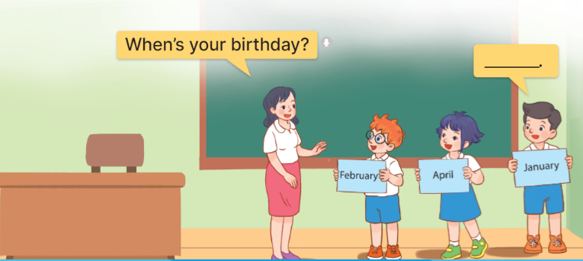  - Elicit the missing words in the speech bubble and write them on the board.  - Have pupils look at the bubbles to understand how the sentence pattern is used. - Have pupils role-play to practise asking the questions and giving their answers in pairs, using picture cues.  - Make sure pupils understand the structure and say them with the right pronunciation and intonation.  - Invite some pupils to practise asking and answering questions in front of the class.  *Consolidation  *Aims: Ss will be able consolidate and wrap up the content of the lesson.  *Procedure:  - T asks ss to answer the following questions:  + What have you learnt from the lesson today?  +What are the core values of the lesson? (if the teacher can take from the lesson).  - T review the vocabulary and model sentences.  - T praises some Ss who are hardworking / active/ good…. as well as encourage others to try more.  - Learn the vocabulary and model sentences by heart  - Prepare the new lesson: Unit 4, Lesson 1 (4,5,6). | - Ss sing and dance the song  - Ss open their books  -Ss listen and answer  - - Ss listen and repeat  + Choral repetition (3 times).  + Individual repetition (3 ss)  - Ss take note  - Ss look, remember and match  -Look at the pictures and get to know the characters in the pictures.  + In picture a:  Nam: Hi, Lucy. What are you doing?  Lucy: I’m making a hat for my birthday party.  + In picture b:  Nam: When’s your birthday?  Lucy: It’s in May.  -Ss listen and repeat in chorus (twice)  -Ss work in pairs to practice  -Ss practice the dialogue  -Ss listen  -Ss look at the picture and answer.  -Ss listen  -Ss listen and repeat  -Ss repeat to parts of the body.  - Ss look, listen and answer  +Picture a: a calendar showing January.  + Picture b: a calendar showing February.  + Picture c: a calendar showing March.  + Picture d: a calendar showing April.  -Ss listen and repeat  -Ss practice in chorus  -Ss practice in chorus  -Ss work in pairs to practice  -Ss listen  -Ss point and say the questions  -Ss listen.  -Ss look at the bubbles and picture and answer  + It’s in ……..  -Ss listen and pay attention  - Ss answer  -Ss work in pairs, ask and answer  -SS ask and answerwith the right pronunciation and intonation.  -Ss perform in front of the class.  -Ss answer the questions  - Ss listen  -Ss listen and clap their hands  -Ss listen and take note

D. ADJUSTMENTS (if necessary):
………………………………………………………………………………………….…..……………………………………………………………………………...………………………………………….…..……………………………………………………………………………….……………………………………………………………………...

