Week 6 Preparing date: October 5 ^{th} , 2023
Period 22 Teaching date: October 10 ^{th} , 2023

Unit 3: My week
Lesson 3 (4, 5, 6)
A. OBJECTIVES:
By the end of the lesson, Ss will be able to:
1. Knowledge:
- read and show understanding of a text and complete a table about Nam’s week.
- complete a paragraph about what pupils do on certain days of the week by writing the target words in the gaps.
- draw two pictures about weekend activities at home and present them to the class by using the target language.
- Vocabulary: Review
- Skills: speaking, listening, reading and writing.
2. Competences:
- Co-operation: ready to help friends in pair work/ group work.
- Self-control and independent learning: perform listening tasks.
3. Attitude/ Qualities:
- Kindness: Help partners to complete learning tasks.
- Honesty: tell the truth about feelings and emotions.
- Diligence: complete learning tasks.
B. TEACHING AIDS:
- Teacher: Teacher’s guide Pages 53,54, website hoclieu.vn, posters, laptop, pictures, textbook, lesson plan, TV or projector.
- Students: Pupil’s book Page 27, notebooks, workbooks, school things.
C. PROCEDURES:
Stages & Time | Teacher’s activities | Students’ activities
1.Warm- up: (5’)  2.Presentation:  (8’)  - Practice: (10’)  4.Production  (9’)  5. Homework. (3’) | Game: “Chant”  *Aims: to create a friendly and active atmosphere in the class to beginning the lesson.  *Procedure:  - Ask Ss chant and do the actions in Unit 3, Lesson 3 page 26 in groups.  - Give point for the groups and encourage them.  - Say “Open your book page 27” and look at “Unit 3, Lesson 3 (4,5,6)”.  Activity 1. Read and complete:  *Aims: Ss will be able to read and show understanding of a text and complete a table about Nam’s week.  *Procedure:  - Draw pupils’ attention to the words provided in the table and the four gaps about Nam’s activities on some days of the week.  - Ask pupils to read the text and complete the table with the missing words.  - Set a time limit for pupils to read the text again and look for specific information to fill in the gaps in the table.  - Tell pupils to swap their answers with a partner.  - Check answers together as a class.  - Write the answers on the board.  - T gives feedbacks.  Key: 1. Go to school 2. go to school  3. do housework 4. Watch TV  Activity 2. Let’s write  *Aims: Ss will be able to complete a paragraph about what pupils do on certain days of the week by writing the target words in the gaps.  *Procedure:  - Ask pupils to read the gapped text and fill in the gaps with their own information.  - Tell pupils that the gaps in the text should focus on their activities and the days on which they do the activities.  - Have pupils do the first gapped sentence together as an example.  - Ask them to read the sentence and elicit the names and write their names in the gap.  - Give pupils time to complete the text independently.  - Get pupils to swap their books with a partner and check their answers before checking as a class.  - Invite a few pupils to read their completed texts in front of the class  Key: 1. Is  2. This is my  3. That’s my teacher  Activity 3. Project.  *Aims: Ss will be able to draw two pictures about weekend activities at home and present them to the class by using the target language.  *Procedure:  - Ask Ss to draw two pictures about weekend activities at home.  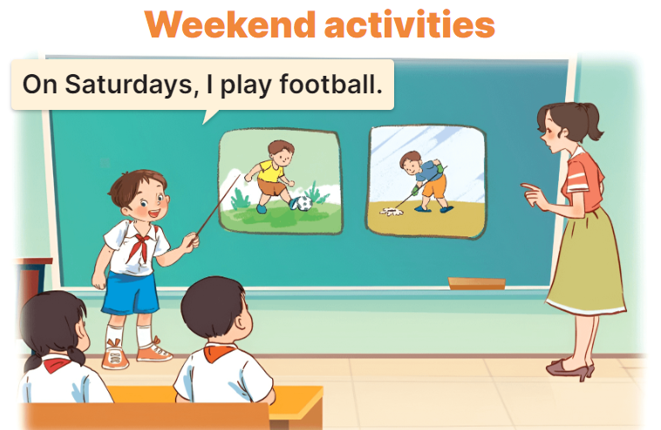  - Tell pupils the goal of the activity.  - Have pupils work in groups of five or six.  -Each pupil looks at his / her notes and tell the group about what he / she does on Saturdays and Sundays.  - Invite a few pupils to look at the notes in their tables and tell the class about them.  - T gives feedback.  *Consolidation  *Aims: Ss will be able consolidate and wrap up the content of the lesson.  *Procedure:  - T asks ss to answer the following questions:  + What have you learnt from the lesson today?  +What are the core values of the lesson? (if the teacher can take from the lesson).  - T praises some Ss who are hardworking / active/ good…. as well as encourage others to try more.  - Prepare the new lesson: Unit 4, Lesson 1 (1,2,3). | - Ss listen and chant  - Ss open their books  - Ss pay attention the text and the table  -Ss read and complete  -Ss read again and fill in the gaps  -Ss swap books and check  -Ss check the correct their answers  -Ss write the answers on the board  -Ss listen  -Ss read the gapped text and fill in the gaps  Ex: I am Huong. I go to school on Mondays, Tuesdays, Wednesdays, Thursday and Fridays. I do housework on Satursdays. On Sundays I play football and listen to music. What do you do at the weekend?  -Ss write the answer  -Ss swap books and check their answer  -Ss read the sentences  - Ss drew and coloured draw two pictures at home.  -Ss listen to the teacher  -Ss work in groups and say  -Ss present their pictures  Ex: Hello, everyone. My name’s Huong. I study at Nghia Lam Primary School. I’m in class 4D. Today, I would like to talk about My weekend: On Saturdays, I play footballwith my friends. On Sundays, I do housework and watch TV.  -Ss answer the questions  -Ss listen and clap their hands  -Ss listen and take note
D. ADJUSTMENTS (if necessary):
………………………………………………………………………………………….…..……………………………………………………………………………...…………

