Week 16 Preparing date: 18/12/ 2024
Period 64 Teaching date: 27/12/2024

Unit 10: Our summer holiday
Lesson 2 (1, 2, 3)
A. OBJECTIVES:
By the end of the lesson, Ss will be able to:
1. Knowledge:
- use the phrases Bangkok, London, Sydney and Tokyo in relation to the topic “Our summer holidays”
- use Where were you last summer? – I was in …. to ask and answer questions about where
- someone was in the past; listen to and demonstrate understanding of simple communicative contexts in relation to the topic “Our summer holidays”.
- Vocabulary: Bangkok, London, Sydney, Tokyo
- Skills: speaking and listening
2. Competences:
- Self-control and independent learning: perform listening tasks.
- Communication and collaboration: work in pairs or groups.
- Sociability: talk to each other, say good words to others.
3. Attitude/ Qualities:
- Kindness: Help partners to complete learning tasks.
- Honesty: tell the truth about feelings and emotions
B. TEACHING AIDS:
- Teacher: Teacher’s guide Pages 142, 143, 144; audio Tracks 101, 102, website hoclieu.vn, posters, laptop, pictures, textbook, lesson plan, TV or projector.
- Students: Pupil’s book Page 70, notebooks, workbooks, school things.
C. PROCEDURES:
Stages&Time | Teacher’s activities | Students’ activities
- Warm- up: (5’)  2. Presentation (16’)  3.Practice: (7’)  4.Production: (7’)  5. Homework. (2’) | Game: Play Game (ppt)  *Aims: to create a friendly and active atmosphere in the class to beginning the lesson.  *Procedure:  - Divide the class into 3 teams.  - Pupils from each team take turns choose a letter and answer a question  - Pupils answer correctly get some points  - Say “Open your book page 70” and look at “Unit 10, Lesson 2 (1, 2, 3)”.  Activity 1. Vocabulary.  *Aims: Ss will be able to know the vocabulary in the new lesson.  *Procedure:  -T elicits the new words  + Bangkok : Băng Cốc (thủ đô nước Thái Lan) (translation)  + Sydney : Xít-ni (thành phố nước úc)  (translation)  + London :Luân Đôn (thủ đô nước Anh)  (translation)  + Tokyo : To-ky-o (thủ đô nước Nhật Bản)  (translation)  - T models (3 times).  - T writes the words on the board.  - Checking: Rub out and remember  Activity 2. Look, listen and repeat:  *Aims: Ss will be able to understand and correctly repeat the sentences in two communicative contexts focusing on asking and answering questions about where someone was in the past.  *Procedure:  - Have Ss look at Pictures a and b and identify the characters, places and activities..  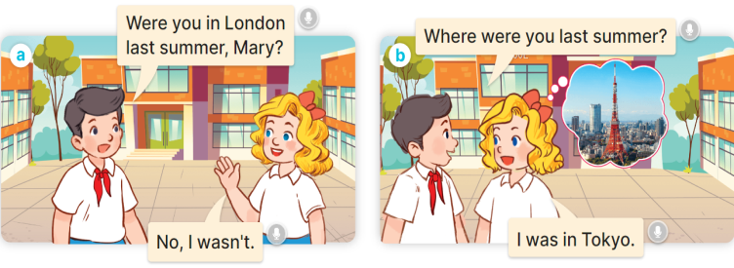  - Play the audio twice (sentence by sentence). Correct their pronunciation where necessary.  - Have Ss to practice the dialogue  - T invites a few pairs to the front of the class to practice.  - T checks pronunciation for ss.  Activity 3 Listen, point and say.  *Aims: Ss will be able to correctly say the words and use Where were you last summer? – I was in….. to ask and answer questions about where someone was in the past.  *Procedure:  * Model sentences:  - T asks Ss look at picture b and helps Ss know the structure from the dialogue.  - T introduces new structure for Ss.  - T explains, models and gives meaning.  - Have Ss repeat the model sentences.  A Where were you last summer  B: I was in Tokyo  *Drill pictures  - Have pupils look at the pictures and elicit the places in the pictures.  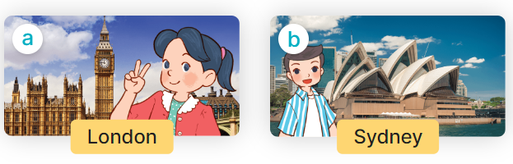    - Run through all the pictures.  - Run through model sentences.  +Run through question sentence  +Run through answer sentence  - Have Ss to practise:  + T asks, Ss answer picture a  + Ss asks, T answers picture b  + Group A ask, group B answer picture c  + Group B ask, group A answer picture d  - Ask Ss to work in pairs.  - T controls and corrects.  - Invite a few pupils to stand up, point at each school thing in the picture and say the sentence aloud.  - T gives feedbacks  Activity 4. Let’s talk.  *Aims: Ss will be able to enhance the correct use of Where were you last summer? – I was in…... to ask and answer questions about where someone was in the past in a freer context.  *Procedure:  - Have Ss look at the picture and elicit the question and the answer in context.  + Who are they?  + Where are they?  + How many places are there?    - Have Ss look at the picture and say the break time activites.  - Have Ss look at the first speech bubble and read Where were you last summer?  - Have Ss point the activities, ask and answer the questions about break time activities  - Give Ss time to practise asking and answering the question Where were you last summer? – I was……. in pairs.  - Invite a few pairs to practise asking and answering questions about break time activites in front of the class.  *Consolidation  *Aims: Ss will be able consolidate and wrap up the content of the lesson.  *Procedure:  - T asks ss to answer the following questions:  + What have you learnt from the lesson today?  +What are the core values of the lesson? (if the teacher can take from the lesson).  - T review the vocabulary and model sentences.  - T praises some Ss who are hardworking / active/ good…. as well as encourage others to try more.  - Learn the vocabulary and model sentences by heart  - Prepare the new lesson: Unit 10, Lesson 2 (4,5,6). | - Ss listen  -Ss play game  -Ss open their books  -Ss listen and answer  - - Ss listen and repeat  + Choral repetition (3 times).  + Individual repetition (3 ss)  - Ss take note  - Ss look, remember and write  -Look at the pictures and say  + In picture a:  Nam: Were you in London last summer, Mary?  Mary: No, I wasn’t.  + In picture b:  Nam: Where were you last summer?  Mary: I was in Tokyo.  -Ss listen and repeat in chorus (twice)  -Ss work in pairs to practice  -Ss practice the dialogue  -Ss listen  -Ss look at the picture and answer.  -Ss listen  -Ss listen and repeat  -Ss repeat  - Ss look, listen and answer  + Picture a: Mai standing by Big Ben  + Picture b: Nam standing by Opera House  + Picture c: Mary standing by Tokyo Tower  + Picture d: Bill standing by Temple of the Golden Buddha  -Ss listen and repeat  -Ss practice in chorus, individuals.  -Ss practice in chorus, individuals.  -Ss work in pairs  - Ss listen to the teacher  -Ss point and say  -Ss listen.  -Ss look at the picture and answer  + a picture of Temple of the Golden Buddha; a picture of Tokyo Tower; a picture of Big Ben; a picture of Opera House  -Ss point and say  -Ss read the sentence  -Ss point, ask and answer  -Ss ask and answer  -Ss work in pairs, point and ask and answer  -Ss answer the questions  - Ss listen  -Ss listen and clap their hands  -Ss listen and take note
D. ADJUSTMENTS (if necessary):
………………………………………………………………………………………….…..……………………………………………………………………………...………………………………………….…..……………………………………………………………………………….……………………………………………………………………...

