Week: 5 Preparing date: 09/10/2024
Period: 20 Teaching date: 11/10/2024

Unit 3: My week
Lesson 2 (4, 5, 6)
A. OBJECTIVES:
By the end of the lesson, Ss will be able to:
1. Knowledge:
- - listen to and understand four communicative contexts about days of the week and what someone does on certain days of the week and number the correct pictures.
- complete four gapped exchanges with the help of picture cues.
- sing the song My week with the correct pronunciation, rhythm and melody.
- Vocabulary: Review
- Skills: speaking, listening, reading and writing.
Students integrate: Complete 2 sentences (5/25); Sing 2 sentences (6/25)
2. Competences:
- Co-operation: ready to help friends in pair work/ group work.
- Self-control and independent learning: perform listening tasks.
3. Attitude/ Qualities:
- Kindness: Help partners to complete learning tasks.
- Honesty: tell the truth about feelings and emotions.
- Diligence: complete learning tasks.
B. TEACHING AIDS:
- Teacher: Teacher’s guide Pages 49, 50,51; audio Tracks 31, 32; website hoclieu.vn, posters, laptop, pictures, textbook, lesson plan, TV or projector.
- Students: Pupil’s book Page 25, notebooks, workbooks, school things.
C. PROCEDURES:
Teacher’s activities | Students’ activities
1.Warm- up: (5’)  Play a game: Guess the pictures  *Aims: to create a friendly and active atmosphere in the class to beginning the lesson.  *Procedure:  - The first Ss has to take the last four or three letters of that word and form a new word.  - The second Ss does the same, and the chain continues until a Ss is unable to form a word.  - The Ss who fails to form a word or misspells it is out of the game.  -T give feedback  - Say “Open your book page 25” and look at “Unit 3, Lesson 2 (4,5,6)”.  2.Practice: (27’)  Activity 1. Listen and number:  *Aims: Ss will be able to listen to and understand four communicative contexts about days of the week and what someone does on certain days of the week and number the correct pictures.  *Procedure:  - Elicit the activities and the days of the week.  - Point at the pictures respectively to explain the context.  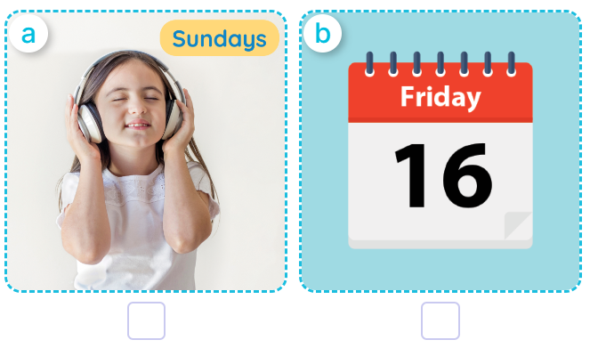  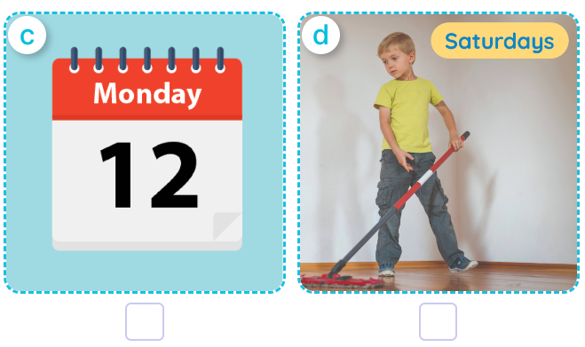  - T ask Ss to guess the answers.  + T writes Ss’guessing on the board.  - Listen to the tape:  + Play the recording  + Play the recording again and get Ss to swap books with their partners.  + Play the recording again to check answers together as a class.  + Write the answers on the board for Ss to correct their answers. Then checks Ss’ guessing.  - Play the recording, sentence by sentence, for the class to listen and repeat in chorus.  Key: 1. c 2. d 3. b 4. a  Activity 2. Look, complete and read  *Aims: Ss will be able to complete four gapped exchanges with the help of picture cues.  *Procedure:  - Have pupils look at the pictures and identify the days of the week and the activities in the pictures.  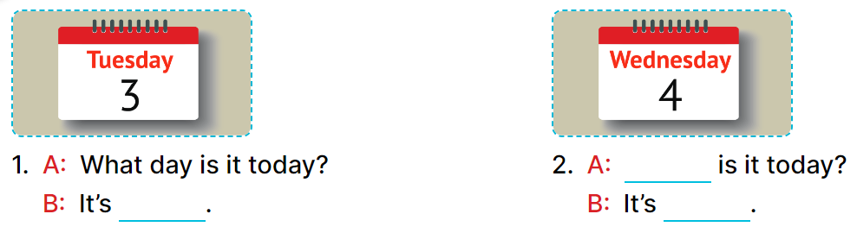  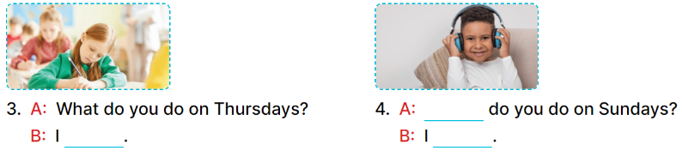  - Have Ss look at the four incomplete dialogue and elicits the missing words in the sentences.  - T models with picture 1  + Ask Ss what is missing in the sentence.  + Have Ss look at the picture and complete the gap, then read the completed sentence in chorus.  -Have Ss work in groups and complete the picture 2, 3 and 4.  - Ask a few Ss to stand up and read the completed sentences aloud.  -T gives feedbacks.  Key: 1. Tuesday  2. What day; Wednesday  3. study at school  4. What; listen to music  Activity 3. Let’s sing.  *Aims: Ss will be able sing the song What day is it today? with the correct pronunciation, rhythm and melody.  *Procedure:  - Draw pupils’ attention to the title and lyrics of the song.  - Encourage pupils to point at the characters’ activities to reinforce their understanding.  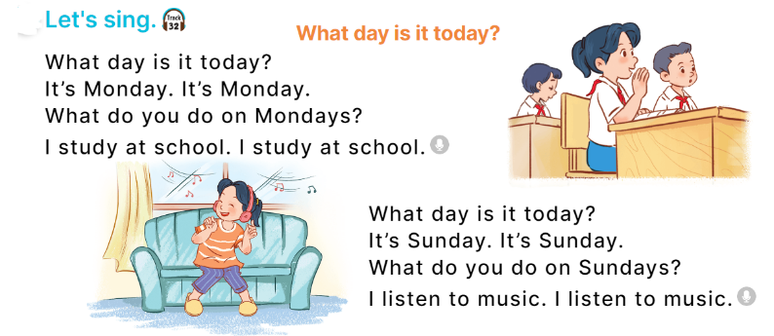  - Play the recording all the way through for pupils to listen to the whole song.  - Play the recording line by line for pupils to listen and repeat.  - Play the recording all the way through for pupils to sing along.  - Play the recording again for pupils to sing and clap along with the recording.  - Pupils can sing the song What day is it today? with the correct pronunciation, rhythm and melody.  *Consolidation  *Aims: Ss will be able consolidate and wrap up the content of the lesson.  *Procedure:  - T asks ss to answer the following questions:  + What have you learnt from the lesson today?  +What are the core values of the lesson? (if the teacher can take from the lesson).  - T praises some Ss who are hardworking / active/ good…. as well as encourage others to try more.  3. Homework. (3’)  - Practice part 5 again.  - Prepare the new lesson: Unit 3, Lesson 3 (1,2,3). | - Sing and dance the song in chorus.  - Ss open their books  -Look at the pictures and say:  a. a girl listening to music on Sundays  b. a calendar: Friday  c. a calendar: Monday  d. a boy doing housework on Saturdays  -Ss guess the answers  - Ss listen to the tape and write number  - Ss listen again, write number and swap books with their partners.  - Ss check their answers and guessing  -Ss listen and repeat.  Students integrate: Complete 2 sentences (5/25); Sing 2 sentences (6/25)  -Ss look and answer  -Ss answer: It’s Tuesday.  -Ss look, complete and read the completed sentence in chorus.  -Ss work in groups and complete the sentence  -Ss read aloud  - Ss listen  -Ss listen to the song  -Ss listen and repeat line by line  -Ss listen and sing along  -Ss sing and clap along  -Ss sing with the correct pronunciation, rhythm and melody.  -Ss answer the questions  - Ss listen  -Ss listen and clap their hands  -Ss listen

D. ADJUSTMENTS (if necessary):
………………………………………………………………………………………….…..……………………………………………………………………………...………………………………………….…..………………………………………………………….

