Week: 5 Preparing date: 09/10/2024
Period :19 Teaching date: 11/10/2024

Unit 3: My week
Lesson 2 (1, 2, 3)
A. OBJECTIVES:
By the end of the lesson, Ss will be able to:
1. Knowledge:
- understand and correctly repeat the sentences in two communicative contexts focusing on asking and answering questions about what someone does on certain days of the week.
- correctly say the phrases and use What do you do on ……? – I ……... to ask and answer questions about what someone does on certain days of the week.
- enhance the correct use of What do you do on ……? – ………. to ask and answer questions about what someone does on certain days of the week in a freer context.
- Vocabulary: study at school, do housework, listen to music, stay at home
- Skills: speaking and listening
Students integrate: Read the words: study at school, do housework, listen to music, stay at home
2. Competences:
- Co-operation: ready to help friends in pair work/ group work.
- Sociability: Talk to each other, say good words to others.
3. Attitude/ Qualities:
- Kindness: Help partners to complete learning tasks.
- Honesty: tell the truth about feelings and emotions
B. TEACHING AIDS:
- Teacher: Teacher’s guide Pages 47,48,49; audio Tracks 29,30, website hoclieu.vn, posters, laptop, pictures, textbook, lesson plan, TV or projector.
- Students: Pupil’s book Page 24, notebooks, workbooks, school things.
C. PROCEDURES:
Teacher’s activities | Students’ activities
1.Warm- up: (3’)  Game: Pass the ball  *Aims: to create a friendly and active atmosphere in the class to beginning the lesson.  *Procedure:  - T gives Ss a ball.  - T asks Ss to listen to music and transfer a ball around the class.  - When the music stops, Ss who keep a ball have to look at the picture and answer the question using: What day is it today? and It’s……..  - T gives feedback.  - Say “Open your book page 24” and look at “Unit 3, Lesson 2 (1,2,3)”.  2. Presentation (16’)  Activity 1. Vocabulary.  *Aims: Ss will be able to know the vocabulary in front of starting the new lesson.  *Procedure:  -T elicits the new words  + study at school : học ở trường (situation)  + do housework : làm việc nhà (situation)  + listen to music : nghe nhạc (mime)  + stay at home : ở nhà (translation)  - T models (3 times).  - T writes the words on the board.  - Checking: What and where  Activity 2. Look, listen and repeat:  *Aims: Ss will be able to understand and correctly repeat the sentences in two communicative contexts focusing on asking and answering questions about what someone does on certain days of the week. *Procedure:  - Have Ss look at Pictures a and b and identify the characters in the pictures.  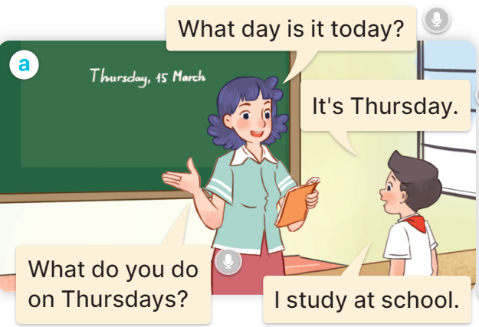  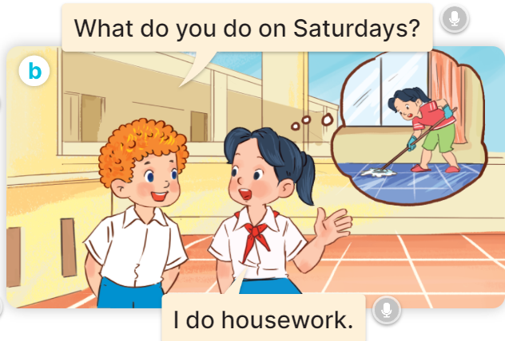  - Play the audio twice (sentence by sentence). Correct their pronunciation where necessary.  - Have Ss to practice the diaguage  - T invites a few pairs to the front of the class to practice.  - T checks pronunciation for ss.  Activity 3. Listen, point and say.  *Aims: Ss will be able to correctly say the phrases and use What do you do on …..? – I …….. to ask and answer questions about what someone does on certain days of the week  *Procedure:  * Model sentences:  - T asks Ss look at picture a, b and helps Ss know the structure from the dialogue.  - T introduces new structure for Ss.  - T explains, models and gives meaning.  - Have Ss repeat the model sentences.  A: What do you do on Mondays?  B: I study at school.  3.Practice: (7’)  *Drill pictures  - Have pupils look at the pictures and elicit the activities and the days of the week.    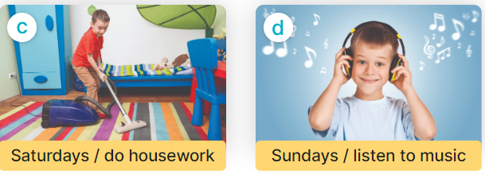  - Run through all the pictures.  - Run through model sentences.  + Run through the questions  + Run through the answers  - Have Ss to practise:  + T asks Ss answer (change role).  + Ss – Ss (change role).  - Ask Ss to work in pairs.  - T controls and corrects.  - Invite a few pairs to come to the front of the classroom, point at the relevant character in each picture, and act out his/her role.  - Invite Ss to go to the board and role play. Encourage Ss to practise speaking English.  - T gives feedbacks.  4.Production: (7’)  Activity 4. Let’s talk.  *Aims: Ss will be able to enhance the correct use of What do you do on …….? – ……. to ask and answer questions about what someone does on certain days of the week in a freer context.  *Procedure:  - Ask questions to help them identify the context.  + What can you see in the picture?  +Who are they?  +Where are they?  +What are they saying?    - T fills the gaps and writes the sentences on the board.  - T models  - T asks Ss use of What do you do on….? to ask, and answer (work in pairs)  - Invite some groups to perform.  - Give feedbacks  *Consolidation  *Aims: Ss will be able consolidate and wrap up the content of the lesson.  *Procedure:  - T asks ss to answer the following questions:  + What have you learnt from the lesson today?  +What are the core values of the lesson? (if the teacher can take from the lesson).  - T review the vocabulary and model sentences.  - T praises some Ss who are hardworking / active/ good…. as well as encourage others to try more.  5. Homework. (2’)  - Learn the vocabulary and model sentences by heart  - Prepare the new lesson: Unit 3, Lesson 2 (4,5,6). | - Ss listen  - Ss play the game  - Ss open their books  Students integrate: Read the words: study at school, do housework, listen to music, stay at home  -Ss listen and answer  - - Ss listen and repeat  + Choral repetition (3 times).  + Individual repetition (3 ss)  - Ss take note  - Ss look, remember and slap  -Look at the pictures and get to know the characters in the pictures.  + In picture a:  Ms Hoa: What day is it today?  Nam: It’s Thursday.  Ms Hoa: What do you do on Thursdays?  Nam: I study at school.  – In picture b:  Bill: What do you do on Saturdays?  Mai: I do housework.  -Ss listen and repeat in chorus (twice)  -Ss work in pairs to practice  -Ss practice the diaguage  -Ss listen  -Ss look at the picture and answer.  -Ss listen  -Ss listen and repeat  -Ss repeat to the introduce someone  -Ss listen and answer  - Ss look, listen and repeat  - Ss practice in chorus  Ex: Mondays/ study at school  A: What do you do on Mondays?  B: I study at school.  -Ss work in pairs to practice  -Ss listen  -Ss point and say  -Ss go to the board and role play.  -Ss listen  -Ss look at the picture and answer  + A boy asks a girl about what she does on Tuesdays, Fridays and Sundays (illustrated by the calendars and her activities)  -Ss note  - Ss say the completed sentences.  -Ss work in pairs  -Ss perform in front of the class.  -Ss listen  -Ss answer the questions  - Ss listen  -Ss listen and clap their hands  -Ss listen and take note

D. ADJUSTMENTS (if necessary):
………………………………………………………………………………………….…..……………………………………………………………………………...………………………………………….…..……………………………………………………………………………….……………………………………………………………………...

