Week; 5 Preparing date: 05/10/2024
Period: 18 Teaching date: 08/10/2024

Unit 3: My week
Lesson 1 (4, 5, 6)
A. OBJECTIVES:
By the end of the lesson, Ss will be able to:
1. Knowledge:
- listen to and understand two communicative contexts about the days of the week and tick the correct pictures.
- complete four gapped exchanges with the help of picture cues.
- revise target words about the days of the week by playing the game Slap the board.
- Vocabulary: Review
- Skills: speaking, listening, reading and writing.
Students integrate: Play the game: Slap the board.
2. Competences:
- Critical Thinking: self-introduce
- Co-operation: ready to help friends in pair work/ group work.
- Self-control and independent learning: perform listening tasks.
3. Attitude/ Qualities:
- Kindness: Help partners to complete learning tasks.
- Honesty: tell the truth about feelings and emotions.
- Communication and collaboration: work in pairs and groups to complete the learning tasks
B. TEACHING AIDS:
- Teacher: Teacher’s guide Pages 45,46,47; audio Tracks 29; website hoclieu.vn, posters, laptop, pictures, textbook, lesson plan, TV or projector.
- Students: Pupil’s book Page 23, notebooks, workbooks, school things.
C. PROCEDURES:
Teacher’s activities | Students’ activities
1.Warm- up: (5’)  Game: Lucky number  *Aims: to create a friendly and active atmosphere in the class to beginning the lesson.  *Procedure:  - Divide the class into 2 teams (boys and girls).  - Each team takes turns to choose a number.  - They need to ask and answer with the picture corresponding to that number to get points.  - The group with more points at the end of the game will be the winner.  - Praise the winner, encourage the other team.  - Say “Open your book page 23” and look at “Unit 3, Lesson 1 (4,5,6)”.  2.Practice: (27’)  Activity 1. Listen and tick:  *Aims: Ss will be able to listen to and understand two communicative contexts about the days of the week and tick the correct pictures.  *Procedure:  - Elicit the days of the week.  - Point at the pictures respectively to explain the context.  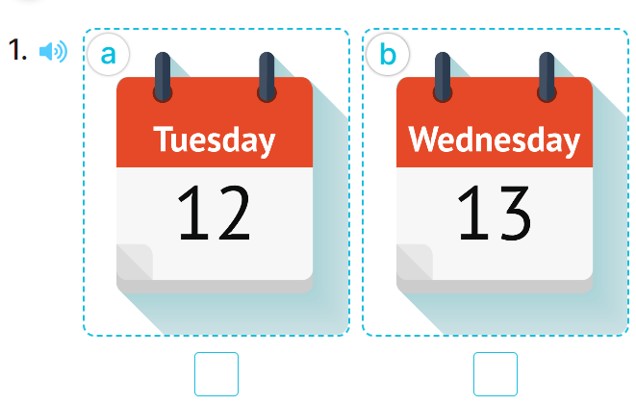  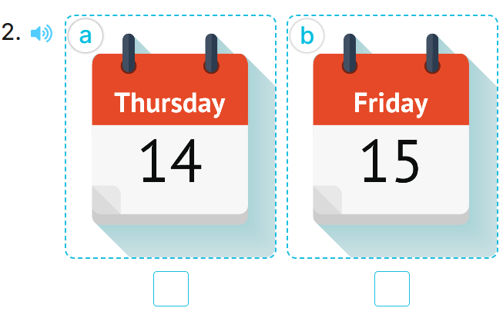  - T ask Ss to guess the answers.  + T writes Ss’guessing on the board.  - Listen to the tape:  + Play the recording  + Play the recording again and get Ss to swap books with their partners.  + Play the recording again to check answers together as a class.  + Write the answers on the board for Ss to correct their answers. Then checks Ss’ guessing.  - Play the recording, sentence by sentence, for the class to listen and repeat in chorus.  Key: 1.b 2.a  Activity 2. Look, complete and read.  *Aims: Ss will be able to complete four gapped exchanges with the help of picture cues.  *Procedure:  - Have pupils look at the pictures and identify the days of the week in the pictures. 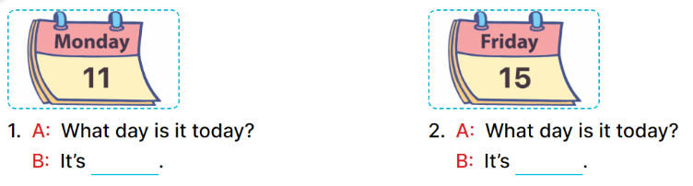  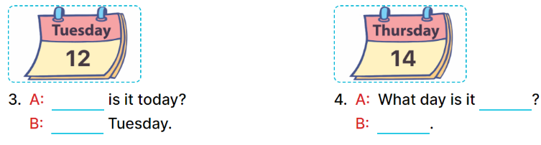  - Have Ss look at the two incomplete dialogue and elicits the missing words in the sentences.  - T models with picture 1  + Ask Ss what is missing in the sentence.  + Have Ss look at the picture and complete the gap, then read the completed sentence in chorus.  -Have Ss work in groups and complete the picture 2.  - Ask a few Ss to stand up and read the completed sentences aloud.  -T gives feedbacks.  Key:  - Monday 2. Friday  - 3. What day; It’s  - 4. today; It’s Thursday  Activity 3. Let’s play: Slap the board  *Aims: Ss will be able to revise target words about the days of the week by playing the game Slap the board. *Procedure:  - Tell pupils that they are going to listen to and slap the correct words as quickly as possible.  - Have them look at the days of the week on the board to recall the days of the week.  - Call two pupils to the front. Get them to stand at a certain distance from the board.  - Say a day of the week using It’s …….with one of the words on the board, for example, It’s Monday.  - The pupil who is the quickest to slap the right word (Monday) gets one point.  - The pupil who slaps the most words is the winner.  - Invite a few pairs to the front of the class to play the game.  - Praise pupils if they perform well.  *Consolidation  *Aims: Ss will be able consolidate and wrap up the content of the lesson.  *Procedure:  - T asks ss to answer the following questions:  + What have you learnt from the lesson today?  +What are the core values of the lesson? (if the teacher can take from the lesson).  - T praises some Ss who are hardworking / active/ good…. as well as encourage others to try more.  3. Homework. (3’)  - Practice part 5 again.  - Prepare the new lesson: Unit 3, Lesson 2 (1,2,3). | - Ss listen to the rule  - Ss play game  Ex: What day is it today?  It’s Tuesday.  -Ss listen  - Ss open their books  -Look at the pictures and say:  + Picture 1a: Tuesday  + Picture 1b: Wednesday  + Picture 2a: Thursday  + Picture 2b: Friday  -Ss guess the answers  - Ss listen to the tape and tick  - Ss listen again, tick and swap books with their partners.  -Ss listen again and check  - Ss check their answers and guessing  -Ss listen and repeat.  -Ss look at the picture and say:  -Ss look and answer  -Ss answer: Monday  -Ss look, complete and read the completed sentence in chorus.  -Ss work in groups and complete the sentences  -Ss read aloud  -Ss listen  Students integrate: Play the game: Slap the board.  - Ss look and listen.  - Ss listen  - Ss pay attention  -Ss play the game  -Ss listen and play games  -Ss listen  -Ss answer the questions  -Ss listen and clap their hands  -Ss listen and take note

D. ADJUSTMENTS (if necessary):
………………………………………………………………………………………….…..……………………………………………………………………………...………………………………………….…..……………………………………………………………………………….……………………………………………………………………...

