Week: 16 Preparing date: 22/12/2024
Period: 62 Teaching date:24 /12/2024

Unit 10: Our summer holiday
Lesson 1 (1, 2, 3)
A. OBJECTIVES:
By the end of the lesson, Ss will be able to:
1. Knowledge:
- use the phrases at the campsite, at the zoo, in the countryside, on the beach in relation to the topic “Our summer holidays”
- use Were you ………last weekend? – Yes, I was. / No, I wasn’t. to ask and answer questions about if someone was somewhere in the past
- listen to and demonstrate understanding of simple communicative contexts in relation to the topic “Our summer holidays”.
- Vocabulary: at the zoo, on the beach, at the campsite, in the countryside.
- Skills: speaking and listening
Students integrate: Read the words: at the zoo, on the beach, at the campsite, in the countryside.
2. Competences:
- Self-control and independent learning: perform listening tasks.
- Communication and collaboration: work in pairs or groups.
- Sociability: talk to each other, say good words to others.
3. Attitude/ Qualities:
- Kindness: Help partners to complete learning tasks.
- Honesty: tell the truth about feelings and emotions
B. TEACHING AIDS:
- Teacher: Teacher’s guide Pages 138,139,140;, audio Tracks 97, 98, website hoclieu.vn, posters, laptop, pictures, textbook, lesson plan, TV or projector.
- Students: Pupil’s book Page 68, notebooks, workbooks, school things.
C. PROCEDURES:
Teacher’s activities | Students’ activities
1.Warm- up: (3’)  Jigsaw puzzle  *Aims: to create a friendly and active atmosphere in the class to beginning the lesson.  *Procedure:  - Divide class into 4 groups: Tom, Jerry, Miu and Chit.  - Ask Ss look at the pieces of picture.  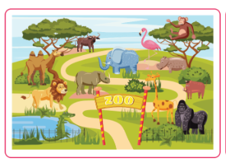  - Ask Ss go to the board and jigsaw puzzle into the correct picture.  -T checks who’s the winner?  - Say “Open your book page 68” and look at “Unit 10, Lesson 1 (1,2,3)”.  2. Presentation (16’)  Activity 1. Vocabulary.  *Aims: Ss will be able to know the vocabulary in the new lesson.  *Procedure:  -T elicits the new words  + at the zoo : ở sở thú (situation)  + on the beach : trên bãi biển (picture)  + at the campsite :ở điểm cắm trại (picture)  + in the countryside : ở miền quê (picture)  + yesterday : ngày hôm qua (translation)  - T models (3 times).  - T writes the words on the board.  - Checking: Rub out and remember  Activity 2. Look, listen and repeat:  *Aims: Ss will be able to understand and correctly repeat the sentences in two communicative contexts in which pupils ask and answer questions about if someone was somewhere in the past  *Procedure:  - Have Ss look at Pictures a and b and identify the characters (Bill and Mai) in the pictures.  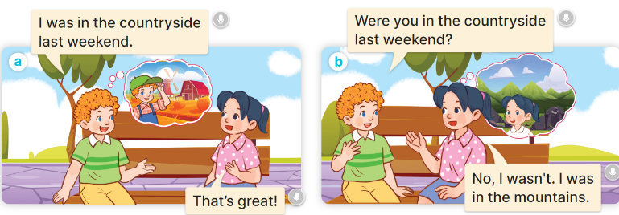  - Play the audio twice (sentence by sentence). Correct their pronunciation where necessary.  - Have Ss to practice the dialogue  - T invites a few pairs to the front of the class to practice.  - T checks pronunciation for ss.  Activity 3 Listen, point and say.  *Aims: Ss will be able to correctly say the words and phrases and use Were you ….. last weekend? – Yes, I was. / No, I wasn’t. to ask and answer questions about if someone was somewhere in the past.  *Procedure:  * Model sentences:  - T asks Ss look at picture b and helps Ss know the structure from the dialogue.  - T introduces new structure for Ss.  - T explains, models and gives meaning.  -Have Ss repeat the model sentences.  A: Were you in the countryside last weekend?  B: Yes, I was. / No, I wasn’t  3.Practice: (7’)  *Drill pictures  - Have pupils look at pictures a, b, c and d and identify the characters and the locations.  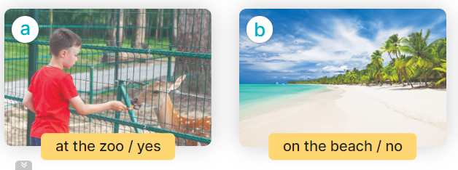  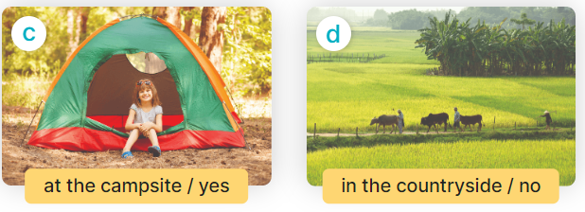  - Run through all the pictures.  - Run through model sentences.  +Run through question sentence  +Run through answer sentence  - Have Ss to practise:  + T asks, Ss answer picture a  + Ss asks, T answers picture b  + Group A ask, group B answer picture c  + Group B ask, group A answer picture d  - Ask Ss to work in pairs.  - T controls and corrects.  - Invite a few pupils to stand up, point at each school thing in the picture and say the sentence aloud.  - T gives feedbacks.  4.Production: (7’)  Activity 4. Let’s talk.  *Aims: Ss will be able to enhance the correct use of Were you ……..last weekend? – Yes, I was. / No, I wasn’t. to ask and answer questions about if someone was somewhere in the past in a freer context.  *Procedure:  - Ask questions to help them identify the places  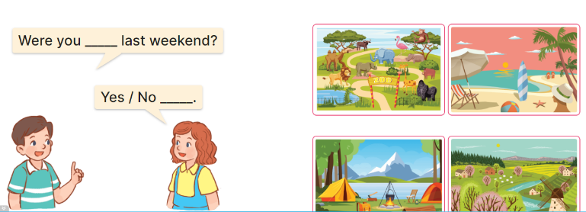  - Have Ss look at the picture and say the activities  - Have Ss look at the first speech bubble and read Were you at the zoo last weekend?  - Then have them point to the pupils at the campsite and complete the gapped answer in the second bubble (Ex: Yes, I was/ No, I wasn’t)  - After that, let them say aloud.  - Give Ss time to practise say the sentence Were you…last weekend?  - Invite some Ss to practise talking about school break time activities in front of the class.  *Consolidation  *Aims: Ss will be able consolidate and wrap up the content of the lesson.  *Procedure:  - T asks ss to answer the following questions:  + What have you learnt from the lesson today?  +What are the core values of the lesson? (if the teacher can take from the lesson).  - T review the vocabulary and model sentences.  - T praises some Ss who are hardworking / active/ good…. as well as encourage others to try more.  5. Homework. (2’)  - Learn the vocabulary and model sentences by heart  - Prepare the new lesson: Unit 10, Lesson 1 (4,5,6). | - Ss listen  -Ss look at the pieces of the picture  -Ss put into the correct picture  -Ss check  -Ss open their books  Students integrate: Read the words: at the zoo, on the beach, at the campsite, in the countryside.  -Ss listen and answer  - - Ss listen and repeat  + Choral repetition (3 times).  + Individual repetition (3 ss)  - Ss take note  - Ss look, remember and write  -Look at the pictures and say  + In picture a:  Bill: Were you in the mountains last weekend?  Mai: Yes, I was.  + In picture b:  Mai: Were you in the mountains last weekend, too?  Bill: No, I wasn’t. I was at the zoo.  -Ss listen and repeat in chorus (twice)  -Ss work in pairs to practice  -Ss practice the dialogue  -Ss listen  -Ss look at the picture and answer.  -Ss listen  -Ss listen and repeat  -Ss repeat  - Ss look, listen and answer  + Picture a: a boy at the zoo / yes  + Picture b: a boy on the beach / no  + Picture c: a girl at the campsite / yes + Picture d: a boy in the countryside / no  -Ss listen and repeat  -Ss practice in chorus, individuals.  -Ss practice in chorus, individuals.  -Ss work in pairs  -Ss point and say  -Ss listen.  -Ss look at the picture and answer  + at the campsite, on the beach, at the zoo, in the countryside  -Ss point and say  -Ss read the sentence  -Ss point and complete  -Ss say aloud  -Ss say the sentence  -Ss practice  -Ss answer the questions  - Ss listen  -Ss listen and clap their hands  -Ss listen and take note
D. ADJUSTMENTS (if necessary):
………………………………………………………………………………………….…..……………………………………………………………………………...………………………………………….…..……………………………………………………………………………….……………………………………………………………………...

