Week: 15 Preparing date:18/12/2024
Period: 59 Teaching date: 20/12/2024

Unit 9: Our sports day
Lesson 2 (4, 5, 6)
A. OBJECTIVES:
By the end of the lesson, Ss will be able to:
1. Knowledge:
- use When's your sports day? – It's in _____. to ask and answer questions about when a sport day is;
- listen to and demonstrate understanding of simple exchanges in relation to the topic "Our sports day".
- Vocabulary: Review
- Skills: speaking, listening, reading and writing.
Students integrate: Complete and read sentence 1 (5/65)
2. Competences:
- Co-operation: ready to help friends in pair work/ group work.
- Self-control and independent learning: perform listening tasks.
3. Attitude/ Qualities:
- Kindness: Help partners to complete learning tasks.
- Diligence: complete learning tasks.
B. TEACHING AIDS:
- Teacher: Teacher’s guide Pages 132,133; audio Tracks 93; website hoclieu.vn, posters, laptop, pictures, textbook, lesson plan, TV or projector.
- Students: Pupil’s book Page 65, notebooks, workbooks, school things.
C. PROCEDURES:
Teacher’s activities | Students’ activities
1.Warm- up: (5’)  Game: The football game  *Aims: to create a friendly and active atmosphere in the class to beginning the lesson.  *Procedure:  - Give each pair some Blue-Tak or something to stick the cards on the wall with.  - Ask pupils to randomly stick their cards all over the walls around the room.  - Then bring everyone into the middle of the room.  - Shout out "January" and everyone has to race over to a January card and touch it.  - Then “February” and so on (in the correct order) until you make it through all the months.  - Play another round, this time faster.  - Say “Open your book page 65” and look at “Unit 9, Lesson 2 (4,5,6)”.  2.Practice: (27’)  Activity 1. Listen and tick:  *Aims: Ss will be able to listen to and understand two communicative contexts in which pupils ask and answer questions about when a sports day is and tick the correct pictures.  *Procedure:  - Elicit the month in each picture.  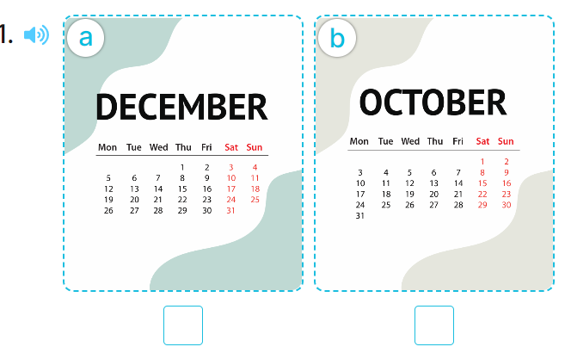  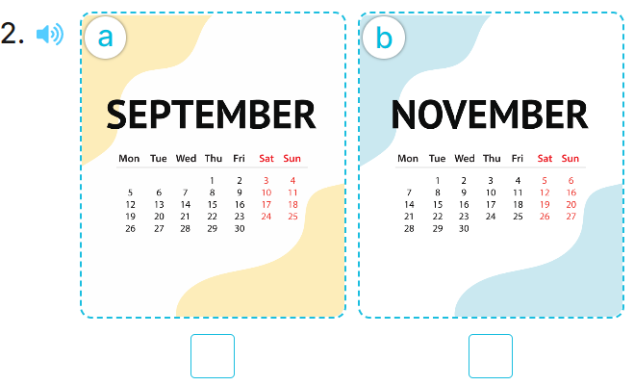  - T ask Ss to guess the answers.  + T writes Ss’guessing on the board.  - Listen to the tape:  + Play the recording  + Play the recording again and get Ss to swap books with their partners.  + Play the recording again to check answers together as a class.  + Write the answers on the board for Ss to correct their answers. Then checks Ss’ guessing.  - Play the recording, sentence by sentence, for the class to listen and repeat in chorus.  Key: 1. b 2.a  Activity 2. Look, complete and read  *Aims: Ss will be able to complete two gapped dialogues with the help of picture cues.  *Procedure:  - Have pupils look at the pictures and identify the event and the month in each picture.  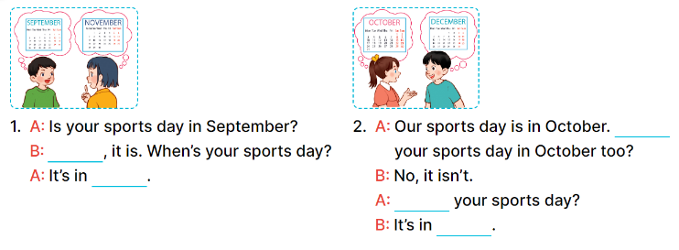  - Have Ss look at the four dialogues and the pictures. Elicit and model with number 1  + Get Ss to read number 1 in chorus.  + Ask them what A and B are talking about.  + Write the word notebook on the board.  + Tell Ss to identify the picture of a notebook (Yes, November).  + Then write number 1 with Yes, November.  -Have Ss work in pairs and complete the sentences 2.  - Ask a few Ss to stand up and read the sentences aloud.  -T gives feedbacks.  Key:  1. Yes; November  2. Is; When’s; December  Activity 3. Let’s play  *Aims: Ss will be able to review vocabulary for months by playing the game Who’s faster?  *Procedure:  - Tell pupils that they are going to play the game Who’s faster? in groups.  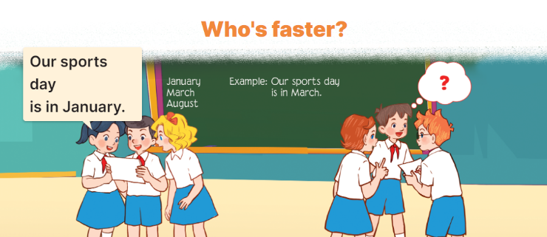  - Explain how to play the game:  + Each group makes sentences using month words and reads them aloud to the class.  - Model, write three month words on the board and a sentence.  Ex: March, May, July.  Our sports day in in May.  - Divide the class into grooups of five.  - Ask groups to look at the words and the example on the board.  - Have groups make two sentences with the two words January and August, then read the sentences aloud to the class.  -The group that makes correct sentences faster wins.  *Consolidation  *Aims: Ss will be able consolidate and wrap up the content of the lesson.  *Procedure:  - T asks ss to answer the following questions:  + What have you learnt from the lesson today?  +What are the core values of the lesson? (if the teacher can take from the lesson).  - T praises some Ss who are hardworking / active/ good…. as well as encourage others to try more.  3. Homework. (3’)  - Practice part 5 again.  - Prepare the new lesson: Unit 9, Lesson 3 (1,2,3). | - Ss listen  - Ss play game  -Ss play game  - Ss open their books  -Look at the pictures and say:  + Picture 1a. a calendar showing December  + Picture 1b. a calendar showing October  + Picture 2a. a calendar showing September  + Picture 2b. a calendar showing November  -Ss guess the answers  - Ss listen to the tape and tick  - Ss listen again, tick and swap books with their partners.  - Ss check their answers and guessing  -Ss write the answer  -Ss listen and repeat.  Students integrate: Complete and read sentence 1 (5/65)  -Ss look at the picture and say  -Ss look and answer  -Ss read  -Ss answer  -Ss write  -Ss listen and write  -Ss work in pairs and complete  -Ss read aloud  -Ss listen the rule  - Ss listen  -Ss play the game  -Ss listen  -Ss answer the questions  -Ss listen and clap their hands  -Ss listen and take note
D. ADJUSTMENTS (if necessary):
………………………………………………………………………………………….…..……………………………………………………………………………...………………………………………….…..……………………………………………………………………………….……………………………………………………………………...

