Week: 15 Preparing date: 15/12/2024
Period: 57 Teaching date: 17/12/2024

Unit 9: Our sports day
Lesson 1 (4, 5, 6)
A. OBJECTIVES:
By the end of the lesson, Ss will be able to:
1. Knowledge:
- use the words and phrase December, July, June, November, October, September, sports day in relation to the topic "Our sports day".
- listen to and demonstrate understanding of simple exchanges in relation to the topic "Our sports day".
- Vocabulary: Review
- Skills: speaking, listening, reading and writing.
Students integrate: Complete and read sentence 1,2 (5/63)
2. Competences:
- Written Communication: complete the sentences.
- Self-control and independent learning: perform listening tasks.
- Communication and collaboration: work in pairs or groups.
3. Attitude/ Qualities:
- Kindness: Help partners to complete learning tasks.
- Honesty: tell the truth about feelings and emotions.
B. TEACHING AIDS:
- Teacher: Teacher’s guide Pages 128, 129, 130; audio Tracks 89, 90; website hoclieu.vn, posters, laptop, pictures, textbook, lesson plan, TV or projector.
- Students: Pupil’s book Page 63, notebooks, workbooks, school things.
C. PROCEDURES:
Teacher’s activities | Students’ activities
1.Warm- up: (5’)  Slap the board  *Aims: to create a friendly and active atmosphere in the class to beginning the lesson.  *Procedure:  - Divide class into 2 groups: Tom and Jerry.  - How to play:  + Each group chooses five Ss to play.  + Class will read aloud.  + Look at the picture, listen and slap the picture you heard.  + Who faster will get 1 mark.  + Which group with higher mark is the winner.  - T gives feedback.  - Say “Open your book page 63” and look at “Unit 9, Lesson 1 (4,5,6)”.  2.Practice: (27’)  Activity 1. Listen and match:  *Aims: Ss will be able to listen to and understand three communicative contexts in which characters ask and answer questions about sports days and match three characters with three correct pictures.  *Procedure:  - Draw pupils’ attention to the pictures of the characters and the months.  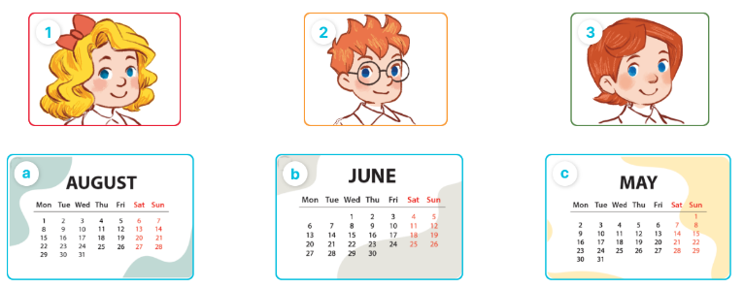  - Play the recording and ask pupils to listen and draw a line to match the character.  Ex: (Mary) with the month (Picture b).  - Play the recording again for pupils to do the task.  - Play the recording a third time to give pupils another listening opportunity if needed.  - Get pupils to swap books with a partner, then check answers together as a class.  - Write the correct answers on the board.  - Play the recording again for pupils to listen and double-check their answers.  - Play the recording, sentence by sentence, for the class to listen and repeat individually and in chorus.  Key: 1. b 2. c 3.a  Activity 2. Look, complete and read  *Aims: Ss will be able to complete four target sentence patterns in four exchanges with the help of picture cues.  *Procedure:  - Have pupils look at the pictures and identify the months.  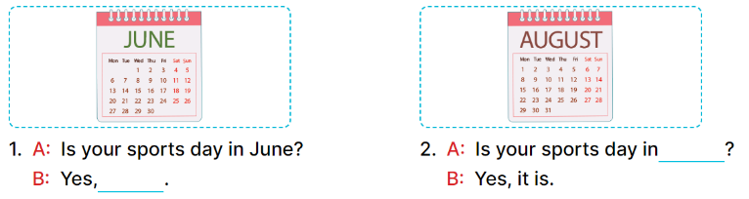  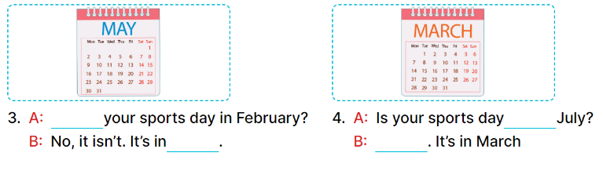  - Have Ss look at the four incomplete dialogue. Elicit and model with picture 1  + Ask Ss to read the sentence 1 in chorus.  + Ask Ss what word is missing in the gap (it is). Then have them complete the sentence (Yes, it is).  -Have Ss work in pairs and complete the sentences 2, 3, 4.  - Ask a few Ss to stand up and read the sentences aloud.  -T gives feedbacks.  Key:  1. it is 2. April  3. Is; May 4. in; No, it isn’t  Activity 3. Let’s sing  *Aims: Ss will be able to sing the song Our sports day with the correct pronunciation, rhythm and melody  *Procedure:  - Draw pupils’ attention to the title and lyrics of the song.  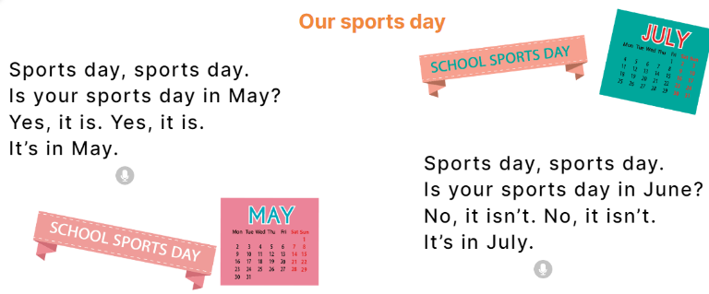  - Play the recording all the way through.  - Play the recording, line by line, for pupils to listen and repeat.  - Introduce actions for pupils to do while they sing along with the recording.  - Play the recording all the way through for pupils to sing along.  - Put pupils into groups to make up their own actions for the song.  - Invite groups to the front of the class to perform, while the rest of the class sings and / or claps along.  Key: 1. red 2. blue  3. yellow 4. brown  *Consolidation  *Aims: Ss will be able consolidate and wrap up the content of the lesson.  *Procedure:  - T asks ss to answer the following questions:  + What have you learnt from the lesson today?  +What are the core values of the lesson? (if the teacher can take from the lesson).  - T praises some Ss who are hardworking / active/ good…. as well as encourage others to try more.  3. Homework. (3’)  - Practice part 5 again.  - Prepare the new lesson: Unit 9, Lesson 2 (1,2,3). | - Ss listen  -Ss listen  - Ss play game  -Ss congratuate the winner  - Ss open their books  -Look at the pictures and say:  1. Mary 2. Ben 3. Lucy  +Picture a. a calendar sheet of April  +Picture b. a calendar sheet of June  +Picture c. a calendar sheet of May  -Ss listen and draw a line to match the character  - Ss listen again and match  - Ss listen again  - Ss swap books and check their answers  -Ss write the correct answer  -Ss listen again and double-check their answers.  -Ss listen and repeat.  Students integrate: Complete and read sentence 1,2 (5/63)  -Ss look at the picture and say  + a yellow pencil, a red pencil case, a brown school bag and a blue pen.  -Ss look and answer  -Ss read  -Ss say and write  -Ss work in pairs and complete  -Ss read aloud  -Ss listen  - Ss listen to all the song  -Ss listen and sing line by line  - Ss sing and do action  - Ss listen and sing along  - Ss sing in groups and do action  -Ss sing in front of the class  -Ss answer the questions  -Ss listen and clap their hands  -Ss listen and take note
D. ADJUSTMENTS (if necessary):
………………………………………………………………………………………….…..……………………………………………………………………………...………………………………………….…..……………………………………………………………………………….……………………………………………………………………...

