Week: 14 Preparing date: 11/12/2024
Period: 55 Teaching date: 13/12/2024

Unit 8: My favourite subjects
Lesson 3 (4, 5, 6)
A. OBJECTIVES:
By the end of the lesson, Ss will be able to:
1. Knowledge:
- read and write about someone’s favourite subject.
- do a survey on their classmates’ favourite subjects and the reasons why they like these subjects and present it to their classmates at Project time.
- Vocabulary: Review
- Skills: speaking, listening, reading and writing.
Students integrate: Read some in the paragraph (4/61)
2. Competences:
- Critical Thinking: complete a task in reading a text.
- Co-operation: ready to help friends in pair work/ group work.
- Self-control and independent learning: perform listening tasks.
3. Attitude/ Qualities:
- Kindness: Help partners to complete learning tasks.
- Diligence: complete learning tasks.
B. TEACHING AIDS:
- Teacher: Teacher’s guide Pages 123, 124, 125; website hoclieu.vn, posters, laptop, pictures, textbook, lesson plan, TV or projector.
- Students: Pupil’s book Page 61, notebooks, workbooks, school things.
C. PROCEDURES:
Teacher’s activities | Students’ activities
1.Warm- up: (5’)  Game: “Chant”  *Aims: to review the vocabulary and structure about greet and respond to greetings.  *Procedure:  - Ask Ss chant and do the actions in Unit 8, Lesson 3 page 60 in groups.  - Give point for the groups and encourage them.  - Say “Open your book page 61” and look at “Unit 8, Lesson 3 (4, 5, 6)”.  2.Practice: (8’)  Activity 1. Read and complete:  *Aims: Ss will be able to read a paragraph and decide whether the sentences are true or false.  *Procedure:  - Have pupils read all the sentences under the paragraph.  - Have pupil read Sentence 1 and pay attention to the keywords name and Peter, then scan the paragraph for the information.  + If it is the same, they should put a tick in the True box.  + If the information is not the same, they should put a tick in the False box.  -Ask pupils to do the activity independently.  - Get pupils to swap books with their partners and check their answers before checking as a class.  - Invite some pupils to stand up and read the paragraph aloud.  Key: 1. True 2. False 3. True 4. False  3.Production: (19’)  Activity 2. Let’s write  *Aims: Ss will be able to read, understand and complete a paragraph about their favourite subjects.  *Procedure:  - Tell pupils what they are going to do.  - Then get them to read the incomplete paragraph.  - Elicit what the paragraph is about (someone’s favourite subject and the reason why he / she likes it).  - Get pupils to fill the first gap with their name as an example.  -Have pupils to complete the paragraph independently.  - Get pupils to swap books with their partners and check the answers in pairs or groups.  - Have a few pupils to stand up and read their writing aloud.  - Invite a few pupils to read their completed texts in front of the class.  Key: Pupils’ answer  Ex: My name is Huong. I have English, PE, music, art and maths today. My favorite subject is English. I like it because I want to be an English teacher. What is your favorite subject?  Activity 3. Project.  *Aims: Ss will be able to do a survey on their classmates’ favourite subjects and the reasons why they like these subjects and present them to the class  *Procedure:  - Tell Ss about the activity.  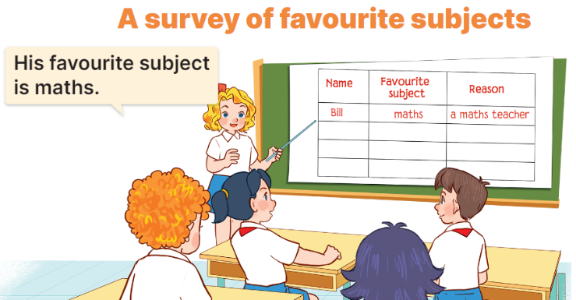  - Get pupils to work in groups to show their surveys on their classmates’ favourite subjects and the reasons why they like these subjects which they have prepared at home as homework.  - Invite a pupil to the front of the class to model the presentation.  Ex: Look at Bill. His favourite subject is maths. He likes it because he wants to be a maths teacher.  - Have the pupils repeat the language a few times to help them feel confident when they present.  - Have pupils to present the project in their groups.  - Invite a few pupils to the front of the class to present their projects.  *Consolidation  *Aims: Ss will be able consolidate and wrap up the content of the lesson.  *Procedure:  - T asks ss to answer the following questions:  + What have you learnt from the lesson today?  +What are the core values of the lesson? (if the teacher can take from the lesson).  - T praises some Ss who are hardworking / active/ good…. as well as encourage others to try more.  4. Homework. (3’)  - Prepare the new lesson: Unit 9, Lesson 1 (1, 2, 3). | - Ss listen and chant  - Ss open their books  Students integrate: Read some in the paragraph (4/61)  - Ss read the paragraph  -Ss read and complete the first sentence  -Ss do the task  -Ss swap their answers  -Ss check their answer  -Ss read aloud  -Ss look and listen  -Ss read  -Ss listen and pay attention  -Ss fill the first gap  -Ss do the task  -Ss swap books and check their answer  -Ss check the answer  -Ss read aloud  -Ss listen and pay attention  -Ss work in groups and show their survey  -Ss report the survey  -Ss repeat the languege  -Ss present into groups  -Ss present in front of the class.  -Ss answer the questions  -Ss listen and clap their hands  -Ss listen and take note
D. ADJUSTMENTS (if necessary):
………………………………………………………………………………………….…..……………………………………………………………………………...…………

