Week: 14 Preparing date: 08/12/2024
Period: 53 Teaching date: 10/12//2024

Unit 8: My favourite subjects
Lesson 2 (4, 5, 6)
A. OBJECTIVES:
By the end of the lesson, Ss will be able to:
1. Knowledge:
- use the words and phrases art, music, PE, IT, an English teacher, a maths teacher, a painter and a singer in relation to the topic “My favourite subjects”.
– listen to and demonstrate understanding of simple communicative contexts in relation to the topic “My favourite subjects”.
- Vocabulary: Review
- Skills: speaking, listening, reading and writing.
Students integrate: Complete and read sentence 1(5/59)
2. Competences:
- Critical Thinking: self-introduce
- Co-operation: ready to help friends in pair work/ group work.
- Self-control and independent learning: perform listening tasks.
3. Attitude/ Qualities:
- Kindness: Help partners to complete learning tasks.
- Diligence: complete learning tasks.
B. TEACHING AIDS:
- Teacher: Teacher’s guide Pages 119, 120, 121; audio Tracks 83; website hoclieu.vn, posters, laptop, pictures, textbook, lesson plan, TV or projector.
- Students: Pupil’s book Page 59, notebooks, workbooks, school things.
C. PROCEDURES:
Teacher’s activities | Students’ activities
1.Warm- up: (5’)  Game: Pass the ball  *Aims: to create a friendly and active atmosphere in the class to beginning the lesson.  *Procedure:  - T gives Ss a ball.  - T asks Ss to listen to music and transfer a ball around the class.  - When the music stops, Ss who keep a ball have to answer the question using: Why do you like……? and Because I……  - T gives feedback.  - Say “Open your book page 59” and look at “Unit 8, Lesson 2 (4,5,6)”.  2.Practice: (27’)  Activity 1. Listen and number:  *Aims: Ss will be able to listen to and understand four communicative contexts in which pupils gives reasons why they like the school subject, and number the correct pictures.  *Procedure:  - Elicit the favourite subject and the reason for liking it.  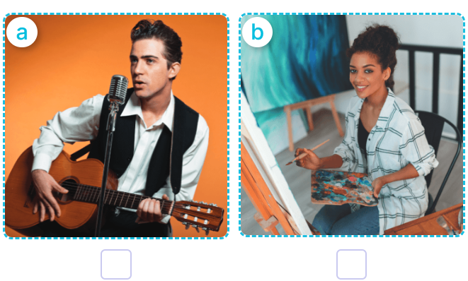  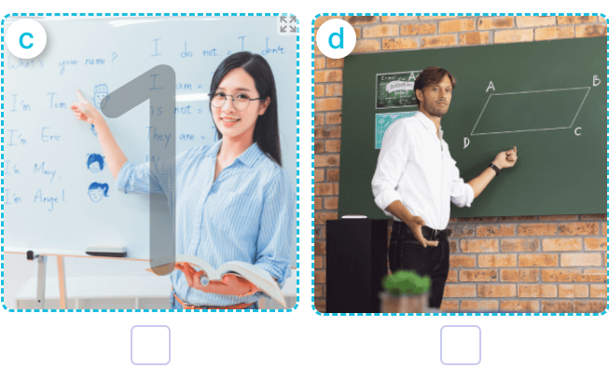  - T ask Ss to guess the answers.  + T writes Ss’guessing on the board.  - Listen to the tape:  + Play the recording  + Play the recording again and get Ss to swap books with their partners.  + Play the recording again to check answers together as a class.  + Write the answers on the board for Ss to correct their answers. Then checks Ss’ guessing.  - Play the recording, sentence by sentence, for the class to listen and repeat in chorus.  Key: 1. b 2. d 3. a 4. c  Activity 2. Look, complete and read  *Aims: Ss will be able to complete two dialogues about their favourite subjects and the reasons why pupils like them with the help of picture cues  *Procedure:  - Get Ss to look at the pictures and ask them what the girl and the boy are doing 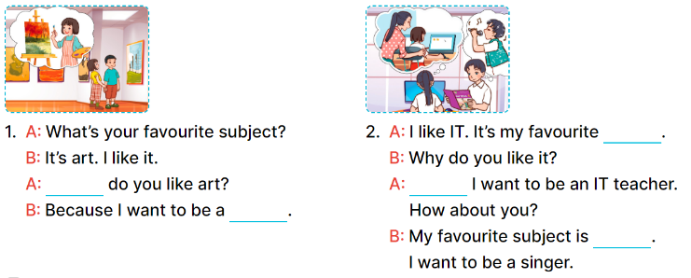  - Model and elicit the missing words from the Exchange 1 (Why, painter).  -Have pupils to do the task individually.  - Get pupils swap books with their partners and check the answers before checking as a class.  - Invite a few pairs to stand up and read the sentences aloud.  Key:  - Why/ painter  - Subject; because; music  Activity 3. Let’s play  Sentence making  *Aims: Ss will be able to practice making meaningful and grammatically correct sentences about future jobs by playing the game “sentence making”.  *Procedure:  - Tell pupils the goal of the game and how to play it. 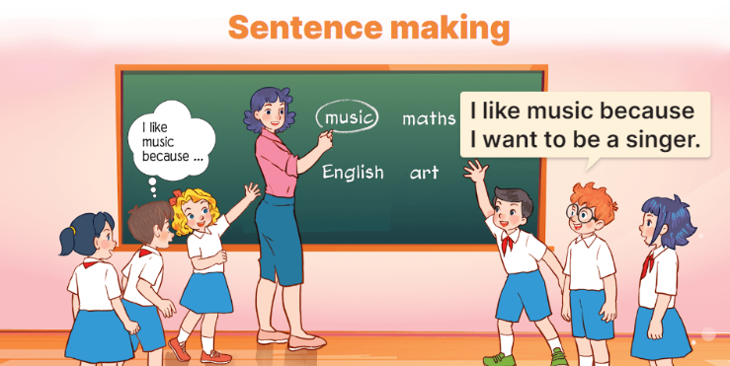  - How to play the game:  + When the teacher circles or says one of the words on the board, the groups make as many sentence as possible.  + The group that gives the correct sentences more quickly gets one point or one star for one correct sentence.  + The group with more points or stars is the winner.  - Divide the class into groups of three or four pupils to play.  *Consolidation  *Aims: Ss will be able consolidate and wrap up the content of the lesson.  *Procedure:  - T asks ss to answer the following questions:  + What have you learnt from the lesson today?  +What are the core values of the lesson? (if the teacher can take from the lesson).  - T praises some Ss who are hardworking / active/ good…. as well as encourage others to try more  3. Homework. (3’)  - Practice part 5 again.  - Prepare the new lesson: Unit 8, Lesson 3 (1,2,3). | - Ss listen  - Ss play game  -Ss play game  - Ss open their books  -Look at the pictures and say:  + Picture a: A male singer singing  + Picture b: A female painter working  + Picture c: An English teacher writing  + Picture d: A maths teacher writing  -Ss guess the answers  - Ss listen to the tape and write  - Ss listen again, write and swap books with their partners.  - Ss check their answers and guessing  -Ss listen and repeat.  Students integrate: Complete and read sentence 1(5/59)  -Ss look at the picture and say  -Ss look and answer  -Ss do the task  -Ss swap books and check their answer  -Ss read the sentences aloud  - Ss listen  - Ss listen  - Ss play game  - Ss play game  -Ss answer the questions  -Ss listen and clap their hands  -Ss listen and take note
D. ADJUSTMENTS (if necessary):
………………………………………………………………………………………….…..……………………………………………………………………………...………………………………………….…..……………………………………………………………………………….……………………………………………………………………...

