Week: 4 Preparing date: 02/10/2024
Period: 16 Teaching date: 04/10/2024

Unit 2: Time and daily routines
Lesson 3 (4, 5, 6)
A. OBJECTIVES:
By the end of the lesson, Ss will be able to:
1. Knowledge:
- read and match the activities in a paragraph with the clocks showing the corresponding time.
- complete a paragraph about pupils’ daily routines.
- draw pictures of their daily routines at home and present them to the class by using the target language.
- Vocabulary: Review
- Skills: speaking, listening, reading and writing.
Students integrate: read 3 sentences in activity 4 (4/21)
2. Competences:
- Critical Thinking: self-introduce
- Co-operation: ready to help friends in pair work/ group work.
- Self-control and independent learning: perform presentation skill.
3. Attitude/ Qualities:
- Kindness: Help partners to complete learning tasks.
- Honesty: tell the truth about feelings and emotions.
- Diligence: complete learning tasks.
B. TEACHING AIDS:
- Teacher: Teacher’s guide Pages 41,42; website hoclieu.vn, posters, laptop, pictures, textbook, lesson plan, TV or projector.
- Students: Pupil’s book Page 21, notebooks, workbooks, school things.
C. PROCEDURES:
Teacher’s activities | Students’ activities
1.Warm- up: (5’)  Game: “Chant”  *Aims: to review the vocabulary and structure about greet and respond to greetings.  *Procedure:  - Ask Ss chant and do the actions in Unit 2, Lesson 3 page 20 in groups.  - Give point for the groups and encourage them.  - Say “Open your book page 21” and look at “Unit 2, Lesson 3 (4,5,6)”.  2.Practice: (8’)  Activity 1. Read and match:  *Aims: Ss will be able to read and match the activities in a paragraph with the clocks showing the corresponding time.  *Procedure:  - Show the pictures and ask Ss some questions:  + What’s this?  + What time is it?  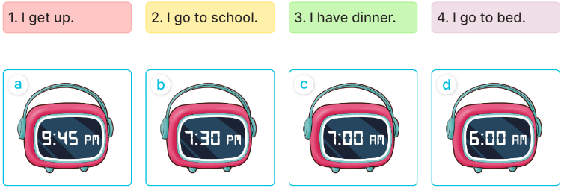  - Have pupils read the paragraph, the sentences, and the time on the clocks.  - Model Sentence 1 (clock d).  - Set a time limit for pupils to do the activity independently.  - Get pupils to swap books with a partner and check their answers before checking as a class.  - Invite some pupils to stand up to read the paragraph aloud.  -Tgives feedback.  Key: 1. d 2. c 3. b 4. a  3.Production: (19’)  Activity 2. Let’s write  *Aims: Ss will be able to complete a paragraph about pupils’ daily routines *Procedure:  - Tell pupils what they are going to do.  - Ask pupils what the paragraph is about (daily routines).  - Set a time limit for pupils to complete the paragraph independently.  - Get pupils to swap books and check their answers in pairs or groups before checking as a class.  - T gives feedback.  .Key: Pupil’s answer  Ex: I get up at six o’clock. I have breakfast at seven o’clock. I go to school at seven fifteen. What about you? What time do you go to school?  Activity 3. Project.  *Aims: Ss will be able to draw pictures of their daily routines at home and present them to the class by using the target language.  *Procedure:  - Ask Ss to draw pictures of their daily routines at home as homework before learning Unit 2 -Lesson 3 (4,5,6)  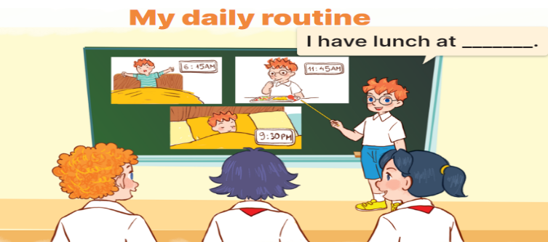  - Explain that pupils have to show simple pictures of their daily routines (getting up, having breakfast, etc.)  - Invite a pupil to the front of the class to model the presentation.  - Put the key presentation language on the board (ex: I get up at six fifteen.).  - Have pupils repeat the key presentation language a few times to make them feel confident when they present their daily routines before an audience.  - Set a time limit for pupils to work in groups.  - Invite a few pupils to the front of the class to present the project.  *Consolidation  *Aims: Ss will be able consolidate and wrap up the content of the lesson.  *Procedure:  - T asks ss to answer the following questions:  + What have you learnt from the lesson today?  +What are the core values of the lesson? (if the teacher can take from the lesson).  - T praises some Ss who are hardworking / active/ good…. as well as encourage others to try more.  4. Homework. (3’)  - Prepare the new lesson: Unit 3, Lesson 1 (1,2,3). | - Ss listen and chant  - Ss open their books  Students integrate: read 3 sentences in activity 4 (4/21)  - Ss look at the pictures and answer  -Ss read and match  -Ss listen  -Ss do the activity and match  -Ss swap books and check their answer  -Ss read the paragraph aloud.  -Ss listen  -Ss listen to the teacher  -Ss listen and answer  -Ss complete the paragraph  -Ss swap books and check their answers  -Ss listen  - Ss draw pictures of their daily routines at home.  -Ss listen to the teacher  -Ss pay attention  -Ss repeat the key presentation  -Ss work in groups  -Ss present the project  -Ss answer the questions  -Ss listen and clap their hands  -Ss listen and take note
D. ADJUSTMENTS (if necessary):
………………………………………………………………………………………….…..……………………………………………………………………………...…………

