Week: 4 Preparingdate: 02/10/2024
Period: 15 Teaching date: 04//10/2024

Unit 2: Time and daily routines
Lesson 3 (1, 2, 3)
A. OBJECTIVES:
By the end of the lesson, Ss will be able to:
1. Knowledge:
- correctly repeat the sounds of the letters t and d in isolation, in the words get and bed, and in the questions What time do you get up? and What time do you go to bed?
- identify the sounds of the letters t and d in sentences while listening.
- say the chant with the correct rhythm and pronunciation.
- Vocabulary: Review
- Skills: speaking, listening, reading and writing.
Students integrate: read: t – get; d - bed
2. Competences:
- Co-operation: ready to help friends in pair work/ group work.
- Sociability: Talk to each other, say good words to others.
3. Attitude/ Qualities:
- Kindness: Help partners to complete learning tasks.
- Honesty: tell the truth about feelings and emotions
B. TEACHING AIDS:
- Teacher: Teacher’s guide Pages 39, 40; audio Tracks 23, 24, 25; website hoclieu.vn, posters, laptop, pictures, textbook, lesson plan, TV or projector.
- Students: Pupil’s book Page 20, notebooks, workbooks, school things.
C. PROCEDURES:
Teacher’s activities | Students’ activities
1.Warm- up: (5’)  Game: Pass the ball  *Aims: to create a friendly and active atmosphere in the class to beginning the lesson.  *Procedure:  - T gives Ss a ball.  - T asks Ss to listen to music and transfer a ball around the class.  - When the music stops, Ss who keep a ball have to answer the question using: What time do you …….and I ……..  - T gives feedback.  - Say “Open your book page 20” and look at “Unit 2, Lesson 3 (1,2,3)”.  2. Presentation (9’)  Activity 1. Listen and repeat:  *Aims: Ss will be able to correctly repeat the sounds of the letters t and d in isolation, in the words get and bed, and in the questions What time do you get up? and What time do you go to bed?  *Procedure:  - T gives instruction to the letter t and d, the word get and bed , and the sentences What time do you get up? and What time do you go to bed?  - Have pupils look at the letter t, d, listen to the recording and repeat the letter until they feel confident.  - Have pupils point at the word get, listen to the recording and repeat the word until they feel confident.  - Get pupils to point at the sentence What time do you get up?, What time do you go to bed?  listen to the recording and repeat it several times.  - Invite a few pupils to stand up to listen to and repeat the sentence.  - Give pupils a time limit to practise pronouncing the letters, saying the words, and reading the sentences in pairs or groups.  3.Practice: (19’)  Activity 2. Listen and circle.  *Aims: Ss will be able to identify the sounds of the letters t and d in sentences while listening.  *Procedure:  - Have pupils read the incomplete sentences.  - Explain that they must listen to the recording and circle the correct options to complete the sentences.  - Play the recording and have pupils listen and circle the correct options.  - Get pupils to swap books with a partner to check their answers before checking as a class.  - Invite a few pupils to stand up and read the completed sentences.  Key: 1.c 2.a  Activity 3. Let’s chant  *Aims: Ss will be able to say the chant with the correct rhythm and pronunciation.  *Procedure:  - Introduce the title and lyrics of the chant.  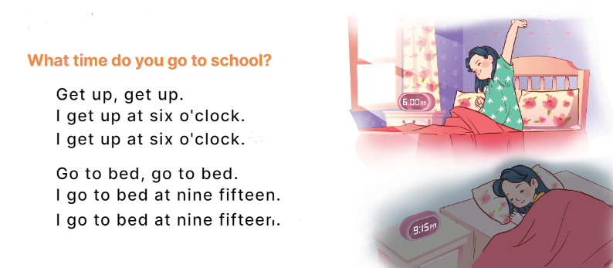  - Play the recording for Ss to listen to the whole chant.  + Have them repeat the title and lyrics line by line.  + Ask Ss to attend to the sounds of the letters t and d and the words get and bed.  - Play the recording all the way through for Ss to listen to pronunciation and melody.  - Play the recording line by line for Ss to listen and repeat  - Play the recording for Ss to chant and clap along.  - Ask Ss to practice chant and clap along in pairs or groups.  - Invite groups to the front of the classroom to perform the chant  -T gives feedback.  *Consolidation  *Aims: Ss will be able consolidate and wrap up the content of the lesson.  *Procedure:  - T asks ss to answer the following questions:  +What are the core values of the lesson? (if the teacher can take from the lesson).  - T review the vocabulary and model sentences.  - T praises some Ss who are hardworking / active/ good…. as well as encourage others to try more.  4. Homework. (2’)  - Practice the chant more.  - Draw and colour a paper birthday cake.  - Prepare the new lesson: Unit 2, Lesson 3 (4,5,6). | - Ss listen  -Ss listen the rules  - Ss play the game  - Ss open their books  Students integrate: read: t – get; d - bed  - Ss recognize the differences about color of letter  - - Ss listen and repeat  - Ss listen, point and repeat  - Ss listen again and repeat  -Ss listen again and repeat  -Ss practice in pairs/ groups  -Ss listen and say:  + Number 1: I……..at six thirty.  + Number 2:I …..at five forty-five.  -Ss listen  - Ss listen to the tape and circle  - Ss listen again, circle and swap books with their partners.  -Ss read the sentences  - Ss look and listen.  -Ss listen to the chant  - Ss listen and repeat line by line without clap their hands  -Ss note the sounds, word  -Ss listen to melody of the song  - Ss listen and chant line by line.  - Ss chant and clap along.  - Ss work in groups (two groups) to chant  -Ss perform in front of the class.  -Ss listen  -Ss answer the questions  - Ss listen  -Ss listen and clap their hands  -Ss listen and take note
D. ADJUSTMENTS (if necessary):
………………………………………………………………………………………….…..……………………………………………………………………………...…………………………………………………………………………………………………………

