Week: 4 Preparing date: 28/09/2024
Period: 14 Teaching date: 01/10/2024

Unit 2: Time and daily routines
Lesson 2 (4, 5, 6)
A. OBJECTIVES:
By the end of the lesson, Ss will be able to:
1. Knowledge:
- listen to and understand four communicative contexts in which pupils ask and answer questions about daily routines and number the correct pictures.
- complete four gapped exchanges with the help of picture cues.
- sing the song What time do you go to school? with the correct pronunciation, rhythm, and melody.
- Vocabulary: Review
- Skills: speaking, listening, reading and writing.
Students integrate: Sing 2 sentences in the song: What time do you go to school?
2. Competences:
- Critical Thinking: self-introduce
- Communication and collaboration: work in pairs and groups to complete the learning tasks.
- Self-control and independent learning: perform listening tasks.
3. Attitude/ Qualities:
- Kindness: Help partners to complete learning tasks.
- Show their responsibility by noticing the time and follow the timetable on time.
- Diligence: complete learning tasks.
B. TEACHING AIDS:
- Teacher: Teacher’s guide Pages 37,38,39; audio Tracks 21, 22; website hoclieu.vn, posters, laptop, pictures, textbook, lesson plan, TV or projector.
- Students: Pupil’s book Page 19, notebooks, workbooks, school things.
C. PROCEDURES:
Teacher’s activities | Students’ activities
1.Warm- up: (5’)  Game: Magic wheel  *Aims: to create a friendly and active atmosphere in the class to beginning the lesson.  *Procedure:  - Press “Spin” to play.  - If pupils have the correct answer, they will get the points shown on the slide.  - The team having higher scores will be the winner at the end of the game.  - Say “Open your book page 19” and look at “Unit 2, Lesson 2 (4,5,6)”.  2.Practice: (27’)  Activity 1. Listen and number:  *Aims: Ss will be able to listen to and understand four communicative contexts in which pupils ask and answer questions about daily routines and number the correct pictures.  *Procedure:  - Elicit the activities and the time in the pictures  - Draw pupils’ attention to the boxes at the bottom right-hand corners of the pictures.  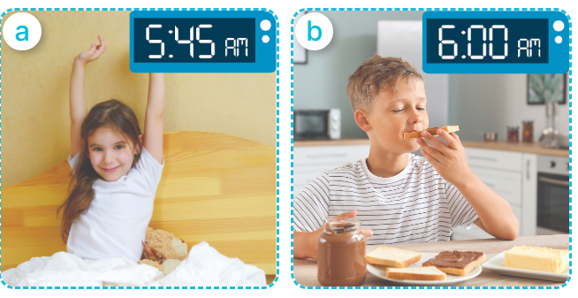  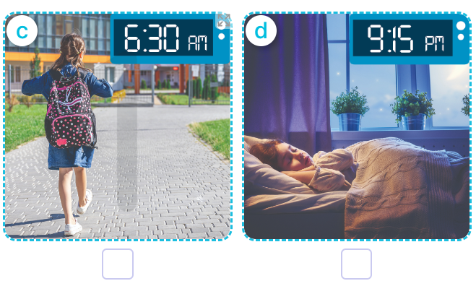  - T ask Ss to guess the answers.  + T writes Ss’guessing on the board.  - Listen to the tape:  + Play the recording  + Play the recording again and get Ss to swap books with their partners.  + Play the recording again to check answers together as a class.  + Write the answers on the board for Ss to correct their answers. Then checks Ss’ guessing.  - Play the recording, sentence by sentence, for the class to listen and repeat in chorus.  Key: 1. d 2. c 3. a 4. b  Activity 2. Look, complete and read.  *Aims: Ss will be able complete four gapped exchanges with the help of picture cues.  *Procedure:  - Get Ss to look at the pictures and identify the ages  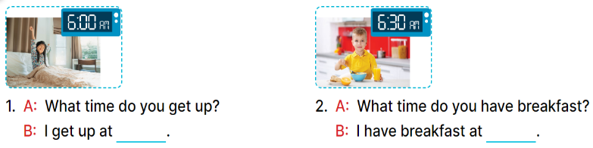  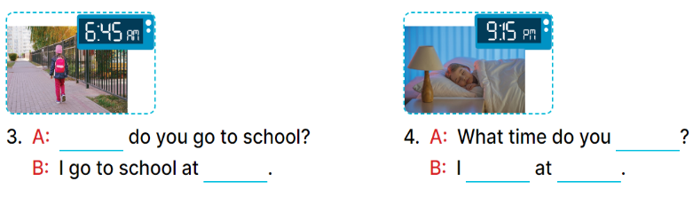  - Have Ss look at the four incomplete sentences and elicits the missing words in the sentences.  - T models with sentence 1  + Ask Ss what is missing in the sentence.  + Have Ss look at the picture and complete the gap, then read the completed sentence in chorus.  -Have Ss work in groups and complete the sentence 2, 3, 4.  - Ask a few Ss to stand up and read the completed sentences aloud.  -T gives feedbacks.  Key:  1. six o’clock 2. six thirty  3. What time; six forty-five  4. go to bed; go to bed; nine fifteen  Activity 3. Let’s sing.  *Aims: Ss will be able to sing the song What time do you go to school? with the correct pronunciation, rhythm, and melody.  *Procedure:  - Introduce the title and lyrics of the song:  “ What time do you go to school?” song.  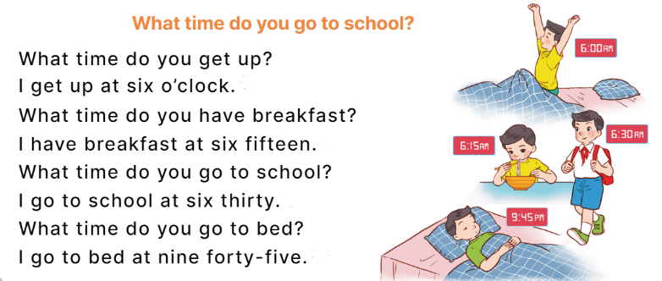  - Play the recording for Ss to listen to the whole song.  + Have them repeat the title and lyrics line by line.  - Play the recording all the way through for Ss to listen to pronunciation and melody of the song.  - Play the recording line by line for Ss to listen, repeat  - Play the recording for Ss to sing and do actions.  - Ask Ss to practice singing and doing actions in pairs or groups.  - Invite groups to the front of the classroom to perform the song  -T gives feedback.  *Consolidation  *Aims: Ss will be able consolidate and wrap up the content of the lesson.  *Procedure:  - T asks ss to answer the following questions:  + What have you learnt from the lesson today?  +What are the core values of the lesson? (if the teacher can take from the lesson).  - T praises some Ss who are hardworking / active/ good…. as well as encourage others to try more.  3. Homework. (3’)  - Prepare the new lesson: Unit 2, Lesson 3 (1,2,3). | - Ss listen  -Ss play game  - Ss open their books  -Look at the pictures and say:  + Picture a: a girl getting up at 5:45 a.m.  + Picture b: a boy having breakfast at 6:00 a.m.  + Picture c: a girl going to school at 6:30 a.m.  + Picture d: a girl is in bed at 9:15 p.m.  -Ss guess the answers  - Ss listen to the tape and write number  - Ss listen again, write and swap books with their partners.  - Ss check their answers together  -Ss write the correct answers and check ss’ answers  -Ss listen and repeat.  -Ss look at the pictures and say:  + A boy is holding a birthday cake with number 7 in picture a  + A girl is holding a birthday cake with number 8 in picture b  +A girl is holding a birthday cake with number 9 in picture b  - Ss listen and answer  -Ss answer: I get up at six o’clock.  -Ss look, complete and read the completed sentence in chorus.  -Ss complete the sentence  -Ss read the sentence aloud  Students integrate: Sing 2 sentences in the song: What time do you go to school?  -Ss look and listen to the teacher  -Ss listen to the song  - Ss listen and repeat line by line without the action.  -Ss listen to melody of the song  - Ss listen and sing line by line.  - Ss sing and do actions.  - Ss work in groups (two groups) to sing.  -Ss perform in front of the class.  -Ss listen  -Ss listen to the teacher.  -Ss answer the questions  -Ss listen and clap their hands  -Ss listen and take note
D. ADJUSTMENTS (if necessary):
………………………………………………………………………………………….…..……………………………………………………………………………...………………………………………….…..…………………………………………………………

