Week: 4 Preparing date: 28/09/2024
Period: 13 Teaching date: 01/10/2024

Unit 2: Time and daily routines
Lesson 2 (1, 2, 3)
A. OBJECTIVES:
By the end of the lesson, Ss will be able to:
1. Knowledge:
- understand and correctly repeat the sentences in two communicative contexts focusing on asking and answering questions about the characters’ daily routines.
- correctly say the phrases and use What time do you…… – I……. at ……. to ask and answer questions about daily routines.
-enhance the correct use of What time do you ……..? - I …….at ………… to ask and answer about someone’s daily routines.
- Vocabulary: get up, have breakfast, go to school, go to bed, do homework.
- Skills: speaking and listening
Students integrate: read the words: get up, have breakfast, go to school, go to bed, do homework.
2. Competences:
- Oral Communication: speak about names, ask and answer the questions.
- Co-operation: ready to help friends in pair work/ group work.
- Self-control and independent learning: perform learning tasks.
3. Attitude/ Qualities:
- Show their responsibility by noticing the time and follow the timetable on time.
B. TEACHING AIDS:
- Teacher: Teacher’s guide Pages 34, 35, 36, 37, audio Tracks 19,20, website hoclieu.vn, posters, laptop, pictures, textbook, lesson plan, TV or projector.
- Students: Pupil’s book Page 18, notebooks, workbooks, school things.
C. PROCEDURES:
Teacher’s activities | Students’ activities
1.Warm- up: (3’)  Game: Which clocks says…..  *Aims: to create a friendly and active atmosphere in the class to beginning the lesson.  *Procedure:  - Spend a few minutes revising the previous lesson by having the class play the game Which clock says ...?  - Say “Open your book page 18” and look at “Unit 2, Lesson 2 (1,2,3)”.  2. Presentation (16’)  Activity 1. Vocabulary.  *Aims: Ss will be able to know the vocabulary in front of starting the new lesson.  *Procedure:  -T elicits the new words  + get up : thức dậy (situation)  + have breakfast : ăn sáng (situation)  + go to school : đi học (picture)  + go to bed : đi ngủ (picture)  + do homework:làm bài tập về nhà (picture)  +wash face : rửa mặt (mime)  + clean teeth : đánh răng (mime)  - T models (3 times).  - T writes the words on the board.  - Checking: Rub out and remember  Activity 2. Look, listen and repeat:  *Aims: Ss will be able to understand and correctly repeat the sentences in two communicative contexts focusing on asking and answering questions about the characters’ daily routines.  *Procedure:  - Have pupils look at Pictures a and b and identify the characters in the pictures.  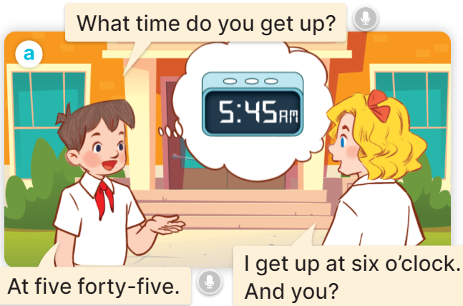  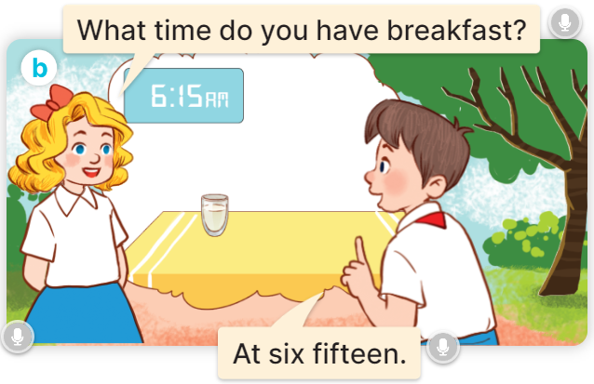  - Play the audio twice (sentence by sentence). Correct their pronunciation where necessary.  - Have Ss to practice the dialogue  - T invites a few pairs to the front of the class to practice.  - T checks pronunciation for ss.  Activity 3 Listen, point and say.  *Aims: Ss will be able to correctly say the phrases and use What time do you ……? – I ……. at ………. to ask and answer questions about daily routines.  *Procedure:  * Model sentences:  - T asks Ss look at picture a and helps Ss know the structure from the dialogue.  - T introduces new structure for Ss.  - T explains, models and gives meaning.  -Have Ss repeat the model sentences.  A: What time do you get up?  B: I get up at six o’clock.  3.Practice: (7’)  *Drill pictures  - Elicit and check comprehension the activities and the time from them.      - Run through all the pictures.  - Run through model sentences.  + Run through the questions.  + Run through the answers.  - Have Ss to practise:  + T asks the first – Ss answer (change role).  + Ss – Ss (change role).  - Ask Ss to work in pairs to ask and answer the question What time do you….? I……at…  - T controls and corrects.  - Invite a few pairs to come to the front of the classroom, point at the relevant character in each picture, and act out his/her role.  - Encourage Ss to practise speaking English.  - T gives feedbacks.  4.Production: (7’)  Activity 4. Let’s talk.  *Aims: Ss will be able to enhance the correct use of What time do you …..? – I …… at ……... to ask and answer questions about pupils’ daily routines in a freer context.  *Procedure:  - Have pupils look at the picture and explain that Nam and Lucy are asking and answering questions about Lucy’s daily routines.  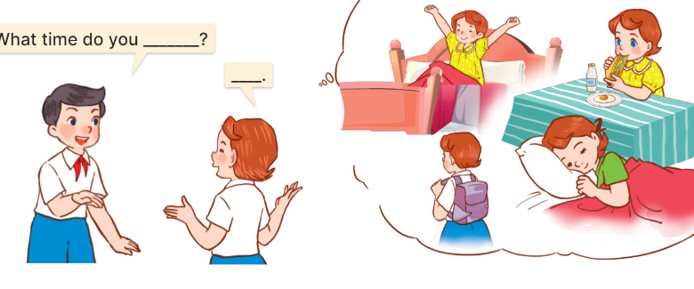  - T asks Ss look at the first speech bubble and ask What time do you get up?  - Get Ss to repeat the question and the answer several times in pairs.  - T models: Go around the classroom, pointing to Ss and asking What time do you……?  - Ask Ss ask and answer the question What time do you …..? – I ……at ………..  - Invite some groups to perform in front of the class.  - Give feedbacks  *Consolidation  *Aims: Ss will be able consolidate and wrap up the content of the lesson.  *Procedure:  - T asks ss to answer the following questions:  + What have you learnt from the lesson today?  +What are the core values of the lesson? (if the teacher can take from the lesson).  - T review the vocabulary and model sentences.  - T praises some Ss who are hardworking / active/ good…. as well as encourage others to try more.  5. Homework. (2’)  - Learn the vocabulary and model sentences by heart  - Prepare the new lesson: Unit 2, Lesson 2 (4,5,6). | - Ss listen.  - Ss play the game  - Ss open their books  Students integrate: read the words: get up, have breakfast, go to school, go to bed, do homework.  -Ss listen and answer  - - Ss listen and repeat  + Choral repetition (3 times).  + Individual repetition (3 ss)  - Ss take note  - Ss look, remember and write  -Look at the pictures and get to know the characters in the pictures.  + In picture a: Minh asks: What time do you get up? And Mary answers: I get up at six o’clock. And you?  Minh answers: At five forty five.  + In pucture b: Mary asks: What time do you have breakfast? And Minh answers: At six fifteen.  -Ss listen and repeat in chorus (twice)  -Ss work in pairs to practice  -Ss practice the dialogue  -Ss listen  -Ss look at the picture and answer.  -Ss listen  -Ss listen and repeat  -Ss repeat to the introduce and respond to greetings.  -Ss look at the picture and answer  + In picture a: a girl is getting up; a clock shows 5:00 AM  + In picture b: a boy is having breakfast; a clock shows 6:15 AM  + In picture c: a pupil is going to school; a clock shows 1:15 PM  + In picture d: a boy is sleeping in bed; a clock shows 9:00 PM  - Ss look, listen and repeat  - Ss practice in chorus  - Ss practice in chorus  -Ss work in pairs to practice  -Ss take turns pointing at the pictures, asking and answering the question in front of the class.  -Ss note  -Ss look at the picture and listen  -Ss look and answer  + I get up at five fifteen.  -Ss repeat the question and answer  -Ss ask and answer  - Ss ask and answer the question  - Ss perform in front of the class.  -Ss answer the questions  - Ss listen  -Ss listen and clap their hands  -Ss listen and take note

D. ADJUSTMENTS (if necessary):
………………………………………………………………………………………….…..……………………………………………………………………………...………………………………………….…..……………………………………………………………………………….……………………………………………………………………...

