Week: 9 Preparing date: 06/11/2024
Period: 35, 36 Teaching date: 08/11/2024

Review 1
Parts 1, 2, 3, 4, 5
A. OBJECTIVES:
By the end of the lesson, Ss will be able to:
1. Knowledge:
- correctly use the following sentence patterns:
+ Where are you from? – I’m from ……..
+ Where’s he / she from? – He’s / She’s from ………
+ What time is it? – It’s…………
+ What time do you ? – I …………at …………
+ What day is it today? – It’s …………..
+ What do you do on …………? – I………….
+ When’s your birthday? – It’s in……………
+ What do you want to eat / drink? – I want .
+ Can you ………….? – Yes, I can. / No, I can’t.
+ Can he / she ………..?– Yes, he / she can. / No, he / she can’t, but he / she can………
- Vocabulary: Review
- Skills: speaking, listening, reading and writing.
Students integrate: Read and match some sentences in activity 4 (4/41)
2. Competences:
- Critical Thinking: self-introduce
- Co-operation: ready to help friends in pair work/ group work.
- Self-control and independent learning: perform listening tasks.
3. Attitude/ Qualities:
- Kindness: Help partners to complete learning tasks.
- Honesty: tell the truth about feelings and emotions.
- Diligence: complete learning tasks.
B. TEACHING AIDS:
- Teacher: Teacher’s guide Pages 73, 74; Track 56; website hoclieu.vn, posters, laptop, pictures, textbook, lesson plan, TV or projector.
- Students: Pupil’s book Page 40, 41, notebooks, workbooks, school things.
C. PROCEDURES:
Teacher’s activities | Students’ activities
1.Warm- up: (5’)  Game: Whispering  *Aims: to review the vocabulary and structure about greet and respond to greetings.  *Procedure:  - Divide class into 2 groups.  -Ask 5 Ss in each group stand in a straight line.  - T says a word or phrase to the first pupil in this line.  - Then, the first pupil whispers what she/ he hear to the second person in line; the second one whispers what he/ she hears to the third one and so on until the last pupil in group hears the word or phrase.  - The last pupil says the word or phrase out loud.  - The faster group has correct word or phrase is the winner.  - Say “Open your book page 40, 41” and look at Review 1.  2.Practice: (52’)  Activity 1. Listen and tick:  *Aims: Ss will be able to listen to and understand five communicative contexts and tick the correct pictures.  *Procedure:  - Elicit the names of the characters in each picture and what they say.  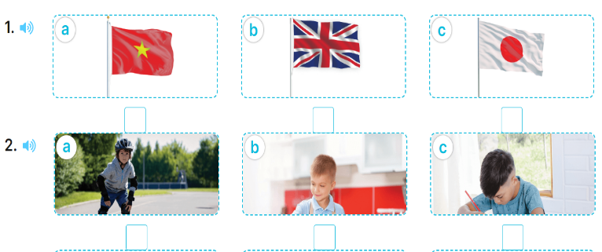  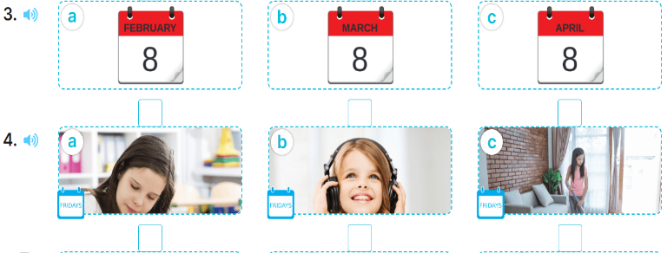  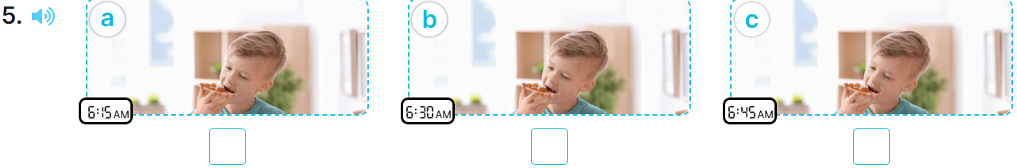  - T ask Ss to guess the answers.  + T writes Ss’guessing on the board.  - Listen to the tape:  + Play the recording  + Play the recording again and get Ss to swap books with their partners.  + Play the recording again to check answers together as a class.  + Write the answers on the board for Ss to correct their answers. Then checks Ss’ guessing.  - Play the recording, sentence by sentence, for the class to listen and repeat in chorus.  Key: 1. c 2. a 3. c 4. b 5. c  Activity 2. Ask and answer:  *Aims: Ss will be able to ask and answer questions using picture cues.  *Procedure:  - Get pupils to look at the clock to identify the time shown on it  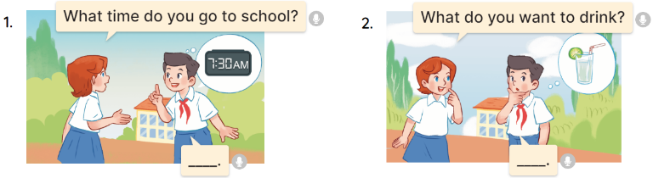  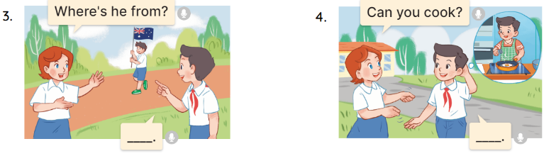  - Draw pupils’ attention to Question 1.  - Have pupils look at the clock in the picture to answer the question.  - Have pupils work in pairs to role-play the four exchanges.  - Invite pairs of pupils to stand up and take it in turns to role-play the target exchanges.  .  Key: 1. b 2. c 3. d 4. a  Activity 3. Read and match  *Aims: Ss will be able to read and match pairs of target sentence patterns  *Procedure:  - Tell Ss about this activity. Point at sentence 1, elicit the answer and models.  - Give Ss work in pairs to do the sentence 2,3,4,5.  - Tell Ss to swap their books with their partners, then check answers together as a class.  - Write the correct answers on the board for Ss to correct their answers.  - Invite some pairs to stand up and read the matched exchanges aloud.  Key:  1. c 2. d 3. b 4. e 5. a  Activity 4. Read and complete  *Aims: Ss will be able to read and complete a gapped passage about Ben.  *Procedure:  - Have pupils read the passage about Ben.  - Have pupils look at the gapped passage.  - Point at the sentence with the first gap and read it as a class.  - Elicit the missing word and give feedback. Complete the sentence and get pupils to read the completed sentence in chorus.  - Get pupils to swap books with a partner, then check answers as a class. Write the correct answer on the board.  - Invite some pupils to stand up and read the completed passage aloud.  Key:  1. Australia 2. Friday  3. guitar 4. Sunday  * Mini game: Comprehension questions  - Ask Ss to read the conversation again  - Give Ss work in pairs and answer the questions:  + Where is Ben from?  He’s from Australia.  + How many days does Ben go to school?  Five days (from Monday to Friday)  + Can he play football?  Yes, he can.  + Can he play the guitar?  Yes, he can.  + Does he go to school on Saturdays?  No, he doesn’t.  3.Production: (10’)  Activity 5. Let’s write  *Aims: Ss will be able to complete a gapped text with the help of picture cues.  *Procedure:  - Ask Ss to read the question and elicit the answer  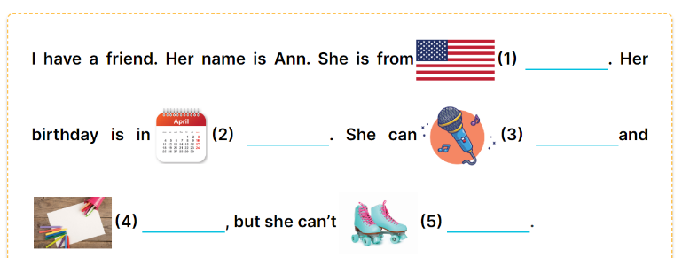  -Tell the class the goal of this activity: to read the gapped text and fill in the gaps using picture cues.  - Write the sentence with the first gap on the board. Read the sentence as a class. When you reach the gap, ask pupils to point at the picture and write (the America).  - Ask pupils complete the other sentences.  - Invite a few pupils to read the sentences they have completed aloud in front of the class.  Key: 1. America 2. April  3. sing 4. draw 5. Roller skate.  *Consolidation  *Aims: Ss will be able consolidate and wrap up the content of the lesson.  *Procedure:  - T asks ss to answer the following questions:  + What have you learnt from the lesson today?  +What are the core values of the lesson?  - T praises some Ss who are hardworking / active/ good…. as well as encourage others to try more.  4. Homework. (3’)  - Prepare the new lesson: Extension activities. | - Ss listen  -Ss play game  - Ss open their books  -Look at the pictures and say:  + Picture 1a: the Vietnamese flag  + Picture 1b: the English flag  + Picture 1c: the Japanese flag  + Picture 2a: a boy roller skating  + Picture 2b: a boy cooking  + Picture 2c: a boy drawing  + Picture 3a: calendar showing 8 February  + Picture 3b. a calendar showing 8 March  + Picture 3c. a calendar showing 8 April  + Picture 4a. a girl studying at school on Fridays  + Picture 4b. a girl listening to music on Fridays  + Picture 4c. a girl doing housework on Fridays  + Picture 5a. a boy having breakfast at 6:15 a.m.  + Picture 5b. a boy having breakfast at 6:30 a.m.  + Picture 5c. a boy having breakfast at 6:45 a.m.  -Ss guess the answers  - Ss listen to the tape and tick  - Ss listen again, tick and swap books with their partners.  - Ss check their answers and guessing  -Ss listen and repeat.  -Look at the pictures and say:  + Picture a:  Lucy: What time do you go to school?  Nam: …………….  + Picture b:  Lucy: What do you want to drink?  Nam: …………..  + Picture c:  Lucy: Where’s he from?  Nam: ………….  + Picture d:  Lucy: Can you cook?  Nam: ………..  -Ss listen to the teacher  - Ss look at the clock and answer.  - Ss work in pairs to role play  - Ss role play  -Ss listen and repeat.  Students integrate: Read and match some sentences in activity 4 (4/41)  -Ss look at the sentence 1 and say  -Ss work in pairs and match  -Ss swap their books and match  -Ss check their answer  -Ss read aloud  -Ss read the passage  -Ss look at the passage  -Ss point at the first gap and read  -Ss complete the missing word  -Ss swap their books and check their answer.  -Ss read aloud  -Ss read the passage again  -Ss work in pairs and answer  -Ss listen and answer  -Ss pay attention  -Ss point and answer the first gap  -Ss complete the sentences  -Ss read aloud.  -Ss listen and answer  -Ss listen and clap their hands  -Ss listen and take note
D. ADJUSTMENTS (if necessary):
………………………………………………………………………………………….…..……………………………………………………………………………...…………

