Week: 9 Preparing date: 03/11/2024
Period: 34 Teaching date: 05/11/2024

Unit 5: Things we can do
Lesson 3 (4, 5, 6)
A. OBJECTIVES:
By the end of the lesson, Ss will be able to:
1. Knowledge:
- read and show understanding of a text by deciding if the statements are true or false;
- complete a gapped text about the abilities and lack of abilities of Lucy, Ben and the pupils themselves;
- carry out a school club survey, collect the information and present their friends’ abilities and lack of abilities to the class by using the target language.
- Vocabulary: Review
- Skills: speaking, listening, reading and writing.
Students integrate: Read some sentences of the paragraph (4/39)
2. Competences:
- Critical Thinking: self-introduce
- Co-operation: ready to help friends in pair work/ group work.
- Self-control and independent learning: perform listening tasks.
3. Attitude/ Qualities:
- Kindness: Help partners to complete learning tasks.
- Honesty: tell the truth about feelings and emotions.
- Diligence: complete learning tasks.
B. TEACHING AIDS:
- Teacher: Teacher’s guide Pages 78,79,80; website hoclieu.vn, posters, laptop, pictures, textbook, lesson plan, TV or projector.
- Students: Pupil’s book Page 39, notebooks, workbooks, school things.
C. PROCEDURES:
Teacher’s activities | Students’ activities
1.Warm- up: (5’)  Game: Hot seat  *Aims: to review the vocabulary and structure about greet and respond to greetings.  *Procedure:  - Divide the class into 2 or 3 teams.  - Call a pupil to come up to the front and pick a flash card.  - He/ She has to use gestures to show their friends what the word or phrase is.  - A pupil from each team asks a question to find out the answer.  - The team that has the correct answer gets a point.  - Say “Open your book page 39” and look at “Unit 5, Lesson 3 (4, 5, 6)”.  2.Practice: (8’)  Activity 1. Read and tick True or False:  *Aims: Ss will be able to read and show understanding of a text by deciding if the statements are true or false.  *Procedure:  -Tell pupils the goal of the activity and explain that they should read the text and tick if the Sentences 1 to 4 are true or false.  - Do Sentence 1 as an example.  + Have pupils read Sentence 1 and find who the sentence is about (It’s about Ha.) and what Ha can do (Ha can swim.).  + Ask pupils to find the information about Ha in the text.  + Ask them to read carefully to decide if the sentence is true or false.  - Set a time limit for pupils to do the task independently.  - Invite one or two pupils to read the text in front of the class.  Key: 1.False 2.True 3.False 4.True  3.Production: (19’)  Activity 2. Let’s write  *Aims: Ss will be able to complete a gapped text about the abilities and lack of abilities of Lucy, Ben and the pupils themselves.  *Procedure:  - Explain that they should read the gapped text and fill in the gaps using the picture cues and with their own information.  - Explain that the gaps in the text focus on the things that people can or can’t do.  - Have pupils do the first gapped sentence together as an example.  + Ask them to read the sentence, look at the picture about Lucy and complete the sentence. + Have them write the answer in the gap.  - Give pupils time to complete the text independently.  - Get pupils to swap their books with a partner and check their answers before checking as a class.  - Invite one or two pupils to read their completed texts in front of the class.  Example: I have two friends, Lucy and Ben. Lucy can run, but she can’t ride a bike. Ben can swim, but he can’t sing. I can sing, but I can’t play the piano.  Activity 3. Project.  *Aims: Ss will be able to carry out a school club survey, collect the information and present their friends’ abilities and lack of abilities to the class by using the target language.  *Procedure:  - Explain the goal of this activity to Ss.  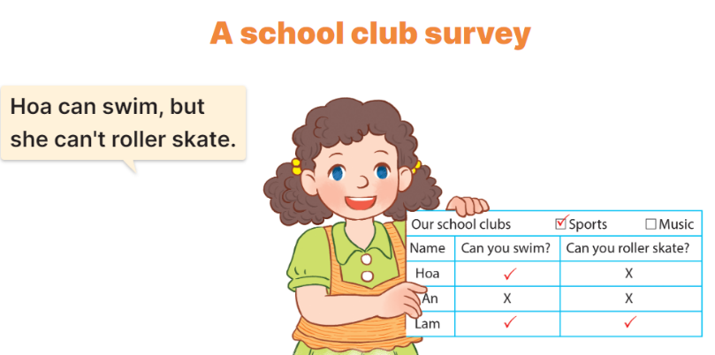  - Explain again that they need to work in groups of four or five to complete a school club survey.  + Each group should choose two clubs such as sports or music.  + Each pupil in a group needs to write questions to ask their friends to find out what they can or can’t do to find members for the club  + Ask pupils presents his / her survey results to the class.  + Ask pupils to show the completed survey that they have prepared at home.  - Have pupils work in their groups.  + Each pupil should hold up their survey results and tell their group about them, ex: Hoa can swim, but she can’t roller skate.  - Invite a few groups to present their surveys to the class.  *Consolidation  *Aims: Ss will be able consolidate and wrap up the content of the lesson.  *Procedure:  - T asks ss to answer the following questions:  + What have you learnt from the lesson today?  +What are the core values of the lesson?  - T praises some Ss who are hardworking / active/ good…. as well as encourage others to try more.  4. Homework. (3’)  - Prepare the new lesson: Review 1 | - Ss listen  -Ss play game  - Ss open their books  Students integrate: Read some sentences of the paragraph (4/39)  - Ss read and answer  -Ss read and tick  -Ss swap books and check  -Ss check the correct their answers  -Ss say  -Ss listen  -Ss listen  -Ss listen and pay attention  -Ss write the first gapped sentence.  -Ss read and complete the sentence  -Ss write the answer in the gap  -Ss complete the text  -Ss swap books and check their answers  -Ss read the completes texts.  -Ss listen  -Ss listen and pay attention.  -Ss work in groups and survey.  -Ss present their surveys  -Ss answer the questions  -Ss listen and clap their hands  -Ss listen and take note
D. ADJUSTMENTS (if necessary):
………………………………………………………………………………………….…..……………………………………………………………………………...…………

