Week: 13 Preparing date: 04/12/2024
Period: 51 Teaching date: 06/12/2024

Unit 8: My favourite subjects
Lesson 1 (4, 5, 6)
A. OBJECTIVES:
By the end of the lesson, Ss will be able to:
1. Knowledge:
- use the words and phrases art, music, PE, IT in relation to the topic “My favourite subjects”.
– use What’s your favourite subject? – It’s ……... to ask and answer questions about someone’s favourite subject.
– listen to and demonstrate understanding of simple communicative contexts in relation to the topic “My favourite subjects”.
– read and write about someone’s favourite subject.
- Vocabulary: Review
- Skills: speaking, listening, reading and writing.
Students integrate: Complete and read sentence 1, 2 (5/57)
2. Competences:
- Written Communication: complete the sentences.
- Self-control and independent learning: perform listening tasks.
- Communication and collaboration: work in pairs or groups.
3. Attitude/ Qualities:
- Kindness: Help partners to complete learning tasks.
- Diligence: complete learning tasks.
B. TEACHING AIDS:
- Teacher: Teacher’s guide Pages 114, 115,116; audio Tracks 83; website hoclieu.vn, posters, laptop, pictures, textbook, lesson plan, TV or projector.
- Students: Pupil’s book Page 57, notebooks, workbooks, school things.
C. PROCEDURES:
Teacher’s activities | Students’ activities
1.Warm- up: (5’)  Sentence Puzzle  *Aims: to create a friendly and active atmosphere in the class to beginning the lesson.  *Procedure:  - Divide the class into groups of four.  - Give each group a sentence that is broken/cut in to pieces.  - Ask Ss to arrange them to make a complete sentence, then read it aloud.  - The group makes it first will be the winner.  - Say “Open your book page 57” and look at “Unit 8, Lesson 1 (4,5,6)”.  2.Practice: (27’)  Activity 1. Listen and tick or cross:  *Aims: Ss will be able to listen to and understand four communicative contexts in which pupils ask and answer questions about their favourite subjects, and tick or cross the pictures.  *Procedure:  - Elicit the subjects in each picture.  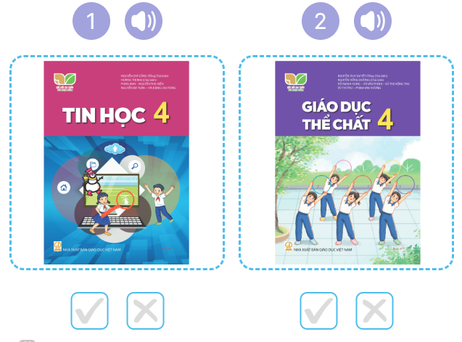  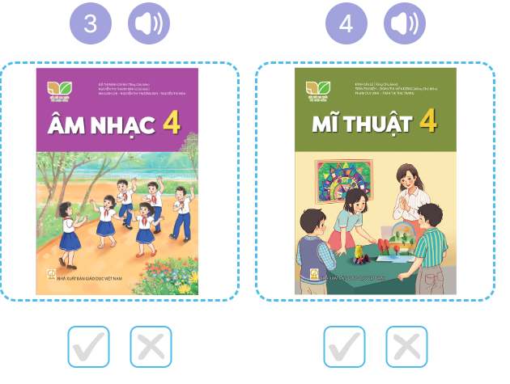  - T ask Ss to guess the answers.  + T writes Ss’guessing on the board.  - Listen to the tape:  + Play the recording  + Play the recording again and get Ss to swap books with their partners.  + Play the recording again to check answers together as a class.  + Write the answers on the board for Ss to correct their answers. Then checks Ss’ guessing.  - Play the recording, sentence by sentence, for the class to listen and repeat in chorus.  Key: 1. v 2. x 3.v 4.x  Activity 2. Look, complete and read  *Aims: Ss will be able to complete four exchanges about characters’ favourite subjects with the help of picture cues *Procedure:  - Ask pupils to look at the pictures and identify the subjects. 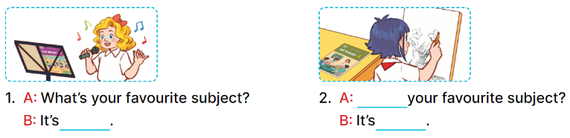  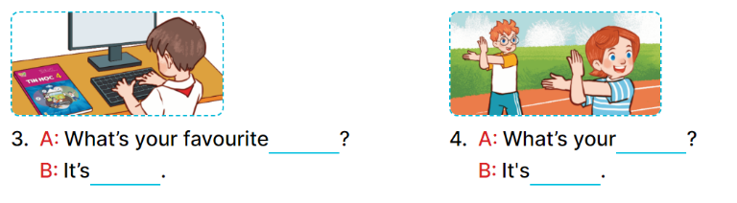  - Have Ss look at the four incomplete sentences. Elicit and model with picture 1  + Ask Ss to read the sentence 1 in chorus.  + Ask Ss what word is missing in the gap (music). Then have them complete the sentence (It’s music).  -Have Ss work in pairs and complete the sentences 2, 3, 4.  - Ask a few Ss to stand up and read the sentences aloud.  -T gives feedbacks.  Key:  1. music 2. What’s; art  3. subject; IT  4. favourite subject; PE  Activity 3. Let’s sing  *Aims: Ss will be able to sing the song My favourite subject with the correct pronunciation, rhythm and melody. *Procedure:  - Have pupils read the song to familiarize themselves with the lyrics  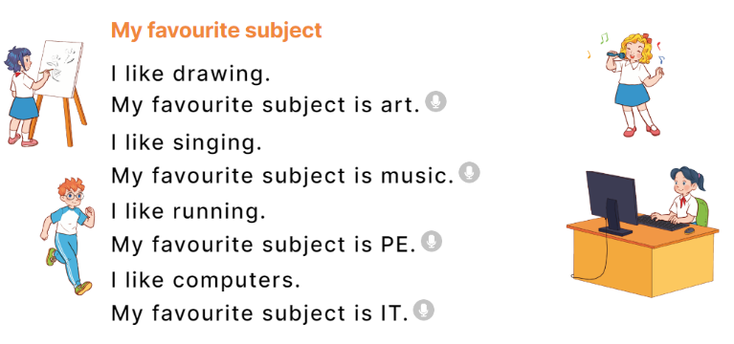  - Play the recording for Ss to listen to the whole song.  + Have them repeat the title and lyrics line by line.  + Tell Ss to point at the pictures while singing.  - Play the recording all the way through for Ss to listen to pronunciation and melody of the song.  - Play the recording line by line for Ss to listen, repeat and point to the pictures  - Play the recording for Ss to sing and do actions.  - Ask Ss to practice singing and doing actions in pairs or groups.  - Invite groups to the front of the classroom to perform the song  -T gives feedback.  *Consolidation  *Aims: Ss will be able consolidate and wrap up the content of the lesson.  *Procedure:  - T asks ss to answer the following questions:  + What have you learnt from the lesson today?  +What are the core values of the lesson? (if the teacher can take from the lesson).  - T praises some Ss who are hardworking / active/ good…. as well as encourage others to try more.  3. Homework. (3’)  - Practice part 5 again.  - Prepare the new lesson: Unit 8, Lesson 2 (1,2,3). | - Ss listen  -Ss listen  - Ss arrange and read aloud  -Ss congratuate the winner  - Ss open their books  -Look at the pictures and say:  + Picture 1: An IT textbook  + Picture 2: A PE textbook  + Picture 3: A music textbook  + Picture 4: . An art textbook  -Ss guess the answers  - Ss listen to the tape and tick/ cross  - Ss listen again, tick/ cross and swap books with their partners.  - Ss check their answers and guessing  -Ss listen and repeat.  Students integrate: Complete and read sentence 1, 2 (5/57)  -Ss look at the picture and say  -Ss look and answer  -Ss read  -Ss say and write  -Ss work in pairs and complete  -Ss read aloud  -Ss read the song  -Ss listen to the song  - Ss listen and repeat line by line without the action.  -Ss point to the pictures while singing  -Ss listen to melody of the song  - Ss listen and sing line by line.  - Ss sing and do actions.  + Ss work in groups (two groups) to sing.  -Ss perform in front of the class.  -Ss listen  -Ss answer the questions  -Ss listen and clap their hands  -Ss listen and take note
D. ADJUSTMENTS (if necessary):
………………………………………………………………………………………….…..……………………………………………………………………………...………………………………………….…..……………………………………………………………………………….……………………………………………………………………...

