Week: 13 Preparing date: 01/12/2024
Period: 50 Teaching date: 03/12/2024

Unit 8: My favourite subjects
Lesson 1 (1, 2, 3)
A. OBJECTIVES:
By the end of the lesson, Ss will be able to:
1. Knowledge:
- use the words and phrases art, music, PE, IT, an English teacher, a maths teacher, a painter and a singer in relation to the topic “My favourite subjects”.
- use What’s your favourite subject? – It’s …..to ask and answer questions about someone’s favourite subject;
- listen to and demonstrate understanding of simple communicative contexts in relation to the topic “My favourite subjects”.
- Vocabulary: PE, IT, favourite.
- Skills: speaking and listening
Students integrate: Read the words: PE, IT, favourite.
2. Competences:
- Self-control and independent learning: perform listening tasks.
- Communication and collaboration: work in pairs or groups.
- Sociability: talk to each other, say good words to others.
3. Attitude/ Qualities:
- Show pride in what they can do and great respect for other people’s abilities by using appropriate gesture and intonation when asking and answering about abilities.
B. TEACHING AIDS:
- Teacher: Teacher’s guide Pages 112, 113, audio Tracks 77, 78, website hoclieu.vn, posters, laptop, pictures, textbook, lesson plan, TV or projector.
- Students: Pupil’s book Page 56, notebooks, workbooks, school things.
C. PROCEDURES:
Teacher’s activities | Students’ activities
1.Warm- up: (3’)  Game: Who says faster  *Aims: to create a friendly and active atmosphere in the class to beginning the lesson.  *Procedure:  - Hold some flashcards about subjects, then reveal it slowly.  - Ask What is it?  - Ask the Ss guess the answer as fast as possible.  - Then have Ss do the same with the rest.  - This can be played in groups to make it more interesting  - Say “Open your book page 56” and look at “Unit 8, Lesson 1 (1,2,3)”.  2. Presentation (16’)  Activity 1. Vocabulary.  *Aims: Ss will be able to know the vocabulary in the new lesson.  *Procedure:  -T elicits the new words  + favourite : yêu thích (situation)  + PE= Physical Education: môn thể dục  (realia)  + IT= Information Technology : môn tin học (realia)  - T models (3 times).  - T writes the words on the board.  - Checking: Rub out and remember  Activity 2. Look, listen and repeat:  *Aims: Ss will be able to understand and correctly repeat the sentences in two communicative contexts focusing on asking and answering questions about someone’s favourite subject.  *Procedure:  - Have Ss look at Pictures a and b and identify the characters (Linh and Ben) in the pictures.  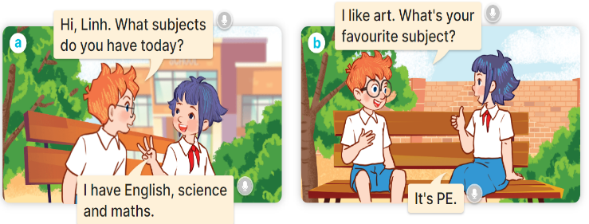  - Play the audio twice (sentence by sentence). Correct their pronunciation where necessary.  - Have Ss to practice the dialogue  - T invites a few pairs to the front of the class to practice.  - T checks pronunciation for ss.  Activity 3 2. Listen, point and say.  *Aims: Ss will be able to correctly say the words and use What’s your favourite subject? – It’s …….. to ask and answer questions about someone’s favourite subject.  *Procedure:  * Model sentences:  - T asks Ss look at picture a and helps Ss know the structure from the dialogue.  - T introduces new structure for Ss.  - T explains, models and gives meaning.  -Have Ss repeat the model sentences.  A: What’s your favourite subject? B: It’s PE  3.Practice: (7’)  *Drill pictures  - Have Ss look at the pictures and elicit the subjects.  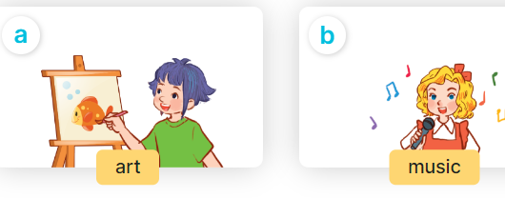  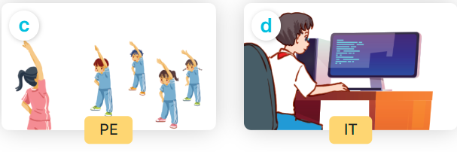  - Run through all the pictures.  - Run through model sentences.  - Have Ss to practise:  +Tell Ss to point the subjects in the picture when they are repeating the sentence  - T controls and corrects.  - Invite a few pupils to stand up, point at each school thing in the picture and say he sentence aloud.  - T gives feedbacks.  4.Production: (7’)  Activity 4. Let’s talk.  *Aims: Ss will be able to enhance the correct use of What’s your favourite subject? – It’s …… to ask and answer questions about someone’s favourite subject in a freer context.  *Procedure:  - Draw pupils’ attention to the two speech bubbles.  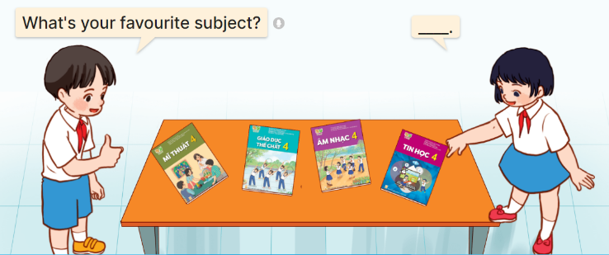  - Ask them to look at the girl’s speech bubble to identify what the answer should be. ex: It’s IT.  - Get pupils to repeat the question and answer several times.  - Have pupils to work in pairs, point at the different books, ask and answer questions about their favourite subjects using What’s your favourite subject? – …..  - Invite some pairs to take turns asking and answering questions about their favourite subjects in front of the class.  *Consolidation  *Aims: Ss will be able consolidate and wrap up the content of the lesson.  *Procedure:  - T asks ss to answer the following questions:  + What have you learnt from the lesson today?  +What are the core values of the lesson? (if the teacher can take from the lesson).  - T review the vocabulary and model sentences.  - T praises some Ss who are hardworking / active/ good…. as well as encourage others to try more.  5. Homework. (2’)  - Learn the vocabulary and model sentences by heart  - Prepare the new lesson: Unit 8, Lesson 1 (4,5,6). | - Ss listen  -Ss play the game  -Ss play the game  -Ss open the books  Students integrate: Read the words: PE, IT, favourite.  -Ss listen and answer  - - Ss listen and repeat  + Choral repetition (3 times).  + Individual repetition (3 ss)  - Ss take note  - Ss look, remember and write  -Look at the pictures and say  + In picture a:  Ben: Hi, Linh. What subjects do you have today?  Linh: I have English, science and maths.  + In picture b:  Linh: I like art. What’s your favourite subject?  Ben: It’s PE.  -Ss listen and repeat in chorus (twice)  -Ss work in pairs to practice  -Ss practice the dialogue  -Ss listen  -Ss look at the picture and answer.  -Ss listen  -Ss listen and repeat  -Ss repeat  - Ss look, listen and answer  + Picture a. A girl painting  + Picture b. Five children singing  + Picture c. A group of pupils doing physical exercise  + Picture d. A boy and a girl working on a computer  -Ss listen and repeat  -Ss practice in chorus, individuals.  -Ss point and say  -Ss listen.  -Ss look at the picture and answer  + a boy pointing at textbooks on a table, and asking a girl about her favourite subject.  -Ss look at the picture and answe  -Ss repeat the question and answer  -Ss work in pairs, point and say  -Ss ask and answer their favourite subjects in front of the class.  -Ss answer the questions  - Ss listen  -Ss listen and clap their hands  -Ss listen and take note
D. ADJUSTMENTS (if necessary):
………………………………………………………………………………………….…..……………………………………………………………………………...………………………………………….…..……………………………………………………………………………….……………………………………………………………………...

