Week: 8 Preparing date: 30/10/2024
Period: 31 Teaching date: 01/11/2024

Unit 5: Things we can do
Lesson 2 (1, 2, 3)
A. OBJECTIVES:
By the end of the lesson, Ss will be able to:
1. Knowledge:
- understand and correctly repeat the sentences in two communicative contexts (pictures) in which the characters talk about abilities and lack of abilities.
- correctly say the words and use Can he / she …….? – Yes, he / she can. / No, he / she can’t, but he / she can ……. to talk about abilities and lack of abilities.
- enhance the correct use of Can he / she ……..? – Yes, …... / No, ……, but ……... to talk about abilities and lack of abilities in a freer context.
- Vocabulary: roller skate
- Skills: speaking and listening
Students integrate: Read the words: ride a bike, ride a horse, play the piano, play the giutar, roller skate
2. Competences:
- Critical Thinking: self-introduce
- Co-operation: ready to help friends in pair work/ group work.
- Sociability: Talk to each other, say good words to others.
3. Attitude/ Qualities:
- Kindness: Help partners to complete learning tasks.
- Honesty: tell the truth about feelings and emotions
B. TEACHING AIDS:
- Teacher: Teacher’s guide Pages 72,73,74; audio Tracks 49, 50, website hoclieu.vn, posters, laptop, pictures, textbook, lesson plan, TV or projector.
- Students: Pupil’s book Page 36, notebooks, workbooks, school things.
C. PROCEDURES:
Teacher’s activities | Students’ activities
1.Warm- up: (3’)  Game: Guessing game  *Aims: to create a friendly and active atmosphere in the class to beginning the lesson.  *Procedure:  - Divide the class into 3 teams.  - Pupils take turns to answer the questions.  - They look at the objects and guess what activity they can do with the objects.  - If they have the correct answers, they get the points for their teams. If the answer is not correct, another team answers  - Say “Open your book page 36” and look at “Unit 5, Lesson 2 (1,2,3)”.  2. Presentation (16’)  Activity 1. Vocabulary.  *Aims: Ss will be able to know the vocabulary in the new lesson.  *Procedure:  -T elicits the new words  + roller skate : trượt pa tin (picture)  - T models (3 times).  - T writes the words on the board.  - Checking: What and where  Activity 2. Look, listen and repeat:  *Aims: Ss will be able to understand and correctly repeat the sentences in two communicative contexts (pictures) in which the characters talk about abilities and lack of abilities.  *Procedure:  - Have Ss look at Pictures a and b and identify the characters and predict the activities that Linh can do on the sports day.  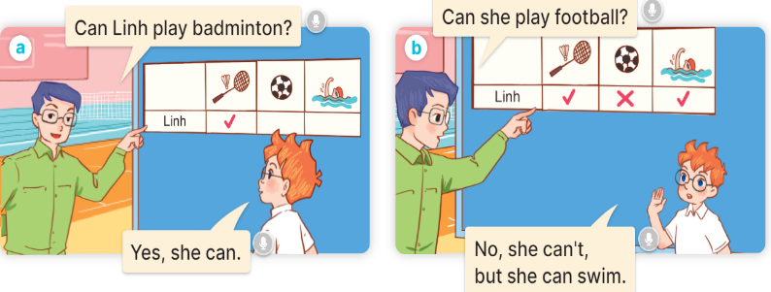  - Play the audio twice (sentence by sentence). Correct their pronunciation where necessary.  - Have Ss to practice the diaguage  - T invites a few pairs to the front of the class to practice.  - T checks pronunciation for ss.  Activity 3. Listen, point and say.  *Aims: Ss will be able to correctly say the phrases and use Can he / she … ? – Yes, he/ she can. / No, he/ she can’t, but he/ she can ……. to talk about abilities or lack of abilities.  *Procedure:  * Model sentences:  - T asks Ss look at picture a and helps Ss know the structure from the dialogue.  - T introduces new structure for Ss.  - T explains, models and gives meaning.  - Have Ss repeat the model sentences.  A: Can he swim?  B: Yes, he can.  A: Can he roller skate?  B: No, he can’t, but he can swim.  3.Practice: (7’)  *Drill pictures  - Have Ss look at the pictures and elicit the activities.  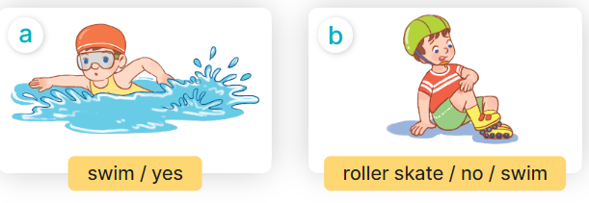  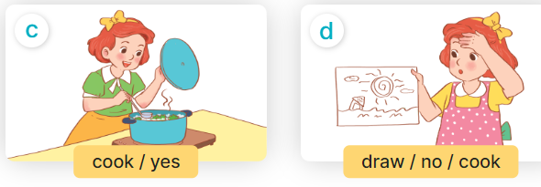  - Run through all the pictures.  - Run through model sentences.  + Run through the questions  + Run through the answers  - Have Ss to practise:  + T asks – Ss answer (change role).  + Ss – Ss (change role).  - Ask Ss to work in pairs.  - T controls and corrects.  - Invite a few pairs to come to the front of the classroom, point at the pictures and say the questions and answers in front of the class.  - T gives feedbacks.  4.Production: (7’)  Activity 4. Let’s talk.  *Aims: Ss will be able to enhance the correct use of Can he / she …. ? – Yes, …. / No, , but ....... to talk about abilities and lack of abilities in a freer context.  *Procedure:  - T asks ss to guess each character and what the children say.  + What can you see in the picture?  +Who are they?  +Where are they?  +What are they doing?  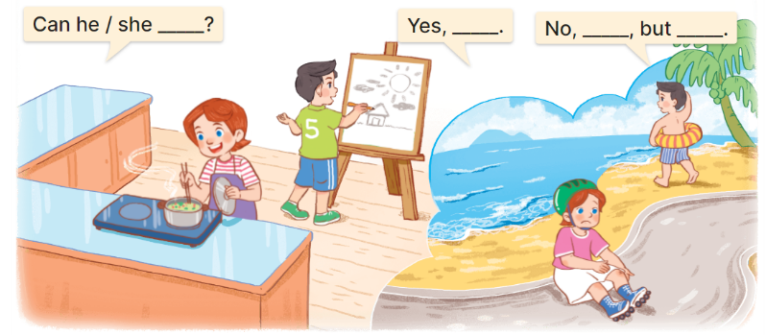  - Put Ss into pairs and encourage them to ask and answer questions using Can he/ she….? I Yes/ No, I….….  - Elicit the missing words in the speech bubbles and write them on the board.  - Get pupils to say the completed sentences.  - Give pupils time to work in pairs and take turns asking and answering about what the friends in the pictures can or can’t do.  - Invite a few pairs to come to the front of the classroom and act out the roles.  *Consolidation  *Aims: Ss will be able consolidate and wrap up the content of the lesson.  *Procedure:  - T asks ss to answer the following questions:  + What have you learnt from the lesson today?  +What are the core values of the lesson? (if the teacher can take from the lesson).  - T review the vocabulary and model sentences.  - T praises some Ss who are hardworking / active/ good…. as well as encourage others to try more.  5. Homework. (2’)  - Learn the vocabulary and model sentences by heart  - Prepare the new lesson: Unit 5, Lesson 2 (4,5,6). | - Ss listen  - Ss play the game  -Ss play the game  - Ss open their books  Students integrate: Read the words: ride a bike, ride a horse, play the piano, play the giutar, roller skate  -Ss listen and answer  - - Ss listen and repeat  + Choral repetition (3 times).  + Individual repetition (3 ss)  - Ss take note  - Ss look, remember and slap  -Look at the pictures and get to know the characters in the pictures.  + In picture a:  Mr Long: Can Linh play badminton? Ben: Yes, she can.  – In picture b:  Mr Long: Can she play football?  Ben: No, she can’t, but she can swim.  -Ss listen and repeat in chorus (twice)  -Ss work in pairs to practice  -Ss practice the diaguage  -Ss listen  -Ss look at the picture and answer.  -Ss listen  -Ss listen and repeat  -Ss repeat to the sentences.  -Ss listen and answer  +Picture a: swim/ yes  +Picture b. roller skate/ no/ swim  +Picture c. cook/ yes  +Picture d. draw/ no/ cook.  - Ss look, listen and repeat  - Ss practice in chorus  - Ss practice in chorus  -Ss work in pairs to practice  -Ss listen  -Ss go to the board and point and say  -Ss listen  -Ss look at the picture and answer  + Lucy is cooking, Nam is drawing, Lucy cannot skate, Nam cannot swim.  -Ss work in pairs  -Ss write the missing words  -Ss say the completed sentences  -Ss check nd answer  -Ss act out in front of the class  -Ss answer the questions  - Ss listen  -Ss listen and clap their hands  -Ss listen and take note

D. ADJUSTMENTS (if necessary):
………………………………………………………………………………………….…..……………………………………………………………………………...………………………………………….…..……………………………………………………………………………….……………………………………………………………………...

