Week: 8 Preparing date: 27/10/2024
Period: 30 Teaching date: 29/10/2024

Unit 5: Things we can do
Lesson 1 (4, 5, 6)
A. OBJECTIVES:
By the end of the lesson, Ss will be able to:
1. Knowledge:
- listen to and understand two communicative contexts in which pupils ask and answer questions about someone’s abilities and tick the correct pictures.
- complete four gapped exchanges with the help of picture cues.
- practise the target vocabulary and sentence patterns by playing the game Can you ...?
- Vocabulary: Review
- Skills: speaking, listening, reading and writing.
Students integrate: Complete two sentences (1, 2) with the help of picture cues (5/35).
2. Competences:
- Critical Thinking: self-introduce
- Co-operation: ready to help friends in pair work/ group work.
- Self-control and independent learning: perform listening tasks.
3. Attitude/ Qualities:
- Kindness: Help partners to complete learning tasks.
- Honesty: tell the truth about feelings and emotions.
- Diligence: complete learning tasks.
B. TEACHING AIDS:
- Teacher: Teacher’s guide Pages 70,71,72; audio Tracks 48; website hoclieu.vn, posters, laptop, pictures, textbook, lesson plan, TV or projector.
- Students: Pupil’s book Page 35, notebooks, workbooks, school things.
C. PROCEDURES:
Teacher’s activities | Students’ activities
1.Warm- up: (5’)  Game: Lucky number  *Aims: to create a friendly and active atmosphere in the class to beginning the lesson.  *Procedure:  - Divide the class into 3 groups.  - Pupils from each team choose a number, then ask and answer with the picture in that number.  - Pupil or teacher clicks the “play” button to roll the dice and clicks the “stop” button to get points.  - After 9 numbers, the group with the most points is the winner  - Say “Open your book page 35” and look at “Unit 5, Lesson 1 (4,5,6)”.  2.Practice: (27’)  Activity 1. Listen and tick:  *Aims: Ss will be able to listen to and understand two communicative contexts in which pupils ask and answer questions about someone’s abilities and tick the correct pictures.  *Procedure:  - Elicit the names of the characters in the pictures.  - Point at the pictures respectively to explain the context.  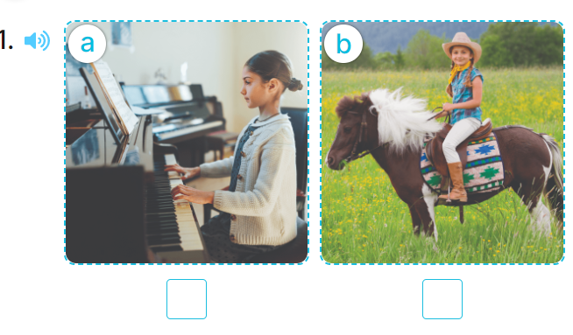  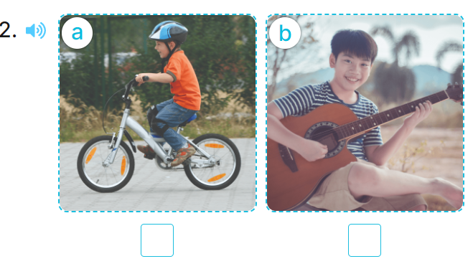  - T ask Ss to guess the answers.  + T writes Ss’guessing on the board.  - Listen to the tape:  + Play the recording  + Play the recording again and get Ss to swap books with their partners.  + Play the recording again to check answers together as a class.  + Write the answers on the board for Ss to correct their answers. Then checks Ss’ guessing.  - Play the recording, sentence by sentence, for the class to listen and repeat in chorus.  Key: 1. b 2. b  Activity 2. Look, complete and read  *Aims: Ss will be able to complete four gapped exchanges with the help of picture cues.  *Procedure:  - Have pupils read the exchange and guess the missing words in the answer.  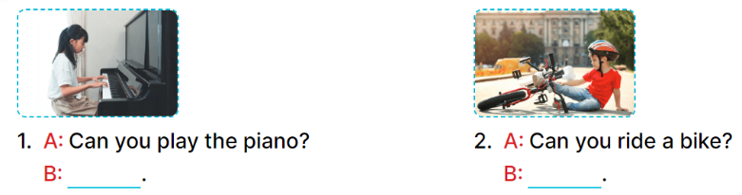  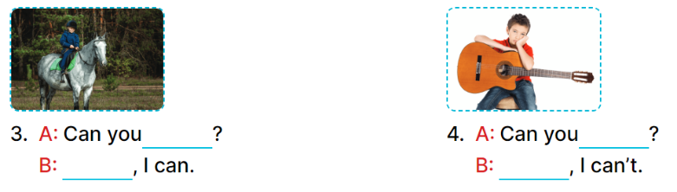  - Have Ss look at the four sentences and the pictures. Elicit with picture 1  - Give pupils time to do the task independently.  - Get pupils to swap books with a partner and check their answers before checking as a class.  - Nominate a pupil to write the answers on the board.  - Invite four pairs of pupils to act out four complete exchanges in front of the class.  Key:  1. Yes, I can 2. No, I can’t  3. ride a horse; Yes 4. play the guitar; No  Activity 3. Let’s play  *Aims: Ss will be able to practise the target vocabulary and sentence patterns by playing the game Can you ...?  *Procedure:  - Invite two groups, each with six pupils, to play the game.  -Tell pupils the goal of the game and how to play it.  + Each group has two minutes to play.  + The teacher holds up a flash card (ride a bike), the first pair looks at the picture, one pupil asks (ex: Can you ride a bike?) and another pupil replies as quickly as possible. +Check with the whole class if the question is correct or not, and ask the group to demonstrate the action.  + The pair who has played goes to the end of the line.  + The second pair moves up and continues with the next flash card.  + For each pair, the group gets three stars, one star for the question, one for the answer and one for the group action.  - Play the game with other groups in the class. The group with the most stars is the winner.  *Consolidation  *Aims: Ss will be able consolidate and wrap up the content of the lesson.  *Procedure:  - T asks ss to answer the following questions:  + What have you learnt from the lesson today?  +What are the core values of the lesson? (if the teacher can take from the lesson).  - T praises some Ss who are hardworking / active/ good…. as well as encourage others to try more.  3. Homework. (3’)  - Practice part 5 again.  - Prepare the new lesson: Unit 5, Lesson 2 (1,2,3). | - Ss listen and pay attention  - Ss play game  -Ss play game  - Ss open their books  -Look at the pictures and say:  + Picture 1a: a girl playing the piano.  + Picture 1b: a girl riding a horse + Picture 2a: a boy riding a bike  + Picture 2b: a boy playing the guitar  -Ss guess the answers  - Ss listen to the tape and tick  - Ss listen again, tick and swap books with their partners.  - Ss check their answers and guessing  -Ss write the correct answer.  -Ss listen and repeat.  Students integrate: Complete two sentences (1, 2) with the help of picture cues (5/35).  -Ss look at the picture and say  -Ss look and answer  -Ss do the task  -Ss work in pairs and swap books  -Ss write the answer on the board  -Ss act out  - Ss listen  -Ss play game  - Ss listen and play game  -Ss answer the questions  -Ss listen and clap their hands  -Ss listen and take note
D. ADJUSTMENTS (if necessary):
………………………………………………………………………………………….…..……………………………………………………………………………...………………………………………………………………………………………………….………

